# THE ENSEMBLE OF CLASSIFICATION SCHEME FOR THE ANALYSIS OF CUSTOMER BEHAVIOUR IN THE BEAUTY INDUSTRY.

# **DECLARATION**

# **CERTIFICATION**

# **DEDICATION**

# **ACKNOWLEDGMENTS**

# **ABSTRACT**

Many businesses and enterprises suffer losses that they can make no meaning of especially in the immediate Nigerian environment, this is most common with small start-ups in Africa. A great number of beauty brand start-ups have customer data with no utilisation and small and upcoming brands repeatedly take the fall for this oversight, either the business growth is stagnant or the business crashes entirely. Data Science is fast becoming a norm, gathering customer data, keeping records and making sense out of what should ordinarily just be plain old record keeping is now being utilised to enhance business performance and design working business models through data analysis and predictions of customer patterns and actions. Enhancing and improving business optimization with the aim of maximising profit, elongating business lifespan and providing maximal utility to customers as consumers is the aim of this analytic solution provided by this research paper. This research uses Big Data Analytic (BDA) Classification algorithms to build a model in order to run predictive analysis with the bid to predict what customer’s action would be so as to make decisions (prescriptive analysis) in sync with customer’s consumer instincts leading to increased profitability is the method of handling the existing problem of failing beauty brands and too much with little utilisation in the status quo. From conducted data analysis and research, a number of BDA Classification algorithms were implemented including: Logistic regression, Decision Trees, K-Nearest Neighbours and Random Forests, taking the accuracy scores from each implementation to decide which algorithm best predicts the customer pattern and is most likely to increase profitability when decisions are made based on its predictions. Turned out to be the most accurate model with an accuracy score of 0.99. This research paper goes without saying to show that customer behaviour is very much relative to the reaction left by previous customers and a customer is likely to react the same way a large population of one’s beauty brand clientele has already reacted if the customer is aware of their review. Hence, in conducting this research, being able to build a model that predicts the choice of a customer is a major accomplishment as this goes to influence business decisions. This is referred to as pre-emptive business strategizing.

**Keywords**: Big Data Analytics (BDA), Data Science, Classification, Consumer Behaviour, Beauty Industry, Business Decisions, Business Growth, Predictive Analysis, Prescriptive Analysis

# **TABLE OF CONTENTS**

Table of Contents

THE ENSEMBLE OF CLASSIFICATION SCHEME FOR THE ANALYSIS OF CUSTOMER BEHAVIOUR IN THE BEAUTY INDUSTRY. 1

DECLARATION 2

CERTIFICATION 3

DEDICATION 4

ACKNOWLEDGMENTS 5

ABSTRACT 6

TABLE OF CONTENTS 7

LIST OF TABLES 10

LIST OF FIGURES 11

Introduction 12

1.1. Background of the Study 12

1.2. Statement Of Research Problem 15

1.3. Aims and Objectives 15

1.4. Research Questions 16

1.5. Motivation of the Study 16

1.6. Significance Of the Study 17

1.7. Scope Of the Study 17

1.8. Study’s Expected Outcome 18

1.9. Organization Of the Dissertation 18

1.10. Definition Of Terms 18

CHAPTER TWO 20

Literature Review 20

2.2 . Big Data Importance in the Beauty Industry 20

2.3. Customer Data in the Beauty Industry 21

2.4. Researches From Related Works 23

2.5. Research Gap 29

2.6. Summary Of Related Works and Research 29

CHAPTER THREE: RESEARCH DESIGN AND METHODOLOGY 30

3.0 Introduction 30

3.1 Research Design 31

3.1.1 Empirical Study 34

3.1.2 Mixed Methods Research 34

3.1.2.2 Qualitative Research Approach 35

3.1.3 Techniques Sampling 35

3.2 Population of the Study 36

3.3 Sample and Sampling Procedure 36

3.3.1 Non-Probability Sampling 37

3.3.2 Purposive Sampling Procedure 37

3.4 Method of Data Collection 37

3.4.1 Primary Data Collection 38

3.5 Data Analysis Method 38

3.5.1 Qualitative Data Analysis 39

3.5.2 Quantitative Data Analysis 39

3.6 Problems Encountered and Solutions 41

CHAPTER FOUR: ANALYSIS OF DATA AND DISCUSSION 42

4.0 Introduction 42

4.1 Overview of Data Collection 42

4.1.1 Research Participants 44

4.1.2 Research Instruments 45

4.1.3 Reliability and Validity of Instruments 45

4.2 Data Analysis 46

4.2.1 Frequency Distribution Analysis 47

4.2.2 Research Question 1 54

4.2.2.1 Descriptive Analysis 55

4.2.2.2 Statistical Analysis 56

4.2.2.2.1 Logistic Regression 56

4.2.2.2.2 Decision Tree 58

4.2.2.2.3 Random Forest 60

4.2.2.2.4 K Nearest Neighbors 62

4.2.2.3 Prescriptive Analysis 62

4.2.3 Research Question 2 63

4.2.3.1 Descriptive Analysis 64

4.2.3.2 Predictive Analysis 67

4.2.4 Research Question 3 67

4.2.4.1 Descriptive Analysis 68

4.2.5 Research Question 4 69

4.3 Discussion 71

4.4.1. Technologies implemented 74

CHAPTER FIVE: SUMMARY AND CONCLUSIONS 76

5.1. Introduction 76

5.2. Summary 76

5.3. Findings Of the Study 77

5.3.1. Limitations of the study 78

5.4. Constitution to Knowledge 79

5.5. Conclusion 79

5.5. Recommendations 80

REFERENCES 82

APPENDIX 86

Appendix A: Informal Discussion Procedure 87

Appendix B: Questionnaire 88

Appendix C: Value of Data and Specification Table 89

Appendix D: Tableau, Jupyter Data Visualizations 90

# **LIST OF TABLES**

# **LIST OF FIGURES**

**CHAPTER ONE**

**Introduction**

## **Background of the Study**

The beauty industry worldwide has grown exponentially, the history of the beauty industry worldwide is as diverse and colourful as all the multiple lip stain colours and diverse cultures that exist. In the late 19th and early 20th century, the beauty industry became an important and viable career path for women, especially African-American women, who created products designed specifically for differently textured hair. (Beauty tips & Blog, 2014). In today’s world the beauty industry is not just occupied and saturated by women alone or just African-American or African women alone but the industry now comfortably houses women of all other races and men as well. At different periods in time, the beauty industry has recorded a paradigm shift that has resulted in different reactions and results from customers all over the world; different classes of customers have risen from different ages as the beauty industry has undergone different changes in medium, method and process. For instance, during the war, the beauty industry took a practical turn, with focus and emphasis on creating sunscreen for soldiers. The basics of sun protection can now be found in a number of different beauty products and is a cornerstone for most facial cosmetics. (Beauty tips & Blog, 2014). Today, the beauty industry has returned to its roots, with science-based products doing double and triple duty. Women not only want to look beautiful they want their makeup and hair care products to benefit them as well. Beauty balms, correction creams, intensive serums, and anti-aging formulas are designed to showcase a woman’s beauty, correct any flaws or imperfections, and help her shine both inside and out.

Customer behaviour and pattern over the years whilst using beauty products or while patronizing the beauty industry has also evolved with time and has phased in and out of different responses to different situations based on consumer reactions.

Businesses are now tasked with the responsibility of figuring out the expectations of their customers as they consume their products and services. The prediction of these customer expectations is simply with the goal of predicting future patterns that would enable beauty industry businesses operate better and provide the precise needs of their customers in order to ultimately give consumer satisfaction to customers who patronize the industry. This study is aimed at analysing customer behaviour over time in the beauty industry using big data analytics in order to arrive at a predictive summary of customer consumer behaviour for better optimization and effectiveness of services in the beauty industry. Classification technique of Big Data Analytics is applied to run analysis on customer behaviour data in the beauty industry in order to have a predictive analysis result on customer consumer behaviour at the end of this research. Classification is a predictive modelling problem where a class label is predicted for a given example of input data. (Brownlee, 2020). From a modelling perspective, classification requires a training dataset with many examples of inputs and outputs from which to learn. A model will use the training dataset and will calculate how to best map examples of input data to specific class labels. As such, the training dataset must be sufficiently representative of the problem and have many examples of each class label. There are classification techniques in the area of big data. Big Data is unstructured data that exceeds the processing complexity of conventional database systems. The data is too big, moves too fast, or doesn’t fit the rule restricting behaviour of our database architectures. This information comes from multiple, distinct, independent sources with complex and evolving relationships in a Big Data which is keep on growing day by day. Big Data concern large-volume, growing data sets that are complex and have multiple autonomous sources. Earlier technologies were not able to handle storage and processing of huge data thus Big Data concept comes into existence. This is a tedious job for users to identify accurate data from huge unstructured data. So, there should be some mechanism which classify unstructured data into organized form which helps user to easily access required data. Classification techniques over big transactional database provide required data to the users from large datasets more simple way. There are two main classification techniques; supervised and unsupervised. (Brownlee, 2020). Big Data Analytics will be implemented with the help of machine learning classification technique in this study as a means to identify meaningful predictive analysis patterns, predictive analytics provides the business intelligence about the future using the insights of Big Data classification techniques. Big Data Analytics will help organizations in providing an overview of the drivers of their business by introducing big data technology into the organization. This is the application of advanced analytic techniques to a very large data set. These cannot be achieved by standard data warehousing applications. These technologies are Hadoop, mapreduce, massively parallel processing databases, in memory database, cloud, search-based applications, etc. The business benefits of Big Data Analytics include turn dormant data into new opportunities making use of big data analytics techniques, intuitively design very complex predictive models using casual factors. (PAT Research, 2013). Big Data Analytics is a vast complex of processes that analyse Big Data from different perspectives to make sure there are patterns and correlations, market trends, and customer preferences with the help of which organization can make the right business decisions. So, data analytics is one of the biggest priorities of all organizations in any industry there is. (Nazar, 2021).

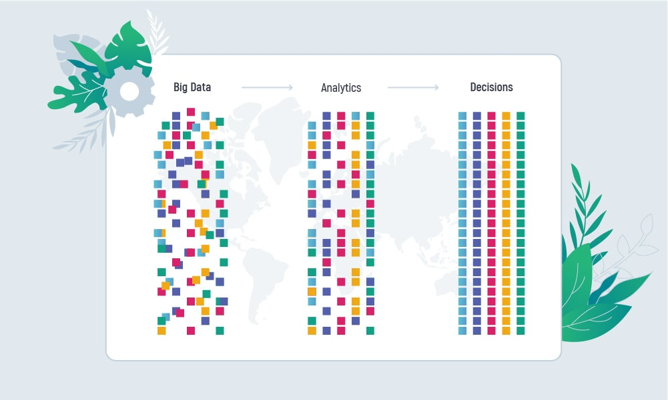

Figure 1. 1 Illustration of Data Optimization with Big Data Analytics from Inoxoft (Nazar, 2021).

The beauty industry worldwide is worth approximately $511 billion in 2021 (Szecsei, 2022), accounting for a very large percentage of the world’s population that make up the frequent patronage circle, many beauty brands start up every year, many stand to survive the test of time and many also fail to survive the test of time, each for different business analytic reasons, smaller beauty brands most often fail to stand the test of time for one business logistic problem or the other. The ability of these beauty branded businesses to ascertain customer needs and responses to an almost accurate level will be highly beneficial to the growth and direction of their business and can apply to other business models outside the beauty industry as well. A very good amount of beauty brands exist without a good enough structure on how to account for their business journey or how to improve their businesses; through this study and implementation of our big data analytic predictive model, prediction of customer behaviour and patterns would make understanding customer responses and reactions to business decisions easier, this is pictured from figure 1.1 above, where mixed up random data gathered is analysed using BDA, once analytics begins, the data starts to make sense and can become useful for prediction and so businesses would make better brand decisions and actions that would not only improve the growth of their business beauty brands but also increase customer consumer satisfaction level.

## **Statement Of Research Problem**

The need to understand one’s environment in every area of life is paramount, this need is reflected in business ventures as well. The urgency to understand one’s market target, their behaviour, needs and desires make business strategies more focused. The beauty industry grows larger every day and the inflow of customers exponentially increases, as a result the diversity of consumers in the market is dynamic and requires more study to make better business decisions.

The problem is a lot of small beauty industry businesses do not take the time to study customers’ data in order to make decisions and so suffer untimely failure of their business venture. In cases where businesses try to take account of customer features in order to arrive at plausible conclusions, the data provided is either too little to make decisions with or too large to handle manually; it for this reason this study to predict customer behaviour in order to make more effective business decisions is being carried out. This research thus will solve the problem of:

1. Business Indecisiveness
2. Excess data control consequences
3. Lack of optimized business solutions

## **Aims and Objectives**

The aim of the research is to develop a predictive model implementing big data analytics classification machine learning technique to sample data and make predictions of prospective customer consumer behaviour in the beauty industry based on data collected and sampled in order to make good business decisions leading to effective business strategies and improvement in customer satisfaction level.

The objectives of the research are:

1. To identify the problem that exists in the beauty industry regarding customer data and behaviour.
2. To understand the influence of customer behaviour prediction on business optimization.
3. To identify how preferences of customers affects customer behaviour in the beauty industry.
4. To identify the most suitable Big Data Analytics technique to achieve the research aim.

## **Research Questions**

The research will attempt to answer the following questions:

1. Does customer data show a correlation to customer behaviour in the beauty industry?
2. Does customer behaviour prediction increase business optimization?
3. What are the preferences of customers in beauty products?
4. What technique is implemented to achieve the aim of this research?

# **Motivation of the Study**

Satisfying and meeting customer needs is an essential for every business that exists to thrive, very many businesses have failed due to inability to keep up this pro tip; many have tried but have been unsuccessful largely due to the means of reaching this goal. For businesses in the beauty industry, it hurts double when customer needs are never met or are continuously evaded, sometimes erroneously.

This is because a vast majority of customers in the beauty industry are women and as a woman and a customer of this industry, it is a pain point when products have the same faults over and over or when other customers can relate to a pain point of a product for more than a few years, this means either the companies do not use customers’ reviews or just do not want to improve or do not know how to. It is for this reason that building a model which would help to predict customer’s behaviour based on customer data over time would become a relief to many other customers just like me. Also, it would be an ardent contribution to a field of interest as well as a welcome idea if a lot of beauty brands especially small brands adopt this data management and utilisation plan for business optimization.

## **Significance Of the Study**

This research has both theoretical and practical significance:

Theoretically, this study will add to already existing work on big data analytics, it will be a clear implementation of data mining and sampling techniques being put to use and would be useful for educational purposes and as a point of reference for other researchers as well as all academics.

Practically, this research will serve as a data bank to student researchers and would be useful to businesses all over, it would be a beacon of light to small businesses especially and would help businesses with optimization and good business decision making processes as well as proper customer view representation in the long run. Consequently, for most small businesses to implement this model, business improvement will be recorded.

## **Scope Of the Study**

The scope of this research is limited to the beauty industry only and would involve majorly small beauty industry enterprises as these businesses suffer from the problem of the research which is ill representation of consumer needs leading to untimely business failure. The implementation of this research will involve big data analytics technique using the tableau analysis software for data visualisation.

## **Study’s Expected Outcome**

1. At the end of this study, a complete software predictive model to visualise customer consumer data in order to make predictions on customer behaviour is to be developed.
2. A comprehensive study composed of literatures reviewed for this paper and research work in order to build the predictive model.
3. A project that fulfils its objectives.

## **Organization Of the Dissertation**

This dissertation is divided into varying parts all with the aim to reach the objective of this study and provide a comprehensive material of the study. These parts of the dissertation include: The Introduction, The Literature Review, Research Design and Methodology, Analysis of Data and Discussion and then Summary and Conclusion. Each aspect of the dissertation designed to contribute significantly to the entire study. The Literature Review houses significant works on related themes by other researchers, it shows the existing gaps to be filled by this research and the update from previous works in pre-existing literatures. The Research Design and Methodology chapter focuses on the research methodology applied to this thesis and the overall design technique implemented. The Data Analysis and Discussion engages the data collection process, the methods and its evaluation for utilization and then the concluding part of this dissertation, the Summary and Conclusion as it implies brings the thesis to a comprehensive end.

## **Definition Of Terms**

Terms used in this chapter: Classification, Machine Learning, Data, Big Data Analytics, Prediction, Predictive Analytics, Business Optimization.

1. Classification: Can be described as when a machine or computer uses an algorithm to draw conclusions from data it already has, and then uses these conclusions to categorise new data it receives.
2. Machine Learning: The use and development of computer systems that are able to learn and adapt without following explicit instructions, by using algorithms and statistical models to analyse and draw inferences from patterns in data.
3. Data: Individual pieces of factual information recorded and used for the purpose of analysis.
4. Big Data Analytics: Big data is a field that treats ways to analyse, systematically extract information from, or otherwise deal with data sets that are too large or complex to be dealt with by traditional data-processing application software.
5. Prediction: In data mining, it is the identification of data points purely on the description of another related data value.
6. Predictive Analytics: It is the use of statistics and modelling techniques to determine future performance based on current and historical data.
7. Business Optimization: Is the process of improving the efficiency, productivity and performance of an organization.
8. Decision Trees: Is a decision support tool that uses a tree-like model of decisions and their possible consequences, including chance event outcomes, resource costs and utility. It is one way to display an algorithm that only contains conditional control statements, it is one of the predictive modelling approaches used in statistics, data mining and machine learning. It uses a decision tree to go from observations about an item to conclusions about the item’s target value.
9. K-Nearest Neighbours: The K-Nearest Neighbors also known as KNN algorithm is a simple, supervised machine learning algorithm that can be used to solve both classification and regression problems.
10. Random Forest: Random forests or random decision forests are an ensemble learning method for classification, regression and other tasks that operates by constructing a multitude of decision trees at training time. For classification tasks, the output of the random forest is the class selected by most trees.
11. Logistic Regression: Logistic regression is a supervised learning classification algorithm used to predict the probability of a target variable. It is one of the simplest ML algorithms that can be used for various classification problems such as spam detection, diabetes prediction, cancer detection, etc.

## **CHAPTER TWO**

## **Literature Review**

This research is hinged on the need to analyse customer behaviour as consumers in the beauty industry, examining the ensemble of classification scheme for this analysis, basically looking at all it involves to analyse customer behaviour via Big Data Analytics Classification techniques while reviewing work done by other researchers to increase business optimization in the beauty industry as the sole aim of this analysis of customer behaviour in the beauty industry is to optimize beauty brands’ businesses especially small beauty brands.

Understanding consumers has long been the goal of any brand, but decoding emotion is extremely complex and requires the power of technology. (Kacey, 2020). A great many factors influence customer behaviour and consequently purchasing habits in any business at all, providing an effective and efficient way to analyse tons of customer patterns in order to understand their behaviour is the focus of this research; other researchers have done work on customer behaviour, in this chapter we review a number of such related works.

Nowadays, businesses adopt ever-increasing precision marketing efforts to remain competitive and to maintain or grow their margin of profit. As such, forecasting models have been widely applied in precision marketing to understand and fulfil customer needs and expectations. In doing so, there is a growing attention to analysis of consumption behaviour and preferences using forecasts obtained from customer data and transaction records in order to manage products. (Seyeden & Mafakheri, 2020).

## **. Big Data Importance in the Beauty Industry**

Big data has proven its ability to help beauty brands optimize a variety of processes. From package and formula design, marketing and sampling campaigns, and strategic plan development, big data can provide access to analyses of consumer behaviour and wants, especially for companies that are interested in targeting Gen-Z buyers to reach a diverse range of customer needs, asking questions about consumer issues can be combined with big data from databases, lab results, and other raw data sources such as imaging or robotic measurement. This helps beauty companies obtain accurate information that is not susceptible to bias or hidden by subconscious human interests. It also helps speed up the process of product development, audience targeting, and opportunity analysis, so that companies can make operations and utilization decisions to provide a diverse range of products with optimized margins. (Broyd, 2020).

Big Data is useful in so many ways and the world are even yet to attain 30% of the potential existent in the field of Big Data. Businesses in all areas appreciate this luxury of Big Data to optimize their businesses effectively simply from the gathering of data regarding the business. The beauty industry is not left out and a good number of beauty brands value what they can do with information. However, lapses of course exist as somehow collection of this data is a problem. Using algorithms and machine learning to analyse the data customers provide, the beauty industry is scaling and generating so much revenue worldwide. “Amazing things happen when you listen to the customer”.

Youngsil et al (2021) reviewed the changes in purchasing changes in the beauty market after COVID-19 pandemic. This review still adds to show the importance of BDA in the consumer scene and consequently in the beauty industry market. Marketing strategies for a lot of beauty brands in this era of course transitioned greatly to an online presence and to adequately follow up progress of the different online marketing strategies applied, different algorithms and machine learning techniques for quite a number of beauty brand companies were applied due to the condition of the circumstance that COVID-19 presented.

## **2.3. Customer Data in the Beauty Industry**

The beauty industry covers a lot of ground where beauty brands are concerned, data in the context of beauty brand customers can be categorized into information derived from customers such as preferences, reviews, quantity, colour, texture, description, likes, dislikes, etc. These sort of information from customers hugely influences the next decision that brands come up with if brands take note of customer responses and feedback. Because Big Data gives feedback untainted by human agenda, it allows companies to identify an audience, mistakes and opportunities as accurately as possible. And it is also enabling companies to provide consumers with precise beauty services and products. (Lim, 2018). Most beauty brands don’t have a lot of first-party data, unless they sell directly through an e-commerce platform. However, even with first-party data, many brands lack the online and offline behavioural insights on the consumers who buy products from a retailer and may not have the data needed to power true personalized marketing. (Slater, 2020).

The analysis of massive databases has long been used for descriptive purposes (in national statistics, for example). With advances in IT and the over-abundance of data retrieved from new technologies, companies are increasingly seeking to predict consumer behaviour. And once reality has been well described and future scenarios anticipated, it is then very tempting to want to take action.

"Beyond prediction, the prescriptive dimension of big data is all the more interesting that the implementation of tracks identified with predictive analysis can concretely be materialized," emphasised Patrick Zerbib. His method consists in collecting large amounts of characterizing data, to best identify all the elements likely to influence consumer behaviour. "We therefore never limit our analysis to our customers’ internal data; we always integrate external data." (Gallon, 2016). Quoting Zerbib from Gallon, 2016; the implementation and utilisation of big data in the cosmetic industry is well underway from just being predictive to prescriptive as well, prediction with long term benefits. This is the idea this research builds on as the model of focus is an implementation of BDA to make lasting effective business decisions in the long run.

Data-driven personalization continues to accelerate as customers increasingly value the advantages of a convenient and fast shopping experience. They're likely to spend more and add extra items to their baskets when the purchasing experience is specifically tailored to their problems and needs. (Revieve, 2021).

In today’s beauty and personal care industry, new product development and innovation are happening as fast as consumers are posting about their beauty routines online. The industry has shown tremendous growth, with a projected market value of $805.51 billion in sales by 2023.

One reason for such rapid growth? Cosmetics consumption — and new innovation ideas — are now born out of digital-first spaces. Consumers no longer need to head to their local makeup counter to find new products. Beauty apps and subscriptions offer individualized care routines and products. Devices like L’Oreal’s smart hairbrush capture consumer data in the product itself. Social media and influencer campaigns offer brands with new options for direct-to-consumer sales online. (Thomas, 2019). An increasing merge of the beauty industry world with the technological space is evident in almost every beauty industry sector and as such an automation of a whole lot of the processes that go into creating advantageous business ideas and decisions is ideal. When consumers visit a store, the experience is high-tech too, with facial recognition displays, VR experiences and digital loyalty programs all continuously gathering personalized data. This new beauty ecosystem means there are both fewer barriers for manufacturers to reach consumers and more ways to gather data to drive product innovation ideas. Big data is empowering beauty brands with the access to information about the consumers’ behaviour and their desires. Thus, beauty brands can create revolutional products and services that revolutionize the industry. (The joy, 2019). The scope of application of big data can address lots of issues — from fraud risk to business growth. Big data can respond to strategic goals of companies, moving “from predictive to prescriptive”, marking the services provided smarter, faster and suitable for a particular individual.

## **2.4. Researches From Related Works**

There are many research works conducted to predict outcome of a particular input with different Machine Learning techniques including Big Data Analytics. This research will focus on the business field of the beauty industry.

In theory data mining can be used in an unlimited number of areas. For instance, zettafox has applied its techniques to sampling distribution or to the transformation rate in duty free stores. One can very well imagine using specific algorithms to maximize the impact of a packaging, the texture or the sensory accuracy to a product. Provided the necessary data is available! But when companies specialized in this area are called upon it is often because companies have already started collecting data and - overwhelmed by the flows - they need to structure them. (Gallon, 2016). One of the most important things with collection of data and further performing analysis on said data is a proper data structure, this is recognized by zettafox in the implementation of different algorithms to optimize their cosmetics business, data collected is of course, rough and unstructured but to achieve anticipated results from such data, data cleaning and transformation has to first of all take place.

Morphitou, R. (2011) examined a Cyprian brand called “The Seventeen” with the goal of examining the brand status in relation to its customer bank and to evaluate ways the image of The Seventeen as a brand could be enhanced and optimized. To do this effectively, it took analysing the customer margin of the brand and analysing how business decisions affect the customers and how the customers of this brand respond to the business choices. The strategy of Morphitou, R. (2011) was to examine the marketing of Seventeen, the Cypriot cosmetic market and more specifically what affects their purchasing decision about cosmetic products and the perceptual map of local users in relation to its position strategy,

To understand customers' behaviour and provide them personalized services to their needs, having rich sources of user data in-house and a streamlined process of analysing and using those data has never been more critical. Data-driven customer personalization is developed based on a combination of first-party user data - collected from consumers and third-party customer data- collected from external organizations. In the beauty industry, customer data such as typical skin types of shoppers, common skin problems, and the allergic ingredients to most customers are precious for beauty brands and retailers. (Revive, 2021). Categorizing data into the relevant types and classes that helps one arrive at the desired goal of the entire data collection process is a skill that never leads a data scientist astray. The Revieve blog article on data privacy and personalization balance explores this.

From The Joy app article on their implementation of Big Data in optimizing the cosmetic industry through customer data, the Joy App will process and sell targeted statistical information on actual trends within the platform’s ecosystem. The companies will be able to get the statistics within the platform with possibility of filtering by gender, age, geography and other. The customers’ personal information, however, will not be accessible, presented only as general trends. This will be helpful to better understand the customers’ behaviour and preferences. The big data on The Joy platform will be also received from regional partners to agree on the pricing and bonus system inside the platform. Using the statistics provided by the big data will also help both brands and salons increase the efficiency of targeted ads.

Thus, the big data module used inside The Joy platform will give salons and practitioners the opportunity to improve their services according to the customers’ demand, following trends and meeting the customers’ requirements in terms of the services provided. The Joy App gives practitioners and businesses an opportunity to use modern blockchain-powered technology and big data statistics to find customers and elevate the quality of their services. (The joy, 2019). This is a beautiful implementation of BDA in building a business, in this research we approach our idea of optimization from a rather different angle, by focusing on collecting customer data as well in order to predict customer behaviour towards beauty products and then use this prediction to make inferences, in other words, to prescribe business solutions thus prescriptive solutions.

Factors that influence consumer behaviour towards cosmetics by Sailakshmi et al (2019) analysed literatures that posed that the idea of satisfying customers is by ticking a box and meeting ever need of a customer, this condition gave birth to long lasting engaging customers in relation to the customers’ level of consumption. Steady analysis of customers pattern of consumption though shows where the shoe itches, this means that with proper analysis and evaluation of the consumption pattern of customers, a business is likely to succeed at satisfying the needs of a customer without exactly analysing organizational needs. Sailakshmi et al discusses the different factors they believe to influence the consumer pattern of customers, these factors are: psychological, social, cultural, personal and economic. A keen study of these factors provides answers to why customers consume the way they do. This is not the response or answer this research seeks to obtain, this paper is streamlined to figuring out how best a business could handle the behavioural patterns of a customer in the beauty industry after analysing this pattern in such a way that it would lead to business growth and progress.

Amberg et al in their study examined consumer behaviour towards the cosmetics in groups, first analysing the factor groups influencing customer behaviour then the gap between science and customer perception and finally moving on to the customer satisfaction then the process possibility of a model developed called the Own model. The idea of the Own model development is to fill the existing gap Amberg et al identified to exist between science so far and the actual customers’ perception of things that influence their purchasing choices in the cosmetic market, the Own model developed by Amberg et is only a theoretical model though and this still leaves gaps to be filled as a practical model stands better chances of providing a higher growth index for businesses, this is the focus of this research, to try out models that aim at improving business efficiency in the beauty industry.

According to Yadav et al (2016) of Indira Ghandi University in India, every company tries to fulfil customer needs and expectations, in their work, they proposed a set of steps to identify customer relationship with managements of businesses. (Dilini & Kulawansa, 2018). The steps proposed include following processes to Big Data, they include Description Analytics as well as Diagnostic and Perspective Analysis. All of these different ML fronts of approach to maximize business optimization, the idea of their work was to study customer relationship to see the effect customer relationship management would have on the growth of businesses. This study comes from a different angle of analysing customer behaviour and habits in order to predict customer patterns to better understand customers so as to meet their needs and expectations. The difference between this research and the research of Yadav et al (2016), is the approach of business optimization; instead of using Big Data Analytics for customer relationship management, we apply Big Data Analytics for customer behaviour prediction using different Big Data Classification techniques to predict outcomes of customer future habits based on the trend in current customer consumer behaviour, this provides better insight to knowing what customers sort of expect and would boost a business way faster than analysing customer relationship although that is important as well but not a prominent determinant of business growth.

Amberg and Gyenge (2020) in their work on developing a model for analysis of customer behaviour in the cosmetics market developed a model of cosmetic consumer behaviour. As expected, the creation of their model was preceded by the exploration of the consumer side of the cosmetics market, checking out cosmetic trends and groups. The model developed by Amberg and Gyenge was purely theoretical and not implemented practically which is the gap that the model developed in this study stands to fill, by building an actual practical model to predict customer consumer behaviour for business growth and optimization. Their model illustrated the consumption and purchase of cosmetics products and services, their aim was for the reason that at the time there was no theoretical approach or research supported by primary data that would describe domestic conditions, but with time this reason has become obsolete as a lot of domestic datasets exists on the internet and in platforms such as Kaggle which is one of the primary sources for this research. The theoretical model proposed by Amberg and Gyenge (2020) stops at a revaluation of customer ethics and patterns, the model in this research on the other hand takes data from customer pattern revaluation and uses said data as the basis to predict future patterns in customer’s habits and behaviour by running the datasets through a number of algorithms and selecting the best algorithm to determine future patterns in a customer’s consumer habits.

The Oberoi siblings in their study of consumer behaviour towards cosmetic products in the Indian scenery focused on correlating the factors that control customers’ will to purchase products. Their study’s objective was to find the correlation among the factors and income and to find the extent of dependence between the significant factors and purchase of cosmetic products. In their study, the siblings used similar testing and analysis tools as in the course of this research and their results bordered on similar axis showing the level of influence income has on purchasing decisions, this of course is not a straight path as one would expect for high earning persons to spend the most at all times but then in some cases even low-income earning persons would spend a largesse of their income surpassing what average or high-income earners would spend. Income thus, stood out as a significant fluctuating factor. In this research paper, the basis of customer behaviour is pinned towards the direction of influence from other consumers and feedback or reviews shared, of course other factors such as price and income are significant but people hold the most influence from our analysis.

Apampa (2016) worked on research to increase the performance of classification algorithms used in the bank customer marketing response prediction of an unnamed Portuguese bank using the Random Forest ensemble. His work was one of the base research projects for this study, as his work was also centred on prediction using ensembles of classification techniques, this happens to be the exact same approach for this study. the study of consumers helps firms and organizations to improve their marketing strategies by understanding issues such as the psychology, mindset, behaviour and motivation of consumers. (Raorane & Kulkarni, 2011). Normally, organizations with an ambition to grow must hold on to customer data in order to develop their business brands. According to Tudor et al (2011), a customer relationship management system is a bucket on information technology (IT) applications and procedures whose target is to identify the main expectations and preferences of clients, and to effectively use client information to improve relationships between the enterprise and its customers, this is what Apampa (2020) built his research on, the relationship between customers and the brand so as to improve the relationship between the enterprise and the customer by prediction of customer’s response to certain marketing strategies. In his research phase, Apampa (2020) went through three classification algorithms; logistic regression algorithm, decision tree algorithm and naïve bayes algorithm, each classification algorithm giving different results at their implementation, the work of Apampa (2020) could have been more broad as he could have gone through more classification algorithms to certify that his prediction model was as accurate as can be; this is a barrier this study intends to break by exploring more classification algorithm to ascertain higher accuracy precision.

In a significant research on pandemic prediction using big data analytics, the research by Imran Ahmed et al (2021) takes advantage of big data analytics and performs four types of analysis, including descriptive, diagnostic, predictive and prescriptive analysis all with the aim of providing in-depth analysis on the pandemic in order to obtain useful information; this is an approach well learnt for this study as gathering information is one of the most important aspects of this study and is very much needed in order to run a good predictive model. In their model, a neural network based model was used to help in the decision making processes for healthcare organizations, the distinct thing about our model is how instead of tracking health related issues, we modify big data analytics using machine learning algorithms instead of neural networks for business optimization using BDA to explore the possibilities of predicting yet to happen behaviour patterns of customers, this can consequently be applied to every other field including medical areas. The work of Ahmed et al (2021) provided a comprehensive study on the analysis done using descriptive, diagnostic, predictive and prescriptive analysis using Internet of Things and Big Data to implement neural networks, the bulk of their work is in their analysis phase to obtain information and arrive at the desired output of their model.

In another well-constructed work by Safara (2020) who did research on prediction of consumer behaviour in the middle of the COVID-19 pandemic, the work done is quite synonymous to the proposed work of this research as Fatemeh also looked at prediction of consumer behaviour but particularly in the pandemic era, she therefore is taking into cognisance the issues that have arisen with the pandemic era, this is quite similar as in our work we also take note of these pandemic causing issues as the business world is now fully situated in a pandemic era and is yet to be out of the said era, but in our research we centre prediction on the behaviour of consumers in the beauty industry. The ideology behind Safara (2020) research was to figure out factors and important features influencing the volume of online purchase during the coronavirus pandemic. With the advent of internet, knowledge-based economies such as online shopping was emerged long time ago. Machine learning methods could be used to extract implicit knowledge from the online shopping sites’ logs (Ahmadi, 2020). Industries and businesses use the knowledge to better understand the consumer behaviour, and opportunities and threats correspondingly. Nowadays, big projects such as Siri Apple, Eco Amazon, Google, Facebook, and Microsoft employ machine learning techniques to automatically analyse their consumers shopping behaviour and provide appropriate service for them (Wu et al. 2019). However, using machine learning methods is not restricted to projects with huge research budgets. Small and Medium Enterprises (SMEs) could benefit from these methods to improve their efficiency as well. In her work, Safara (2020) proposed and used two approaches to predict consumer behaviour in COVID-19; statistical approach and Machine Learning approach, in statistical approach, correlation between different features is calculated and analysed. In machine learning approach, a predictive model is proposed to anticipate consumer behaviour in online shopping.

## **2.5. Research Gap**

Research discussions and inquiry process of this paper and reviewed literatures revealed a number of things. Although, the emergence of data science and big Data Analytics is a glorious upscale in business technology, the shortcomings of availability of data poses a problem; where there is a reluctance on the part of customers to leave information required by organizations, the needed data bank for analysis is insufficient to make inferences upon. A questionnaire was prepared for the cause of gathering data in this research, it took a good number of months to attain a significant number of responses, this slows down the entire process in business situations.

Also, it takes thorough understanding of the different classification schemes and a good grasp of the whole idea of data science and computations to run an analysis model, because of this, third party software is utilised such as Tableau, Jupyter notebook and other Bi applications. This makes the computation process easier but takes away the intimate understanding of the computational analysis and its workings.

The complexity of some of the classification schemes applied makes the use of Bi applications worthwhile yet there is still a gap that needs to be bridged when it comes to fully grasping these external classification models.

The problem of mobility affected the will to explore more small scale beauty brand businesses in the beauty industry, the expenditure required for effective mobile ventures in this regard just was not favourable to the terms of carrying out this research and as such this stood as a shortcoming, although the online space proved to be of some aid in bridging this gap.

Generally, more data would make future researches easier, data from real time businesses and customers. For research purposes and business growth businesses should encourage customers to share feedback and recommendations as often as possible as this just might bridge the gap to a faster customer behaviour understanding and subsequently business growth.

## **2.6. Summary Of Related Works and Research**

Table 2.1 provides a tabular summary of the major works by other researchers this thesis hinged on; it shows a comparative analysis of the ensemble of each literature thoroughly analysed in the course of this thesis on the basis of the technology and model implemented in providing solution and the solution model type.

|  |  |  |  |  |
| --- | --- | --- | --- | --- |
|  | Machine Learning Models | Classification Ensembles | Big Data Analytics | Practical Working Models |
| Romika Yadav, Monika, Tarun Karun & Garima | YES | YES | NO | YES |
| Nora Amberg & Balazs Gyenge | NO | NO | NO | NO |
| Olatunji Apampa | YES | YES | NO | YES |
| Imran Ahmed et al | NO | NO | YES | YES |
| Morphitou Ria | NO | NO | YES | NO |
| Oberoi Parul $ Oberoi Prerna | NO | NO | YES | YES |
| The Joy App | YES | NO | YES | YES |
| Salakshmi, Y.P & Suresh Babu, M. | NO | NO | NO | NO |
| Youngsil & Ki Han Kwon | NO | NO | NO | NO |
| Fatemeh Safara | YES | YES | NO | YES |
| (This should bear the name of the owner of this work) | YES | YES | YES | YES |

Table 2.1 Comparative Analysis and Summary of Reviewed Works

## **CHAPTER THREE: RESEARCH DESIGN AND METHODOLOGY**

# **Introduction**

The chapter analyses the strategy used to implement the plan of this project. Research design and methods are closely related but different; the research design is a framework of research methods and techniques implemented in this research whereas the methodology is the path through which this research is conducted. The beauty industry constantly produces sublets and outlets all over the world as many entrepreneurs start up beauty brands in large numbers on a yearly basis, the demand for beauty products is only increasing and on the high side too, the need to properly manage and utilise data is more prominent for beauty brands especially small start-up beauty brands in order to see them sail and not sink, customer data is more important than ever in this data analytic age, where data interpretation is the bedrock for so much decision making processes in a business, and intelligent utilisation of data interpretation information is key to successful business growth.

In this chapter, the research design techniques used to implement this model to analyse customer consumer behaviour in order to make inferences and predictions on customer future actions will be discussed as well as the methodology of this whole research process.

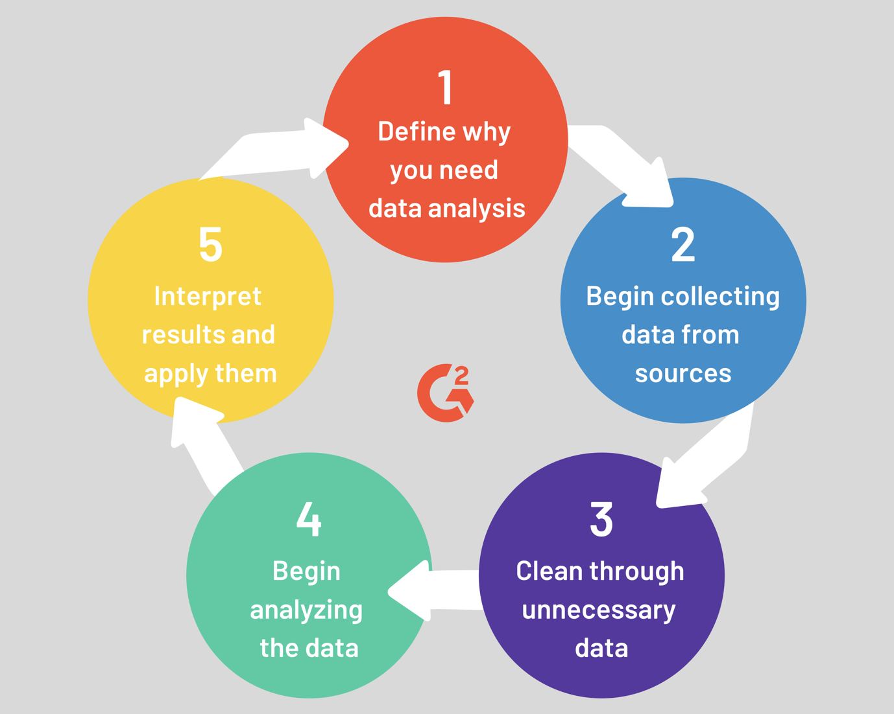

Figure 3. 1 Illustration of the research design process

## **Research Design**

The design of a research explains the research type. The design phase of this project is the phase where the data collection process is defined, data measurement and data analysis are conducted in this phase. The techniques applied to collect, measure and analyse data make up the research design of this thesis. Data mining has attracted lot of attention in the research industry and in society as a whole in recent years, due to enormous availability of large amount of data and the need for turning such data into useful information and knowledge. Data mining, also called Knowledge Discovery in Databases (KDD), is the field of discovering new and potentially useful information from huge databases. (Kaur, Pet al 2015). The population utilized, sample data and sampling procedure are assessed in this chapter, data is gathered through an interview discussion session with a few numbers of small beauty brand owners in order to further establish the need for beauty brands to utilise customer data and to emphasize the importance of understanding customer behaviour for successful business decision making processes. This data collected is solely to showcase the importance of this research process, data from a beauty brand business was also gathered from Kaggle software showing distinct definitive features which would be the basis for our predictive analysis, samples of the datasets extracted for the purpose of this project are highlighted in chapter four.

In visualizing the extracted datasets in order to see beyond features and numbers, the tableau data analysis software is used, this allows for representation of the alphanumeric data in pictorial form, making it easier to notice trends and distinctions in the data analysis and description stages. First things first, after assessing the datasets, a systematic step by step procedure to arrive at a successful conclusion was aligned, data visualisation of the datasets untouched right before definition and analysis of data, present in chapter four of this thesis are samples of the data visualized on the tableau data analysis software.

The methodology used in this research, a survey cum experimental methodology is used. The data was collected via different sources using mixed methods by surveying stakeholders like beauty store owners sharing insight on their customer patronage. Secondary data was obtained from the Kaggle online data bank, particular datasets for a beauty industry store showing customer level of patronage, frequently purchased products, period of purchase, total money spent. From research done on literatures and existing works and then research on the beauty industry environment, a number of factors considered to be influential on customers and how they behave were pointed out and identified. The data collected was analysed using multiple big data methods and techniques. (See Section 3.6).

To carry out successful prediction of customer behaviour, after taking cognisance of the statistical data at hand, we start to apply the ensemble of big data analytics classification techniques we have selected for the purpose of this research process, going through the following techniques one after the other;

- Decision Trees

- K-Nearest Neighbours

- Random Forest

- Logistic Regression

After each technique is applied, the results are stored for reference and comparison in the end, the data is also visualised after each technique is applied to it.

At the end of trying out all the techniques aforementioned earlier, the data results are all compared, the technique with the most accurate results is assumed to be the best predictive solution and from this result we presume it safe to carry out prescriptive analysis in order to make inferences on customer behaviour in the beauty brand as well as to make decisions that would ahead of time record positive impact on beauty brand businesses.

This study is based on mixed methods research which involves the adoption of both quantitative and qualitative research design methods. Basically, this research uses numerical data obtained from Kaggle which makes for quantitative design method and the online surveys which makes for the qualitative design method. This dissertation research is guided by a systematic workflow in its design method that sees it achieve its end goal.

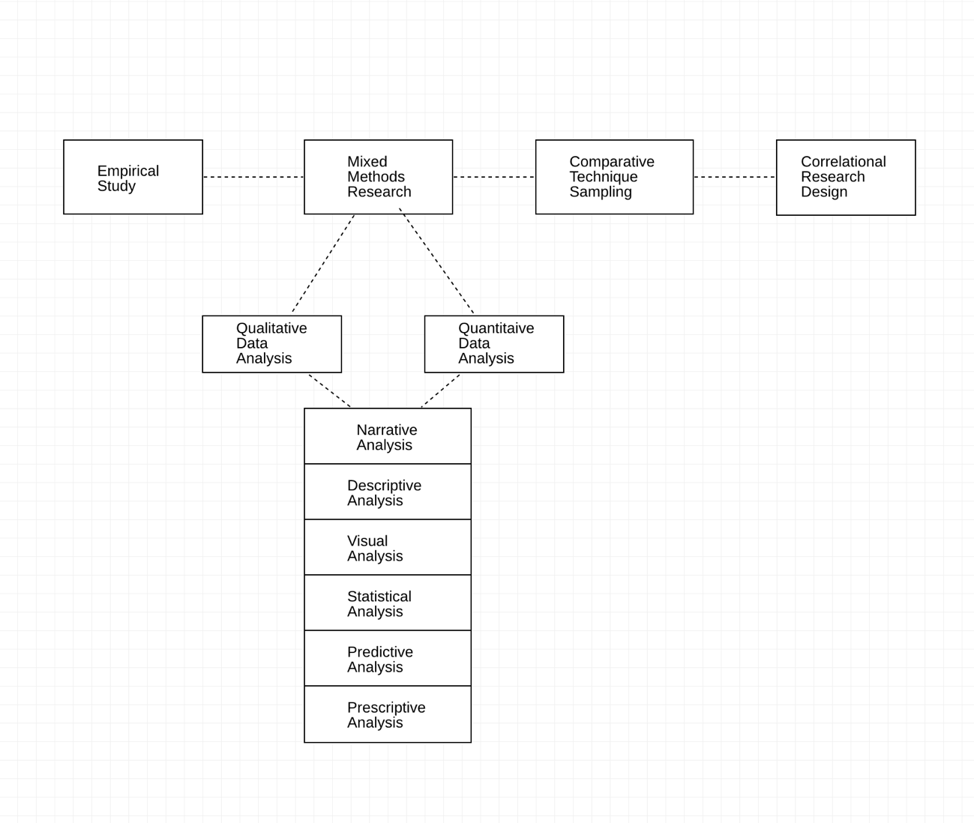

Figure 3. 2 Research Design Workflow

## **3.1.1 Empirical Study**

An empirical study is concerned with or verifiable by observation or experience rather than theory or pure logic. Study here must be originated in or based on observation alone without due regard for system and theory. For an empirical study, the qualitative method is the preferred method which explains why for this dissertation, the empirical study relies on the experience of beauty brand owners evaluated through the qualitative method of research approach applied in the research story.

## **Mixed Methods Research**

A Mixed Method Research is as the name implies, it is a combination of research methods, a research approach whereby researchers collect and analyse both quantitative and qualitative data within the same study. In the cause of this thesis, this survey cum experiment after observation hybrid research method is applied; basically, in a single research study, techniques that fall under both methods of research are conducted to obtain end goal and desired result. This sort of research expands the evidence base. (Shorten & Smith, 2017).

* + - 1. **Quantitative Research Approach**

Quantitative research methods emphasize objective measurement and the statistical, mathematical, or numerical analysis of data collected through polls, questionnaires, surveys or through the manipulation of pre-existing statistical data using computational techniques. (Babbie Earl, 2010). In this paper, this research method was adopted to quantify, evaluate and interpret pre-existing numerical obtained from the Kaggle data source which makes up for the primary data of this research; this method makes presentation of numerical data simplified and readable by researchers.

## **Qualitative Research Approach**

Qualitative research methods focus on and involves collecting and analysing non-numerical data such as text, video, audio in order to understand concepts, opinions or experiences with the aim to gather in-depth insight into a problem, to generate new ideas for research or to solidify evidence of a research. While quantitative research method involves collecting and analysing numerical data for statistical analysis, qualitative research approach is quite the opposite. (Bhandari, 2020). This research method was adopted in this work to solidify the knowledge base for this research and strengthen the onus of this research from the experiences and responses of participants in the data gathering process which makes up for the secondary data of this research.

## **Techniques Sampling**

Techniques sampling is another approach in the research design process modelled to fit the goal of this research, this approach involves and focuses on the relevant and required methods of result delivery to this research process, considering both quantitative and qualitative data gathered. Sampling techniques is an important approach in researches. In research design, this helps narrow the idea of a research to a precise population. In this case, techniques sampling is a run-through of the required Big Data Classification techniques to be utilised in the course of this dissertation; this helps to streamline the data visualization and evaluation process. Here, the researcher’s role is to identify techniques relevant to the dissertation.

* + 1. **Correlational Research Design**

Correlational research is a type of research method that involves observing two or more variables in order to establish a statistically corresponding relationship between them. The aim of correlational research is to identify variables that have some sort of relationship to the extent that a change in one creates some change in the other. This type of research is descriptive, unlike experimental research that relies entirely on scientific methodology and hypothesis. For example, correlational research may reveal the statistical relationship between high-income earners and relocation; that is, the more people earn, the more likely they are to relocate or not. (Formplus Blog, 2020). This dissertation is modelled with this research approach, data collected, visualized and evaluated are all interrelated and change in one variable has change on another variable which goes a long way to show and explain customer reaction to certain business decisions such as change in price or product.

## **Population of the Study**

A population in research is a collection of individuals with the same characteristics and are of particular interest to the researcher based on the research questions and expectations. The population data utilised in this research obtained through an electronic survey gathering information on the expectations of beauty stores from their customers and data from Kaggle was collected from a particular store which had accumulated customer data of 862 customers. The population of this study is the populace of beauty brand owners and customers actively engaged in online exchange of commodities.

# **Sample and Sampling Procedure**

A sample is a subset of the entire population usually sharing some features remarkably similar to represent and characterise the entire population. The portion of a population used to typically carry out and confirm research is called a sample. Sampling is a technique of selecting individual members or a subset of the population to make statistical inferences from them and estimate characteristics of the whole population. There are different sampling types applied to researches. The criteria set for the data gathering process of this research was simply that every member of the population must be part of a beauty industry either as an owner or a customer with focus on customers from our Kaggle data, the sample selected for this research is the entire dataset population of the online beauty store from Kaggle. The sample size of this sample is 862. The sampling procedure used is a Purposive Non-Probability Sampling Procedure.

# **Non-Probability Sampling**

Non probability sampling is used in some situations, where the population may not be well defined. In other situations, there may not be great interest in drawing inferences from the sample to the population. The most common reason for using non probability sampling procedure is that it is less expensive than probability sampling procedure and can often be implemented more quickly (Michael, 2011).  It includes purposive, convenience and quota sampling procedures. (KENPRO, 2012). Nonprobability sampling is the selection of participants because they are available, convenient or, they represent some characteristics the researcher wants to study (Samar, 2017).

# **Purposive Sampling Procedure**

In purposive sampling procedure, the researcher chooses the sample based on who he/she thinks would be appropriate for the study. The main objective of purposive sampling is to arrive as at a sample that can adequately answer the research objectives. The selection of a purposive sample is often accomplished by applying expert knowledge of the target population to select in a non-random manner a sample that represent a cross-section of the population (Henry, 1990). (KENPRO, 2012). This sampling technique is the ideal sampling procedure for this research as the most of the research population are chosen because of their relevance to the research goal and based off of their aligning factors in order to have a sample that closely relates to the end goal and would be efficient in getting the desired answers of this research, this sample also largely characterises the entire population which explains why for the sample, an online customer data bank is used.

# **Method of Data Collection**

Data collection is the process of gathering and measuring information on variables of interest, in an established systematic fashion that enables one to answer stated research questions, test hypotheses, and evaluate outcomes. The data collection component of research is common to all fields of study including physical and social sciences, humanities, business, etc. While methods vary by discipline, the emphasis on ensuring accurate and honest collection remains the same. (Data Collection, 2022). Data collection is broken into two methods; primary and secondary data collection methods.

# **Primary Data Collection**

Primary data is the type of data that has not been around before. Primary data is unique findings of your research. Primary data collection and analysis typically requires more time and effort to conduct compared to the secondary data research. For this research, data is collected via an online survey and a specifically designed google forms questionnaire to further emphasize the need for this research, interviews at random where response was manually recorded from beauty store owners were another primary data source for this research.

* + 1. **Secondary Data Collection**

Secondary data is quite unlike primary data, secondary data is already collected and collated data that a researcher applies to his research, this data collection method is considered easier than primary data collection. A vast majority of quantitative data is usually secondary data. Such data is our sample data for this research. For this research, secondary data include:

1. Customer data including but not limited to name, time of purchase, purchased item, amount spent to purchase, ratings on a product, etc., was collected.
2. Product data also collected with fields such as product name, product number, product type, product quality, product rating, etc.
3. Price data showing the prices customer spend on products.
4. IT data sources from related research papers, manuals and journals emphasizing Big Data Analytics and Classification techniques of evaluating data.

# **Data Analysis Method**

In our data rich age, understanding how to analyse and extract true meaning from data is one of the primary drivers of success. Data analysis is the process of collecting, modelling and analysing data to extract insights that support decision-making. These methods are largely based on two main areas which are qualitative and quantitative. In the course of this research, the data analysis methods applied include: narrative analysis, descriptive analysis, statistical analysis, visual analysis, inferential analysis and finally prescriptive analysis.

# **Qualitative Data Analysis**

1. Narrative Analysis: This is a data analysis method that explains the content of qualitative data, gives the data a definition or concise narration of the research. Here, the goal is to understand the data provided and sum it all up in order to relate its relevance to the research work. This data analysis method was applied to the response from surveys and interviews in the course of the research with the end goal to make meaning of customer and beauty brand owners’ responses.

# **Quantitative Data Analysis**

1. Descriptive Analysis: This is a data analysis method applied in this research to our qualitative data to analyse mostly the numeric, tabular data provided, it explains the “what” of the research, what happened? What is going on? Here, the goal is to understand the data, analysing the fields and features of the data to understand what the data is about. It allows for more meaningful and in-depth insight to the data presented. Using different descriptive analysis tools in this research, the collected data was described. The Jupyter notebook was used to present the data collected in histograms, pie charts, plotting graphs in order to further describe and make meaning from the data.
2. Visual Analysis: This data analysis method is the data visualization aspect of the data collected and collated, this is very important as it makes loads of numbers evenly readable and understandable with little effort for interpretation after the data has been visualised. It is key to possess high resolution and scalable data visualization tools that can detect hidden patterns and trends in data to allow informed decision making. This visualization was conducted using business intelligence software, Tableau. Tableau Prep Builder and tableau Desktop software was used to visualise data before and after inferential analysis. After the raw data visualisation, the important features of the dataset are set out as this is our point of focus in understanding and predicting customer behaviour in beauty brands.
3. Statistical Analysis: This is the main method for analysing quantitative data. It means investigating trends, patterns, and relationships using quantitative data; a lot of the other analysis methods can be classified or categorised as statistical analysis in some texts. It is basically the science of collecting data and uncovering patterns and trends. After collecting data, the data can be summarised usually in pictorial summaries which make data more meaningful as it is visualised.

Predictive Analysis: Predictive analysis relies on existing trends and past data to make business decisions and this is the idea as in this research, we predict customers actions to certain business decisions in terms of price, product and ratings based on pre-existing customer reactions over the years. It is mainly used to predict rules based on existing data. It is also used to understand the relationship between variables in data to aid in conclusion, or generalization regarding a large population. (Norman Blaikie, 2022). The predictive data analysis method involving features in terms of numeric data and classes using big data classification algorithms to process data and make predictions based on the features of the gathered data. In the data analysis phase of this research, first understanding the data gathered and why the data was gathered is very important, which is something that has been thoroughly established and emphasized through the course of previous chapters, looking at why customers make certain decisions is another angle explored in our data analysis, this is described as diagnostic analysis of the data and then to the heart of the data analysis method which is predictive focusing on what will happen based on what our data gathered indicates has happened, the tail end of our data analysis method is descried as prescriptive analysis, here we are able to make business decisions like when to sell a product or if to even sell a particular product because we now know customers are less likely to buy that particular product based on our predictive analysis. Important variables of the sample data on which the entire quantitative analysis rested on include:

- Prices

- Products

- Number of purchases

- Periods customer’s shop

- Customer ratings

- Number of reviewers

1. Prescriptive Analysis: Prescriptive analytics gathers data from a variety of both descriptive and predictive sources for its models and applies them to the process of decision-making. Prescriptive analysis is analysis run on the basis of results and conclusions of research; this sort of analysis provides ground for decision making as it is description of the way forward based on conclusions of the research.

# **Problems Encountered and Solutions**

During the different phases of this research process, multiple problems arose and were resolved to arrive at a conclusion, these include:

1. *Uncontrollable anomalies in secondary data:* Considering that the secondary data was sourced from the Kaggle data bank, missing data entries, Nans and mixed-up values were included in the sample data. To manage this situation, in the phases of interpreting data, the data was cleaned by dropping anomalies, representing string data with Boolean data, etc.
2. *Long Response Time:* Data that was collected from surveys required a long period of time for response to be obtained and this dragged the research process making certain phases longer than expected and slowing down the research progress but, in the end, responses were gathered but of course, not until after the long wait time.
3. *Lack of means to carry out more expansive interviews:* Most of the responses from beauty brand owners on the needs of their customers and some reactions of their customers and customer habits or traits was obtained through the survey via google forms as a solution to the problematic solution of not being better equipped to seek out beauty brand stores across the capital.

This chapter of this paper presents the approach and methods of research design, data gathering and collection process as well as data analysis methods applied to carry out this research. Research design maximises the effort of a research in the first place to answer the research questions of said research. Extensive detailing on the data analysis methods and approaches is contained in chapter four of this dissertation.

# 

# **CHAPTER FOUR: ANALYSIS OF DATA AND DISCUSSION**

## **Introduction**

This chapter provides a concise overview of the data collection and analysis applied to data gathered as well as precise discussions targeted at emphasizing the objectives of this entire research and its end goal in the form of a predictive model developed using Big Data Analytic classification techniques, running a comparative analysis based on accuracy of the models developed and the predictive classification techniques applied. The statistical analysis gives meaning to the meaningless numbers, thereby breathing life into a lifeless data. The results and inferences are precise only if proper statistical tests are used. (Ali & Bhaskar, 2016).

## **Overview of Data Collection**

Before data manipulation and analysis, the gathered data was first cleaned and extracted for the research. Cleaning data is always an important part and this was done using the python library to view and examine data and observe the noise present in the data and then dropping all the noisy content of the gathered data. This process was mainly conducted with the data obtained from the digital platform Kaggle. Data gathered through the google forms survey was extracted as well but being qualitative data did not need the same form of cleaning and extraction as the quantitative data from Kaggle.

Two fundamental data collection methods were applied for this research as earlier stated in chapter 3, data outsourced from Kaggle containing available customer data sources and then data survey collected through the google forms questionnaire designed for this research. Another more informal data collection method was applied where random small beauty brand owners answered some questions in an informal discussion, this data was specifically collected to better understand the ideas from the business owner angle. This informal discussion allowed the researcher better insights and more questions outside of the set expectations. The data collected from Kaggle contained many useful fields and only numerical target data was considered, this data fields include: product, product category, product make, price, customer ratings on product and review total. The specific numeric target data used for computation are the price, ratings and review total. Figure 4.7 through to figure 4.10 show visualizations of this data.

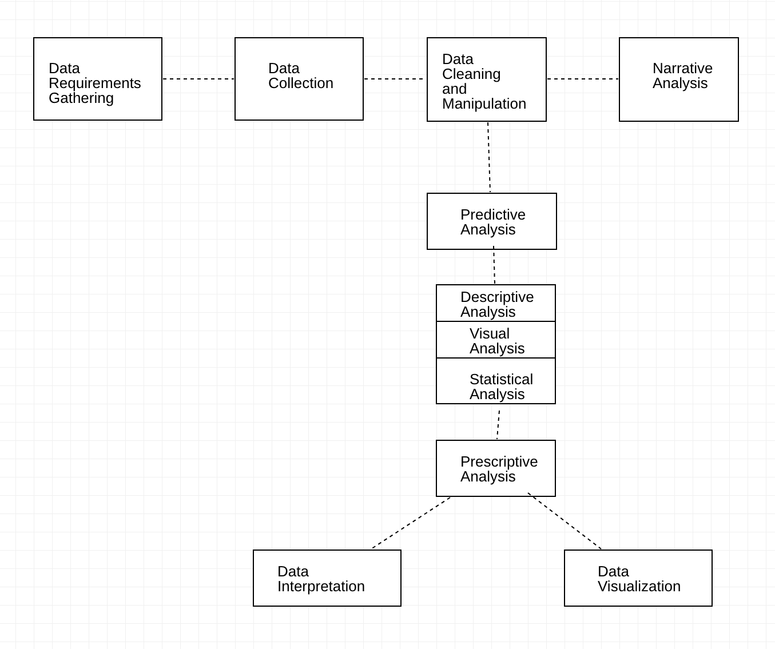

Figure 4. 1: Data Collection Overview

## **Research Participants**

This section of chapter four provides insight to the population of selected participants for this research using descriptive statistics techniques. This research was carried out in Nigeria and is purposive research where target participant expectations are already known with two major data sources; the questionnaire and Kaggle provided data bank with a total population of 862 from Kaggle and 77 participants from the google forms survey thus a total of 939 (N = 939). The purposive sampling technique was used for this research as it best suited the goal of the researcher allowing the researcher to pick any data bank of group of participants ideally because they help answer the questions of the research more opinionatedly and efficiently accurate enough to arrive at a desirable end. The data collected under-went cleaning and further data manipulation to make it better suited for computation, where alphabetic data was converted to numeric data in order to run such data through statistical analysis and classification techniques using python. The narrative and descriptive analysis was conducted on the questionnaire data to properly represent the ideal responses of the participants which revolved around the beauty businesses they own and their customers. This prepared the landing for the entire research process as the computational and statistical analysis is dependent on these responses from the survey to validate the results.

## **Research Instruments**

Research instruments are the tools used to collect, measure and analyse data related to one’s subject. These could be tests, surveys, scales, questionnaires or even checklists. Validity of an instrument refers to the degree to which an instrument measures what it is supposed to measure (Polit & Beck, 2012). If an instrument is developed to measure anxiety, it should not have items related to fear, though both are closely related. In other words, the instrument should have items that measures only anxiety. Internal validity and External validity are the two important types of validity to be considered by the researcher. (Sathiyaseelan, 2015). According to Sathiyaseelan, research instruments and the effect on obtaining research needs basically data is very much important, the kind of research instruments for research should be able to fulfil internal and external validity. To gather data, a questionnaire was designed by the researcher to survey a number of beauty brand owners quizzing them on the need for having and understand customer data to further lay emphasis on the need for the research objectives to be met. This questionnaire was created via google forms and was relatively easy to pass across a good volume of beauty brand owners, it was used to gain insight from the beauty brand owners. The questionnaire had 13 questions that each had options allowing participants choose the option best suiting them. The google form was shared through various social media platforms. Data obtained from Kaggle was more easily sourced as this is an open-source data bank with a wide range of data variety with endless possibilities and great accessibility. (See Appendix B for full questionnaire visualization and data visualizations).

## **Reliability and Validity of Instruments**

Validity and Reliability of the research instruments was checked first on the basis of content validity by consultation with a colleague and expert lecturer researchers who first resent the questionnaire for reviewing and requested the question dynamics to be broadened after which the questionnaire was considered to capture the needed result and was asserted valid enough to receive accurate responses. The reliability of instruments is basically the extent that the instrument yields the same results over multiple trials, this was checked using the Test re-test method where the same question is administered to different sets of people at two different points after a wide interval; in using this questionnaire instrument to obtain data, one of the disadvantages happened to be the wide gap and timing to collate data from up to 50 persons, this in itself helped to sort the reliability of the instrument as over 4 months of data collation, a lot of the responses for multiple questions have proved to have the same response from different participants with almost nothing in common but running beauty brand. This emphasized the reliability using the Test re-test method as response at the different time periods were highly correlated and so is considered reliable. (Statistics Solutions, 2020). To measure test re-test reliability, you conduct the same test on a group of people at two different points in time. Then calculate the correlation between the two sets of result; on first test i.e., first questionnaire response 40 responses were obtained and on second response, 37 responses were obtained. This is similar to interrater reliability as same questions on different participants is the basis for the reliability accuracy.

The reliability correlation for test re-test is calculated as

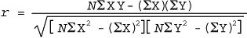

Where N = the total number of test takers, test and retest

X = the test score

Y = the retest score

Σ = sum

## **Data Analysis**

Data collected is analysed and visualised using a number of statistical tools such as pie charts, bar charts, packed bubbles, scatter plots, tree maps and circle views to show the different data features and categories in ways different from numeric elements. This data analysis process was further extended to making statistical calculations in order to design predictive models based on a number of classification algorithms by applying and sticking to Big Data Analytics (BDA). The data analysis phase of this research began in proper at the employment of the Tableau software in collaboration with the Jupyter notebook Anaconda software package. Statistical computation was then conducted to arrive at expectations of the research objectives and questions. Visual analysis was conducted at every stage, before data manipulation and cleaning, after data manipulation and cleaning, at every point of statistical analysis with every Big Data Analytic technique applied to the data.

The subsections below give detailed accounts of all the analysis conducted.

## **Frequency Distribution Analysis**

**Table 4.1: Frequency Distribution of the Demographic Characteristics of Data Collected**

|  |  |  |  |
| --- | --- | --- | --- |
| **Variable** | **Classification** | **Frequency** | **Percentage (%)** |
| Trade Specialty | Hair | 16 | 21.6 |
| Skin | 26 | 35.1 |
| Clothing | 31 | 41.9 |
| Makeup | 16 | 21.6 |
| All | 11 | 14.9 |
| **Total** |  | **74** | **135.1** |
| Customer Range | 1 – 20 | 62 | 80.5 |
| 20 – 50 | 13 | 16.9 |
| 50 – 80 | 2 | 2.6 |
| 80 – 100/more | 0 | 0 |
| **Total** |  |  | **100** |
| Months frequented | January | 5 | 6.9 |
|  | February | 1 | 1.4 |
|  | March | 1 | 1.4 |
|  | April | 6 | 8.3 |
|  | May | 1 | 1.4 |
|  | June | 1 | 1.4 |
|  | July | 2 | 2.8 |
|  | August | 3 | 4.2 |
|  | September | 0 | 0 |
|  | October | 0 | 0 |
|  | November | 5 | 6.9 |
|  | December | 47 | 65.3 |
| **Total** |  | **72** | **100** |
| Season | Wet Season | 9 | 12.2 |
| Dry Season | 65 | 87.8 |
| **Total** |  | **74** | **100** |
| Amount Range | 100 – 5000 NGN | 12 | 16.2 |
| 5000 – 10000 NGN | 26 | 35.1 |
| 10000 – 30000 NGN | 27 | 36.5 |
| 30000 – 60000 NGN | 9 | 12.2 |
| **Total** |  | **74** | **100** |
| Decision Factor | Yes | 55 | 93.2 |
| No | 4 | 6.8 |
| **Total** |  | **59** | **100** |
| Beneficial | Yes | 56 | 96.6 |
| No | 2 | 3.4 |
| **Total** |  | **58** | **100** |

**Table 4.2: Kaggle Data Frequency Distribution Demographic Table**

|  |  |  |  |
| --- | --- | --- | --- |
| **Variable** | **Classification** | **Frequency** | **Percentage (%)** |
| Price | 0 – 100 | 437 | 50.69 |
| 100 – 500 | 328 | 38.05 |
| 500 – 1000 | 79 | 9.16 |
| Above 1000 | 18 | 2.08 |
| **Total** |  | **862** | **100** |
| Overall Rating | 0.0 – 1.0 | 0 | 0.00 |
| 1.0 – 2.0 | 5 | 0.58 |
| 2.0 - 3.0 | 28 | 3.25 |
| 3.0 – 4.0 | 426 | 49.42 |
| 4.0 – 5.0 | 403 | 46.75 |
| **Total** |  | **862** | **100** |
| Will | Yes | 647 | 75.06 |
| No | 215 | 24.94 |
| **Total** |  | **862** | **100** |
| No of Reviews | 0 – 100 | 267 | 30.97 |
| 100 – 500 | 386 | 44.78 |
| 500 – 1000 | 108 | 12.53 |
| Above 1000 | 101 | 11.72 |
| **Total** |  | **862** | **100** |

Table 4.1 and Table 4.2 gives a summarized and detailed account of the data demographic information of the participants in the study. The first table provides a summary of the responses from beauty brand owners obtained via the google form questionnaire. This shows the number of beauty brands invested in the different categories and sections of the beauty industry, showing the frequency of customer patronage, the period of patronage, the amount frequently spent and the number of customers who patronize, it also shows the things customers buy regardless of external influence; this provides insight to how beauty brand owners see their customers and how customers behave. The second table displays a summary of our primary data for computation and customer behaviour analysis, depicting the price range of products customers buy, the ratings customers give to different grade of products and the willingness of customers to buy a product after viewing reviews and ratings hence willingness to purchase a product based on price, reviews and ratings. This second table majorly makes up for the quantitative data of this dissertation. Figures 4.2 give visualizations of the demographic information of participants represented in the questionnaire. Table 4.3 presents the various statistical BDA methods and techniques utilized for each research question. The Tableau Business Intelligence software and Jupyter notebook Anaconda software were used to run these analytic techniques in Python programming language. (See Appendix for Visual Representations).

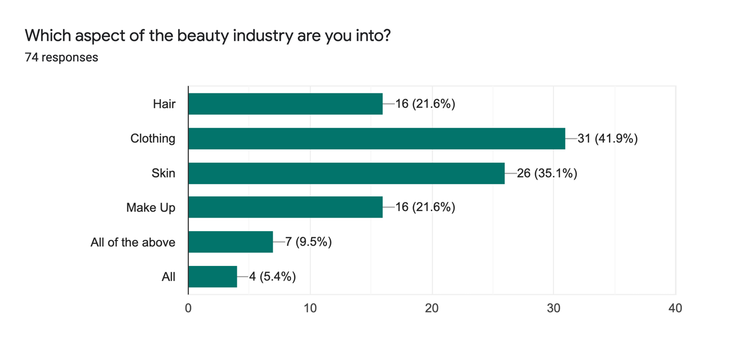

Figure 4. 2 Respondent Data from Beauty Brands

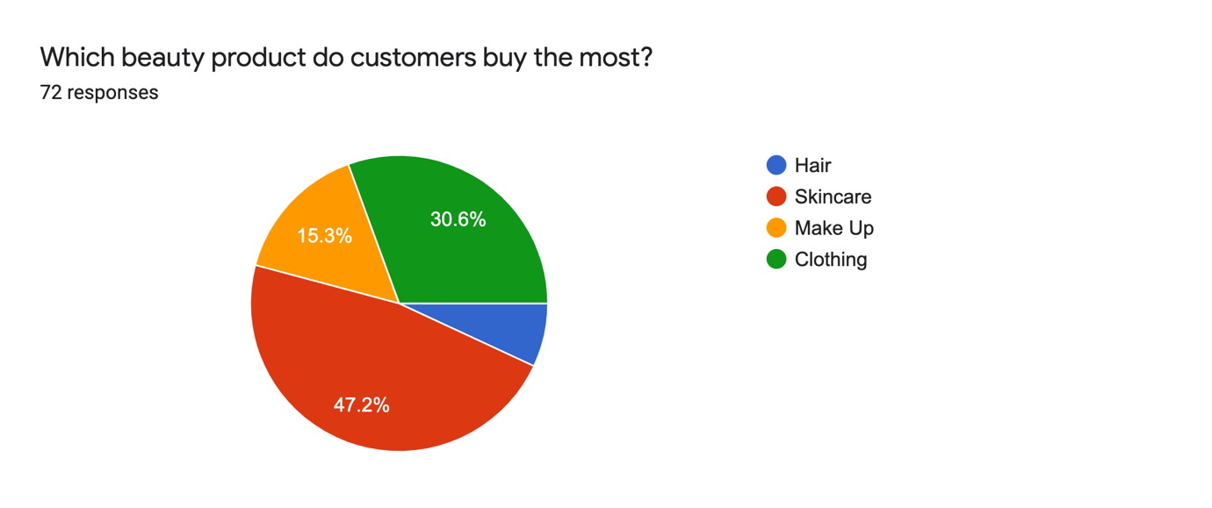

Figure 4. 3 Most Purchased Products

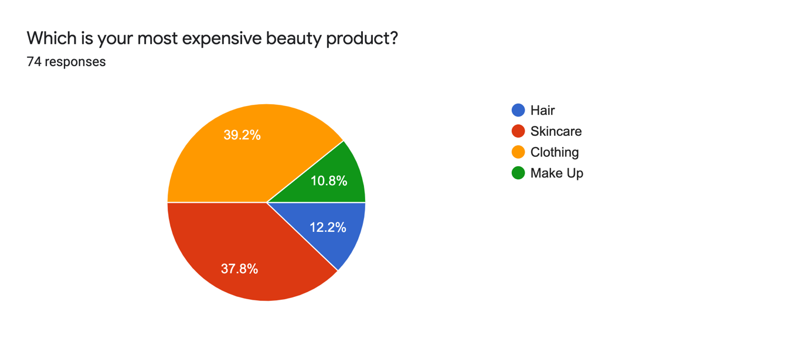

Figure 4. 4 Customer Expense Allocation Demographic

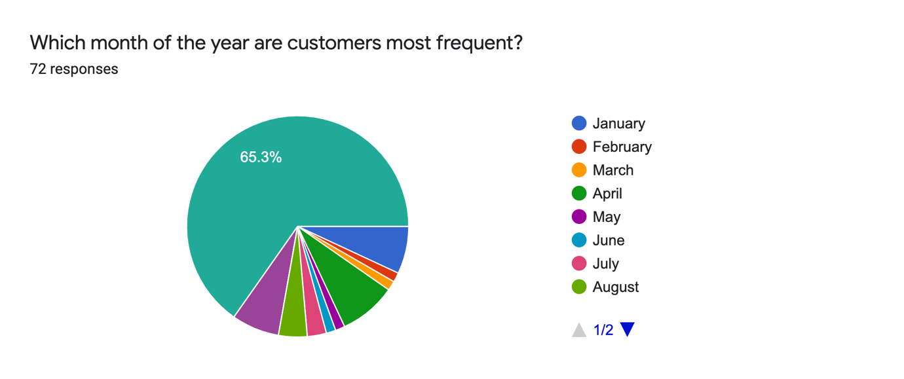

Figure 4. 5 Frequency of Customer Patronage

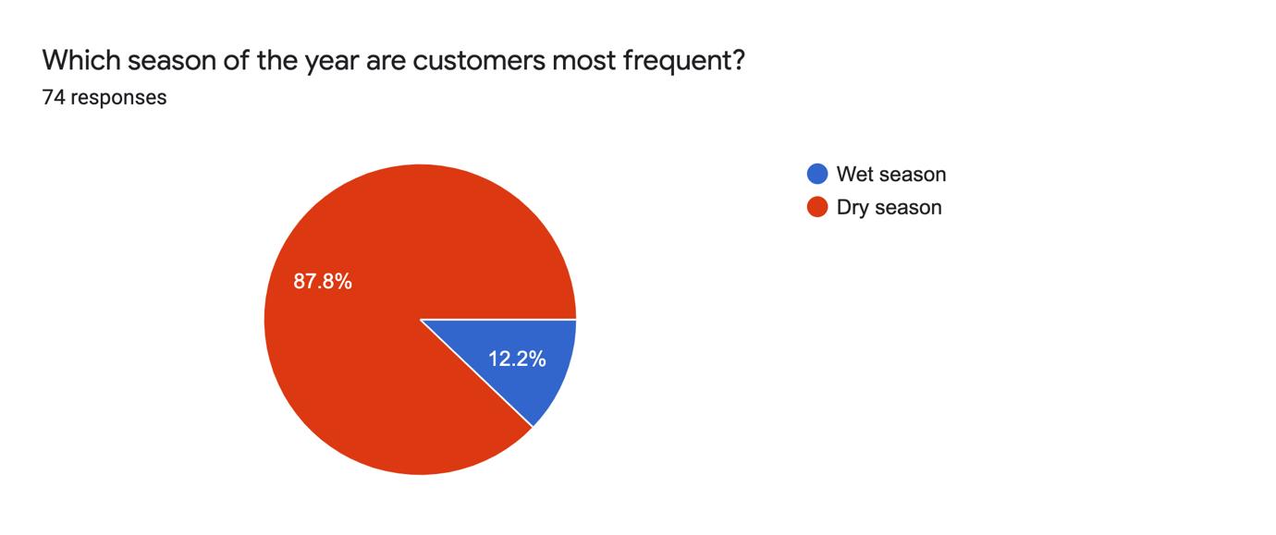

Figure 4. 6 Seasonal Customer Patronage Distribution

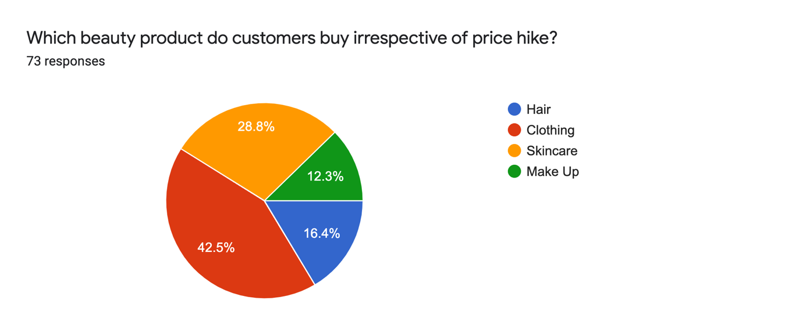

Figure 4. 7 Most Purchased Products Under External Influence

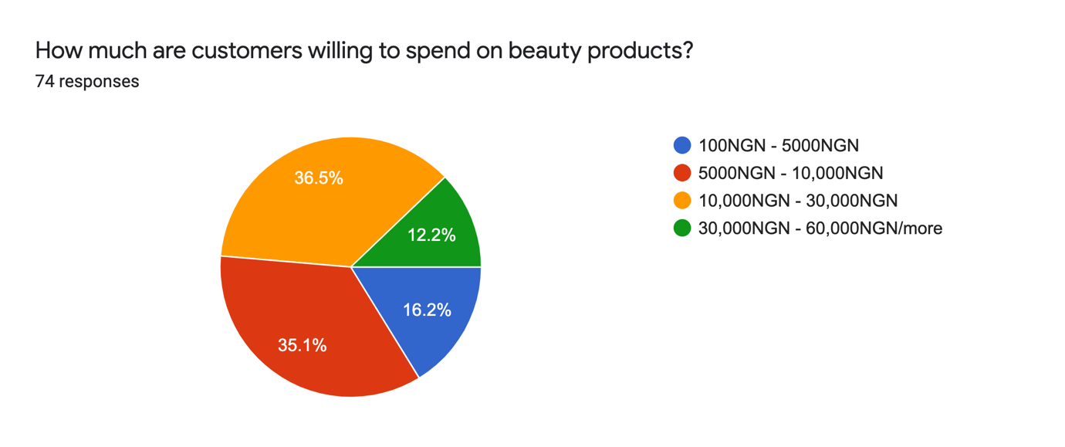

Figure 4. 8 Customer Financial Will

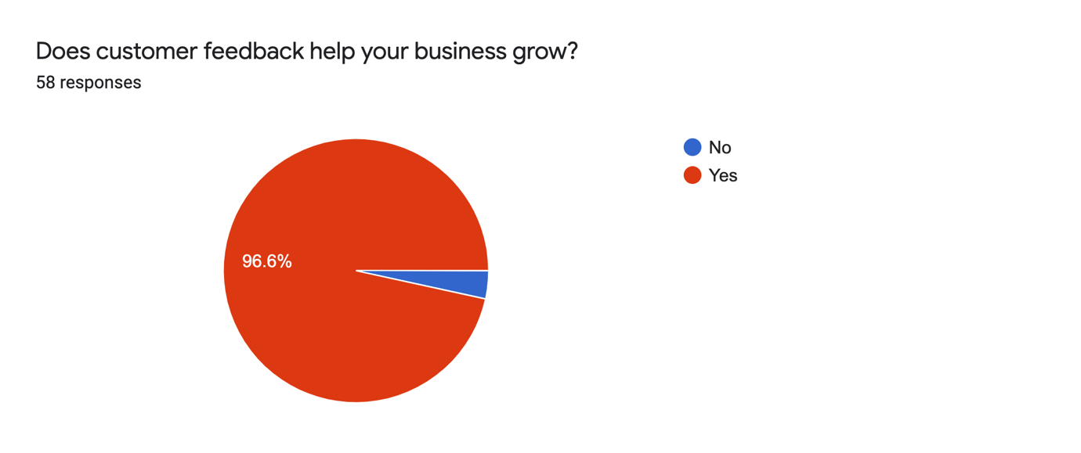

Figure 4. 9 Predict Verdict from Beauty Brands

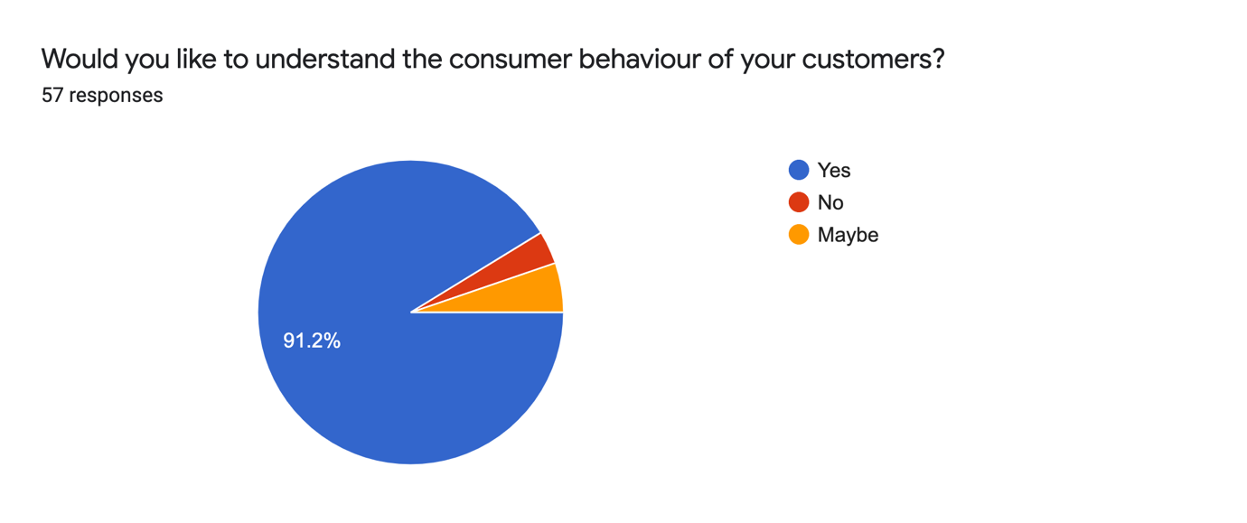

Figure 4. 10 Need Distribution for Understanding Customer Behaviour

**Table 4.3: Research Question(s) and Analysis Method(s)**

|  |  |
| --- | --- |
| **Question(s)** | **Analysis Method(s) & Technique(s)** |
|  | Descriptive analysis, Frequency analysis, Statistical analysis: Logistic Regression, Decision Tree, Random Forest, K Nearest Neighbors, Predictive analysis, Prescriptive analysis |
|  | Descriptive analysis, Predictive analysis, Prescriptive analysis |
|  | Narrative analysis, Descriptive analysis, Frequency analysis |
|  | Descriptive analysis, Statistical analysis |

## **Research Question 1**

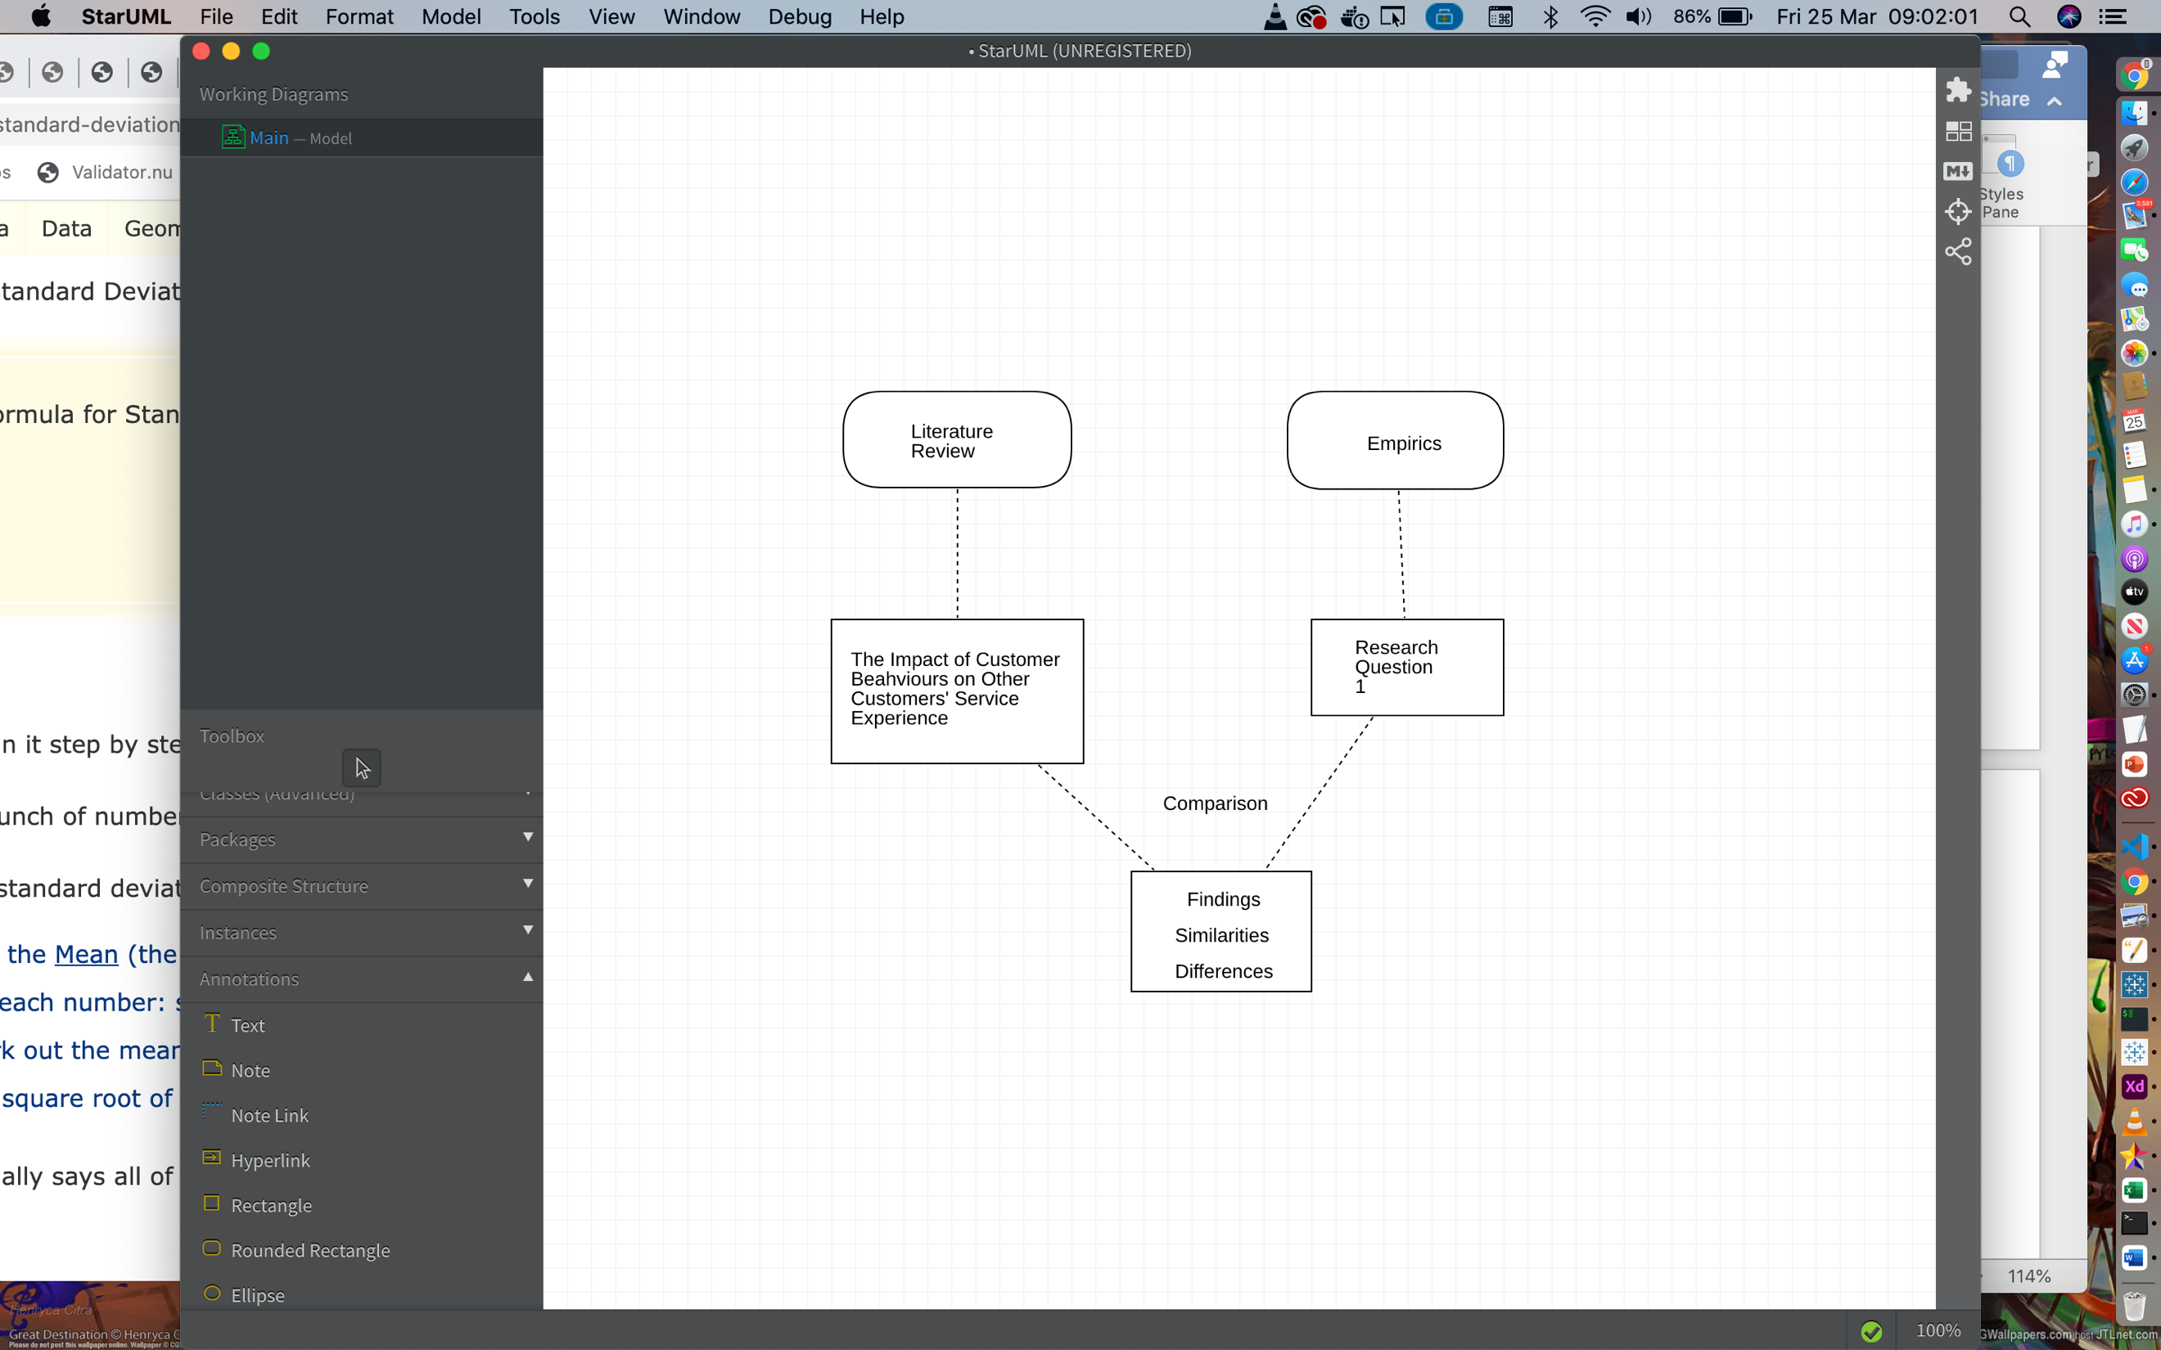

Figure 4. 11 Research Question 1 Analysis Model

Table 4.4 shows an outline of the variables identified from research question 1 and used for data analysis to reach a conclusion to research question 1, this data analysis method was adopted from appropriate related literature to achieve results.

Table 4.4: Research Question 1

|  |  |
| --- | --- |
| **Independent Variable(s)** | **Dependent Variable(s)** |
| Price of product | Will (Yes / No) |
| Product Rating |
| Existing Customer Reviews |

From Table 4.3, the analysis seeks to show if or how customer information provided in the data has any correlation to customer’s behaviour. In this context, customers’ behaviour refers to willingness of a customer to purchase a product or not. And so, our finding goal here is to establish if these independent variables have an effect on customers’ will to purchase, showing why a customer would or would not make a purchase.

## **Descriptive Analysis**

Table 4.5: Frequency Distribution when will is Yes and when will is No

|  |  |  |  |
| --- | --- | --- | --- |
| **Variable** | **Will: Yes** | **Will: No** | **Frequency** |
| Price | 0 – 100 | _ | 437 |
| 100 – 500 | _ | 328 |
| _ | 500 – 1000 | 79 |
| _ | Above 1000 | 18 |
| **Total** |  |  | **862** |
| Rating | _ | 0.0 – 1.0 | 0 |
| _ | 1.0 – 2.0 | 5 |
| _ | 2.0 – 3.0 | 28 |
| 3.0 – 4.0 | _ | 426 |
| 4.0 – 5.0 | _ | 403 |
| **Total** |  |  | **862** |
| No of Review(s) | _ | 0 – 100 | 267 |
| _ | 100 – 500 | 386 |
| 500 – 1000 | _ | 108 |
| Above 1000 | _ | 101 |
| **Total** |  |  | **862** |

Table 4.5 describes the different points through the price of a product, rating of a product and existing reviews of customer that a customer would be willing to proceed to buy a product or not. It gives good description of how these three independent variables cause the will variable to depend on the values of these variables showing the frequency of customers’ purchase when the independent variables carry high or low values. An important factor is how will is always dependent on rating and reviews but not always on price, although the norm for price is that a high price = will (No) but sometimes this may not be the case. This table sums up the descriptive analysis with respect to research question 1. The descriptive characteristics of the variables here is tasked with showing how customer data provided actually correlates with the resulting behaviour of the customer; it is a clear indication from the data above that when for instance, customer ratings are low for a product, less customers want to buy such product and when ratings are high the more people would buy the product.

## **Statistical Analysis**

To further show the correlation between the presented customer data and the resulting customer behaviour in terms of willingness to purchase product, we run data through predictive analytic algorithms using Big Data Analytics with the aim of designing a system which predicts customers’ willingness to purchase a product based on price, product rating and number of reviews. The statistical analysis on available data is divided into a series of different classification techniques to arrive at the best suitable model which is most accurate. The BDA classification algorithms used in this analysis include: Logistic regression, Random Forest, Decision Trees and K-Nearest Neighbours. To carry out successful prediction of customer behaviour, after taking cognisance of the sample data, we apply the ensemble of big data analytics classification techniques we have selected for the purpose of meeting the research objectives, going through the following techniques one after the other;

- Logistic Regression

- Decision Trees

- Random Forest

- K-Nearest Neighbours

## **Logistic Regression**

From our model which implements logistic regression algorithm as the method to predict customer’s behaviour, our measure values for this model are split into three features: price, rating and review. These features form the hinge for our predictive analysis.

With logistic regression, the outcome or target variable is dichotomous in nature i.e., there are only two possible classes and from our analysis what we seek to find if customer’s willingness to purchase a product based on existing trend in data, customer will = yes or no where yes = 1 and no = 0. Here we compute the probability of the occurrence of customer will either 1 or 0.

For this statistical analysis, we employ a Binary Logistic Regression. We build a model to predict customers Will using Logistic Regression Classifier.

First, we load the Kaggle dataset into Tableau

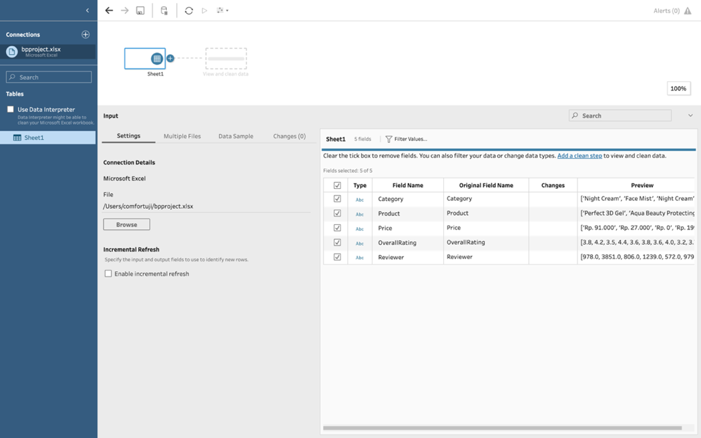

Figure 4. 12 Loaded Dataset for Logistic Regression

To run further computations, the data has to be split into independent and dependent variables, the dependent variable being the target variable for prediction.

To understand model performance, splitting the dataset into training and testing data is good strategy. Using the function *train_test_split()* and passing three necessary parameters features, target and test_set size, the dataset is split. The dataset is broken into two parts in a ratio of 75:25 where 75% data will be used for model training and 25% data for model testing.

At this point, using the Logistic Regression python module imported, a Logistic Regression Classifier object is created with the LogisticRegression() function.

Fitting the model on the train set using fit(), prediction is thus performed using predict() function.

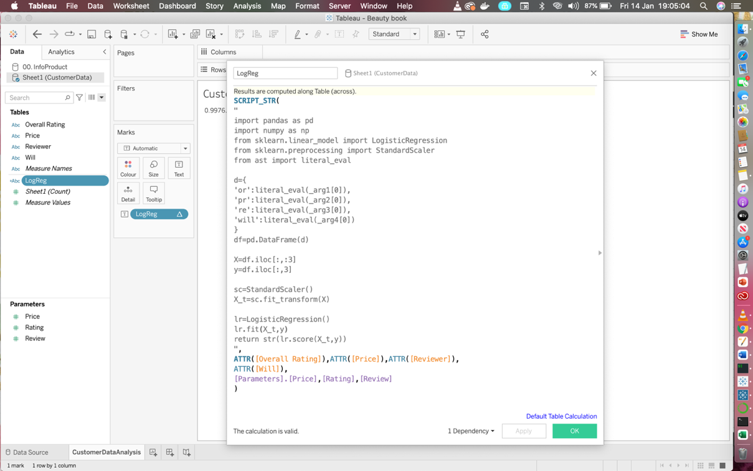

Figure 4. 13 Logistic Regression Computation

To evaluate the performance of the Logistic Regression prediction model, we draw up a confusion matrix. The fundamental of a confusion matrix is the number of correct and incorrect predictions summed up class-wise.

Using the metric of Accuracy and evaluating this accuracy in python:

The accuracy of this model = 0.99

## **Decision Tree**

The goal of using decision tree is to create a training model that can be used to predict the value of a target variable by learning simple decision rules inferred from prior data which would be our training data. For the decision tree, we applied DecisionTreeClassifier and DecisionTreeRegressor in order to get the most perfect fit to our data. First to select the root nodes for our decision tree model, checking the entropy of data features is an important step.

Entropy is the measure of randomness of the information being processed, the higher the entropy, the higher it is to draw any conclusion from that data. Using the formula:

Ε(S) = ∑ci=1 − ρi log2 ρi

Table 4.6: Data to Calculate Entropy

|  |  |
| --- | --- |
| **CUSTOMER WILL** | |
| YES | NO |
| 647 | 215 |

Entropy (Customer Will) = Entropy (215, 647)

= Entropy (215/862, 647/862)

= (0.25log20.25) – (0.75log20.75)

= -(-1.32)

= 1.32

Where S = current state

Pi = Probability of an event

Decision tree on whether or not customer will would be yes or no at the point of purchase based on price, reviews and ratings was designed firstly with the root node having three decision nodes being price, rating and reviews.

Instead of solving and evaluating formulas and computations, using the Scikit-learn in python, the computation is run in the background and our model is built, just like for logistic regression; first thing is to separate independent variables from dependent variables dividing the data into training and test data sets.

This tree was fed into the model built and used to simply predict a customer’s potential will at purchase point.

Next, we performed feature scaling on our data to ensure the data fits in the Decision Tree Classifier and then running python functions imported, we make predictions and check model accuracy to ascertain we have a safe model.

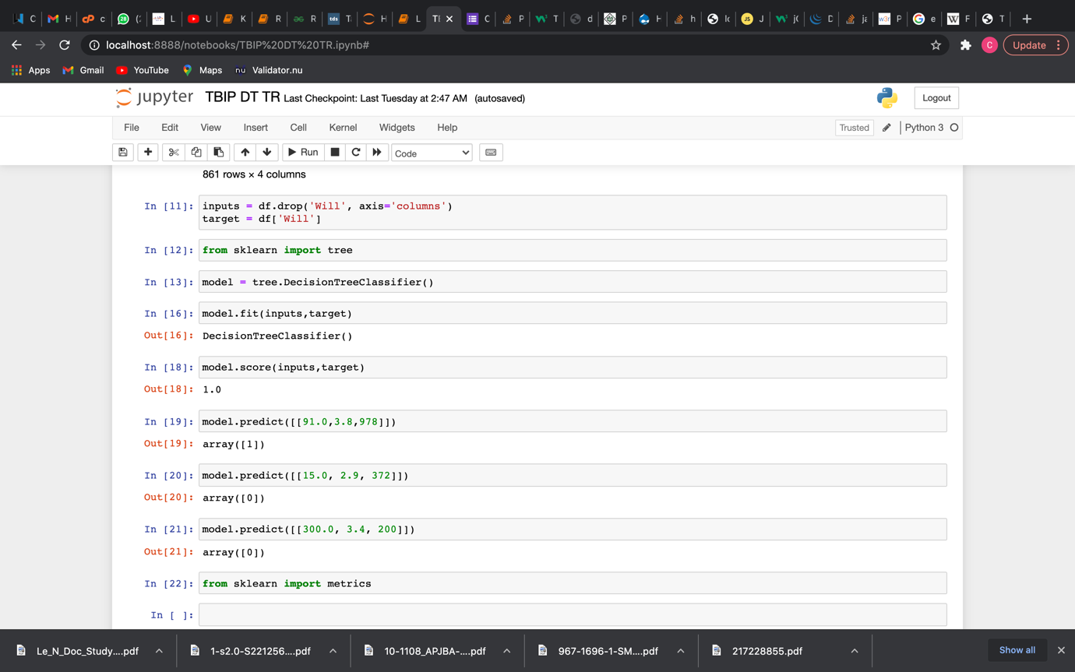

Figure 4. 14 Prediction with the Decision Tree Model

This model appeared to be the most accurate and matching fit to our desired target and is most likely the best model for this prediction.

The accuracy score of this model = 0.94. We visualise the predictions of our model afterwards. (See Appendix).

## **Random Forest**

The Random Forest model is a high-level decision tree model, more like an upgrade to the logic applied to the decision tree model as it also implements decision trees, in this case it utilises decision trees based on the existing features in the dataset so here we have three decision trees, one for each feature, instead of deciding based on node, the random forest model decides based on mean of the decision tree values.

The model building takes the same form as the previous models, what remains distinct about each model is the sklearn imported formula for prediction. Each function is evaluated in the background differently.

The features of the dataset are split into independent and dependent variables to enable a training and a test set. For each tree, training and test sets are created. Next, we establish baseline and train our model.

Using scikit-learn, we import the random forest regression model RandomForestRegressor, train the model and make predictions with our model.

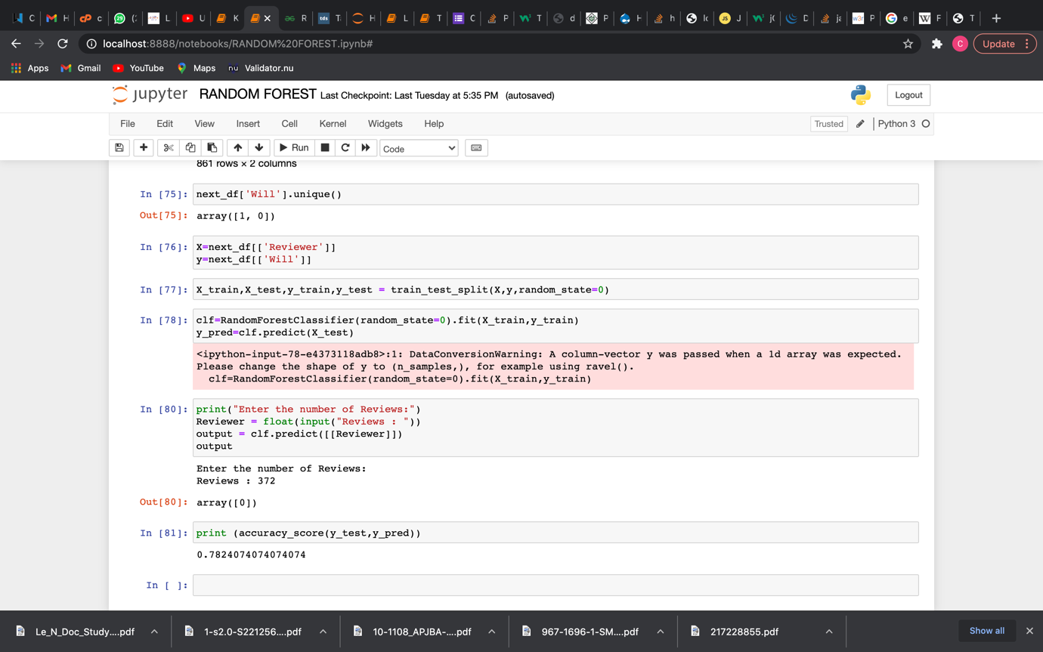

Figure 4. 15 Prediction using Random Forest

Checking, the accuracy of each tree in order to take an average gives us the general accuracy of our model. This way we are able to determine the performance metric of the prediction model.

This model has a pretty good accuracy score but some anomalies in prediction. The accuracy score for each decision prediction happens to vary.

For the prediction based on price, accuracy score = 0.81

For the prediction based on rating, accuracy score = 1.0

For the prediction based on reviews, accuracy score = 0.78

The overall model accuracy score = 0.81 + 1.0 + 0.78 / 3 = 0.86

The accuracy score of this model = 0.86

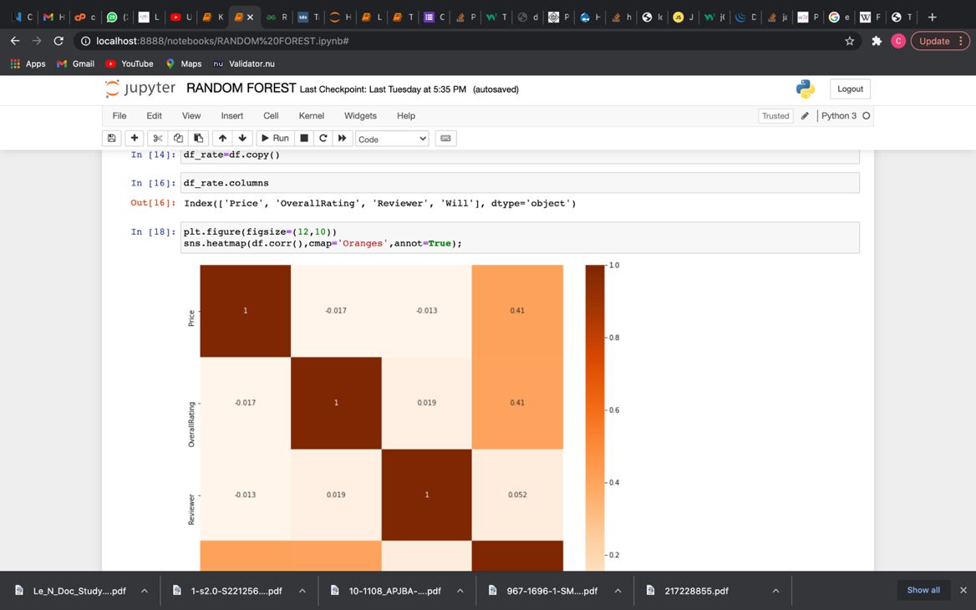

Figure 4. 16 Visualization after Prediction with Random Forest

## **K Nearest Neighbors**

The K Nearest Neighbors algorithm was used for the final prediction model, this model predicts quite differently from every other model and relies on the best assigned k value to make an accurate prediction. It measures the distance of points to the k value and the closest points to the k value are most likely the correct predictions. For this model, we used a k value of 9 which gave us an accuracy of 0.85.

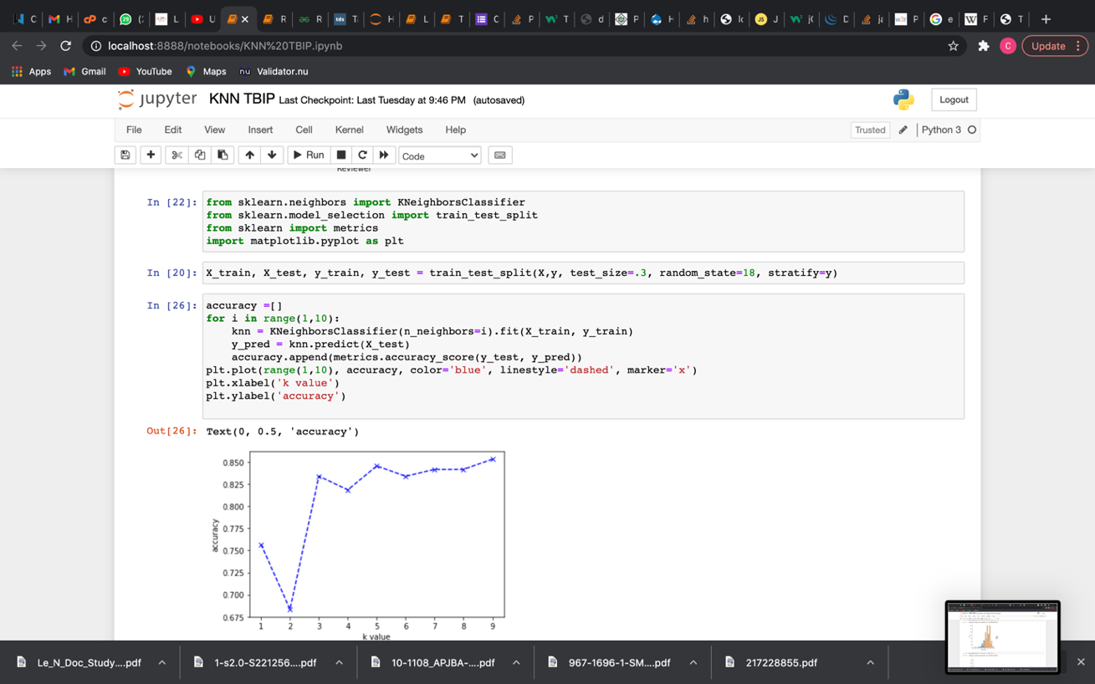

Figure 4. 17 KNN Model Accuracy Plot

Prediction with this model for the available dataset was not fluid and this would be considered the most misleading algorithm for our multi feature dataset though the model had an accuracy of 0.85.

## **Prescriptive Analysis**

Prescriptive Analysis involves taking the results of predictive and statistical analysis done to make inferences and decisions on the basis of these results, in this context; from the results obtained, we decide that our most fit models are the decision tree and logistic regression. The logistic regression has a performance accuracy of 0.99 which is almost a 100, we are inclined to think this is a model to perfect and some errors may lie within this perfect accuracy and so it is not entirely considered all the way as the best possible model for our prediction. The decision tree model on the hand more than fits our data descriptions, with a training and test set well aligned to give off the target value for our prediction and the model has an accuracy of 0.94, this seems a better, safer performance metric value and so this lines to be our best model. Now, with prescriptive analysis, we proffer solution; with these models we have arrived at the target goal of building a system that allows business owners predict what a customers’ will would be based on the price, rating and number of reviews on a product, automatically customers are attracted to products with high ratings, plenty reviews and within average price range, although customers tendency to buy a product when price is high is less, if said product has enough ratings and reviews, customers will buy. Hence, beauty brands owners should use to the idea of customer feedback and should welcome customers rating their services and products as this influences business visibility beyond a lot of other factors.

## **Research Question 2**

Figure 4.18 shows the analysis model of research question 2 which displays the methods used to provide a solution and arrive at a plausible conclusion to the research question. Appropriate literature was consulted.

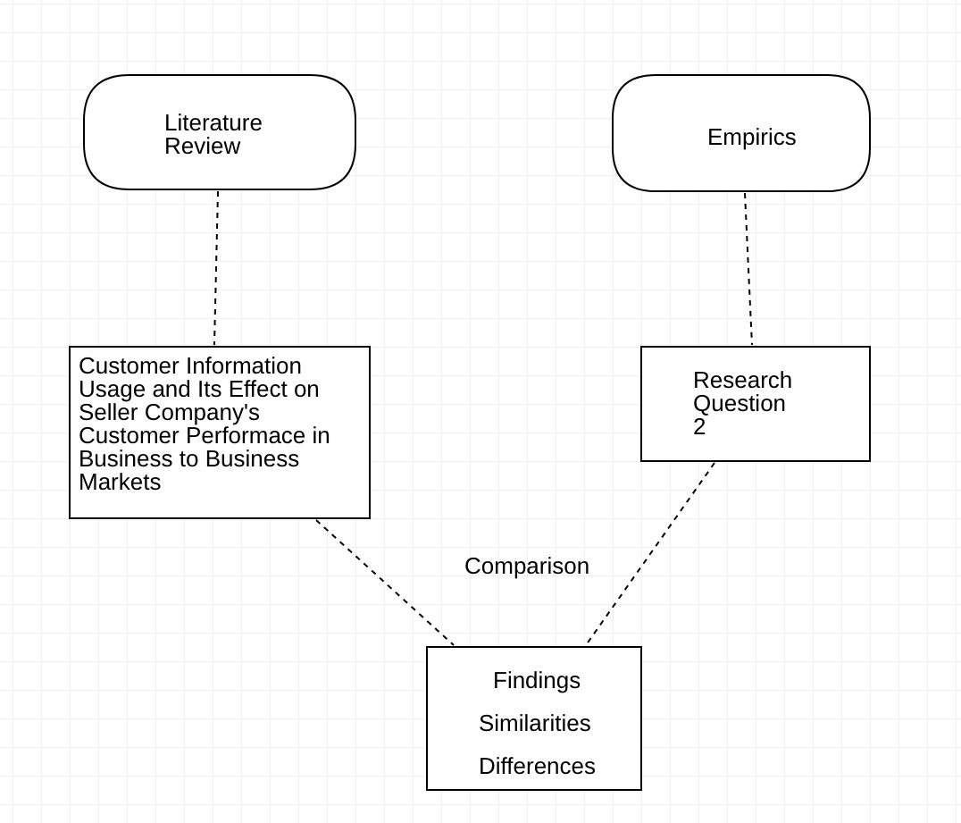

Figure 4. 18 Research Question 2 Analysis Model

Table 4.7 shows the key variables identified from research question 2 for data analysis, these variables represent the possibility of increase in business optimization dependent on prediction of customer behaviour. This analysis is coined from related literatures in business analytics and customer environment in different industries, in this context the beauty industry.

Table 4.7: Research Question 2 Variables Classification

|  |  |
| --- | --- |
| **Independent Variable(s)** | **Dependent Variable(s)** |
| Customer Will (Yes/No) | Growth Index |

## **Descriptive Analysis**



Figure 4. 19 Visualization of Beauty Brand Response on Understanding Customer Behaviour

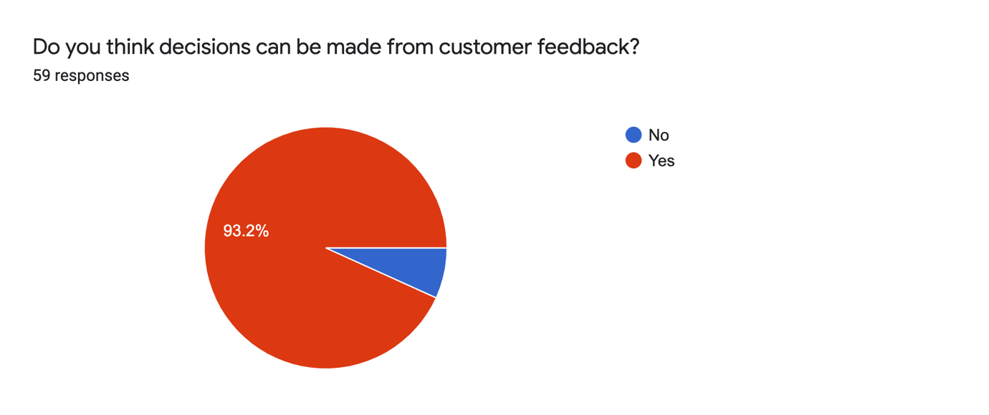

Figure 4. 20 Representation Beauty Brands Understanding of Customer Data

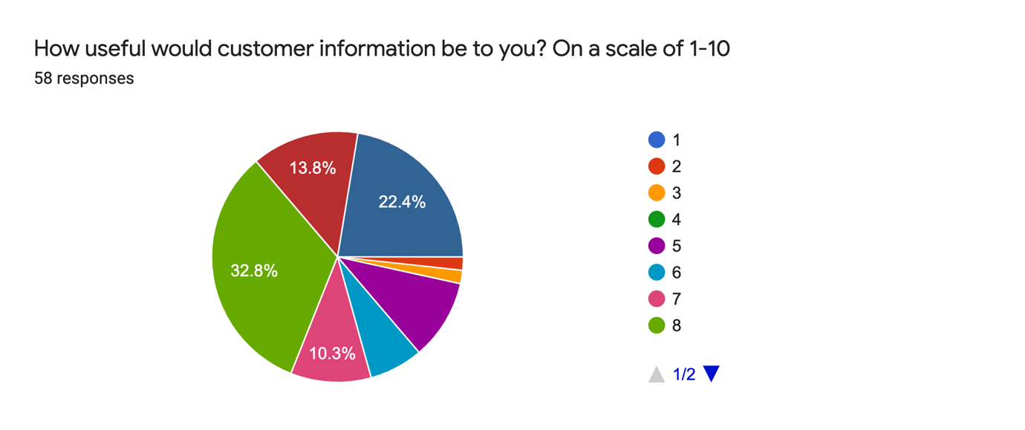

Figure 4. 21 Respondent Need for Customer Data Distribution I

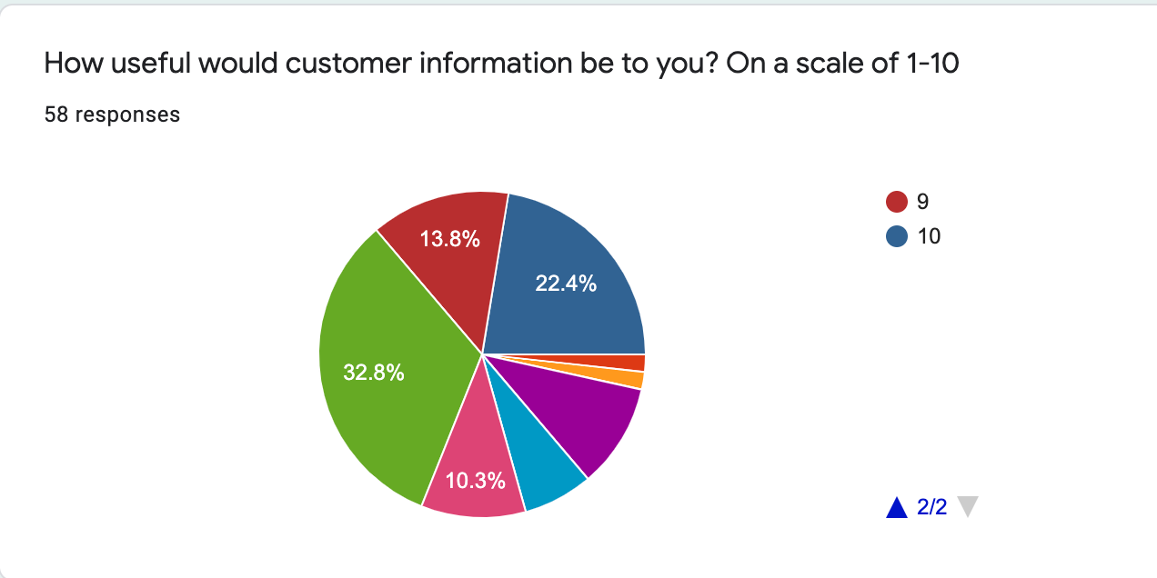

Figure 4. 22 Respondent Need for Customer Data Distribution II

Figures 4.20 - 4.22 Shows the responses from participants in beauty brands, persons who regularly interact with customers in the course of their business and who own beauty brand stores or houses. The figures show what business owners think of the need for understanding their customers and how they think it can be useful or influential to their business growth, a vast majority of the respondents agree that customer data and understanding the behaviour (will) of their customers would positively impact their businesses.

Table 4.8: Frequency Distribution of Usefulness of Customer Info to Businesses

|  |  |  |  |
| --- | --- | --- | --- |
| **Variable** | **Classification** | **Frequency** | **Percentage (%)** |
| Usefulness of Customer Data to Business | 1 | 0 | 0 |
| 2 | 1 | 1.7 |
| 3 | 1 | 1.7 |
| 4 | 0 | 0 |
| 5 | 6 | 10.3 |
| 6 | 4 | 6.9 |
| 7 | 6 | 10.3 |
| 8 | 19 | 32.8 |
| 9 | 8 | 13.8 |
| 10 | 13 | 22.4 |
| **Total** |  | **58** | **100** |

Table 4.8 provides a tabular description of how useful beauty brand business owners think understanding customer data is to them, this basically is how much influence they think customer behaviour can have over their businesses. It gives a good description and clear depiction of business owners’ intention towards their business growth process. The data shows a frequency of more beauty brand business owners agreeing to a need to have customer data as it is of course beneficial to the growth process of any successful business enterprise. Although quite a number of the businesses did not share this same notion, on a scale of 1 – 10, most of the business owners were all inclined towards the part of the scale that claims high importance clearly depicting that customer data is important to business growth.

Table 4.9 shows the descriptive characteristics of the variables involved with research question 2, it shows a descriptive statistic of the necessary variables employed to answer the research question 2. These computations are the mean, standard deviation and variance.

Mean =.

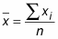

Standard deviation (S) =

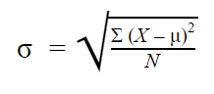

Variance = σ2

Table 4.9: Descriptive Statistics of Usefulness of Customer Data to Business Growth

|  |  |  |  |
| --- | --- | --- | --- |
| **Variable** | **Mean** | **Standard Deviation** | **Variance** |
| Usefulness of Customer Data to Business Growth | 5.8 | 5.896 | 34.76 |

## **Predictive Analysis**

The confirmation of the descriptive analysis of the variable on which research question 2 is dependent, opens room for predictive analysis on the outcome of a business’s growth process with regards to customer data and consequently, customer behaviour. How this predictive analysis runs in the entirety of this research’s function; showing the resulting effect on a business when customers’ behave a certain way or when customers’ data is implemented for the optimization of said business. Table 4.10 below shows the confidence interval of the variable and the business growth index calculated using predictive method:

Table 4.10: Usefulness of Customer Data to Business Growth Index

|  |  |  |  |
| --- | --- | --- | --- |
| **Mean** | **Standard Deviation** | **95% Confidence Interval** | |
| **Lower** | **Upper** |
| 5.8 | 5.896 | 4.64 | 6.96 |

## **Research Question 3**

Research question 3 seeks to discover the preferences of customers when it comes to available beauty products in a beauty brand business, this preference is split between Clothing, Skin, Make Up and Hair. Different beauty products are heavily situated in the beauty industry but very high-level diversity of customers and customer preference is actually what determines which product makes the most sale in a beauty brand business. A number of factors can influence the preference of a customer such as ratings and reviews, price doesn’t necessarily affect preference but it ultimately decides what the customer buys as price controls the purchasing power of the customer. From both data banks for this research, business owners tell which product their customers buy the most and the Kaggle customer info data shows based on frequency, the most purchased products. Below in Table 4.11 is a frequency distribution of customer preference in products.

Table 4.11: Frequency Distribution of Customer Preference in Products (from business owners)

|  |  |  |
| --- | --- | --- |
| **Variable** | **Frequency** | **Percentage (%)** |
| Hair | 5 | 6.9 |
| Clothing | 22 | 30.6 |
| Skin | 34 | 47.2 |
| Make Up | 11 | 15.3 |
| **Total** | **72** | **100** |



Figure 4. 23 Representation of Customer Preference in Beauty Products

## **Descriptive Analysis**

Table 4.12 shows the frequency distribution of products purchased from the Kaggle data. This shows the preference levels of beauty brand business patronage. Customers will always choose what they want, beauty brands can only try to influence this choice, and the most effective way is through other customers; this is why for a lot of businesses, the style of influencing is through brand ambassadors; these are other potential group of customers with high social presence thus making their lifestyles influential enough to make an impression on other customers. This theory makes sense and has been proven time and again. Customers are most influenced by history of pre-existing customers.

Table 4.12: Frequency Distribution of Products Purchased

|  |  |  |
| --- | --- | --- |
| **Variable** | **Frequency** | **Percentage (%)** |
| Hair | 12 | 16.4 |
| Skin | 21 | 28.8 |
| Clothing | 31 | 42.5 |
| Make Up | 9 | 12.3 |
| **Total** | **73** | **100** |

## **Research Question 4**

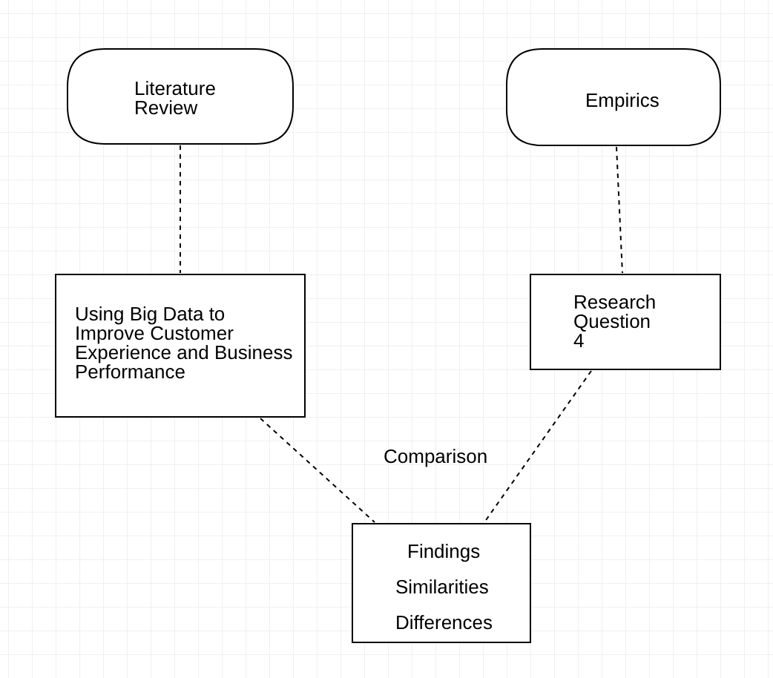

Figure 4. 24 Research Question 4 Analysis Model

To arrive at a plausible conclusion to the aims and objectives of this thesis, a variety of Big Data Analytics Techniques and Methods had to be employed. The reason for this is to ensure that variation exists in the exploration process for a solution. After checking through and running analysis using Logistic Regression, Decision Trees, Random Forests and K Nearest Neighbors with the central idea being purely for exploration of solutions possibly available, with clear results and computational analysis conducted using TabPy functions of the Tableau Business Intelligence software and further Python computations using Anaconda, satisfying statistical conclusion have been made. This thus means that to satisfy the entirety of the research objectives, four big data analytics techniques were explored.

Based off of the different computations with each BDA classification algorithm applied to the existing data set, the Decision Tree algorithm model is found to be most accurate with quite an accurate fit match and is best for the prediction of customer behaviour when fed input for computation. Following the predictions made by the model, we can now tell that some products would be what we describe as “bad market” for business and should not necessarily be on our beauty store shelves in the first place.

At the end of our assessment, we see that using big data analytics does make it all easier, instead of gathering data slowly and trying to make sense of all those numbers, analytic computation does help us arrive at a solution in real and reasonable time. This entire research of course has its setbacks and points that could be improved on by further future research.

For the methodology used in this research, a mixed research survey cum experimental methodology is used. From research done on literatures and existing works and then research on the beauty industry environment and discussion with three small beauty brand owners, a number of factors considered to be influential on customers and how they behave were pointed out and identified. These factors that influence customer consumerism and behaviour are categorized as input variables. For this work, real world data is collected from Kaggle, this data is then filtered out using statistical techniques, the data is analysed and visualized thereafter using the tableau data analysis software tool, after the implementation, results for the implementation are produced and analysed after different algorithms have been used to test the data set in order to pick the most efficient algorithm that best provides an almost accurate predictive inference.

## **Discussion**

A major conclusive end for this research is to build a working prediction model which accepts inputs on a number of fields and runs computation based on whichever algorithm from the selected ones identified in the previous chapter is implemented depending on the particular model to return output in form of expected predictions.

To achieve this, the Tableau business intelligence software was used to design a dashboard which houses all computations written and configured through worksheets all embedded in the dashboard. Each worksheet is a platter of computations and representation of data visualizations in order to design a dashboard where all the work done is simplified and presented on one pane. For this project we design a dashboard to suit our purpose of predicting customer behaviour based on the price of the product, rating on that product and number of customers who left ratings on the product.

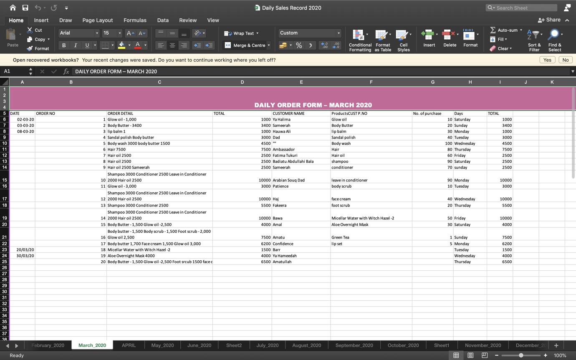

Figure 4. 25 Daily Sales Record

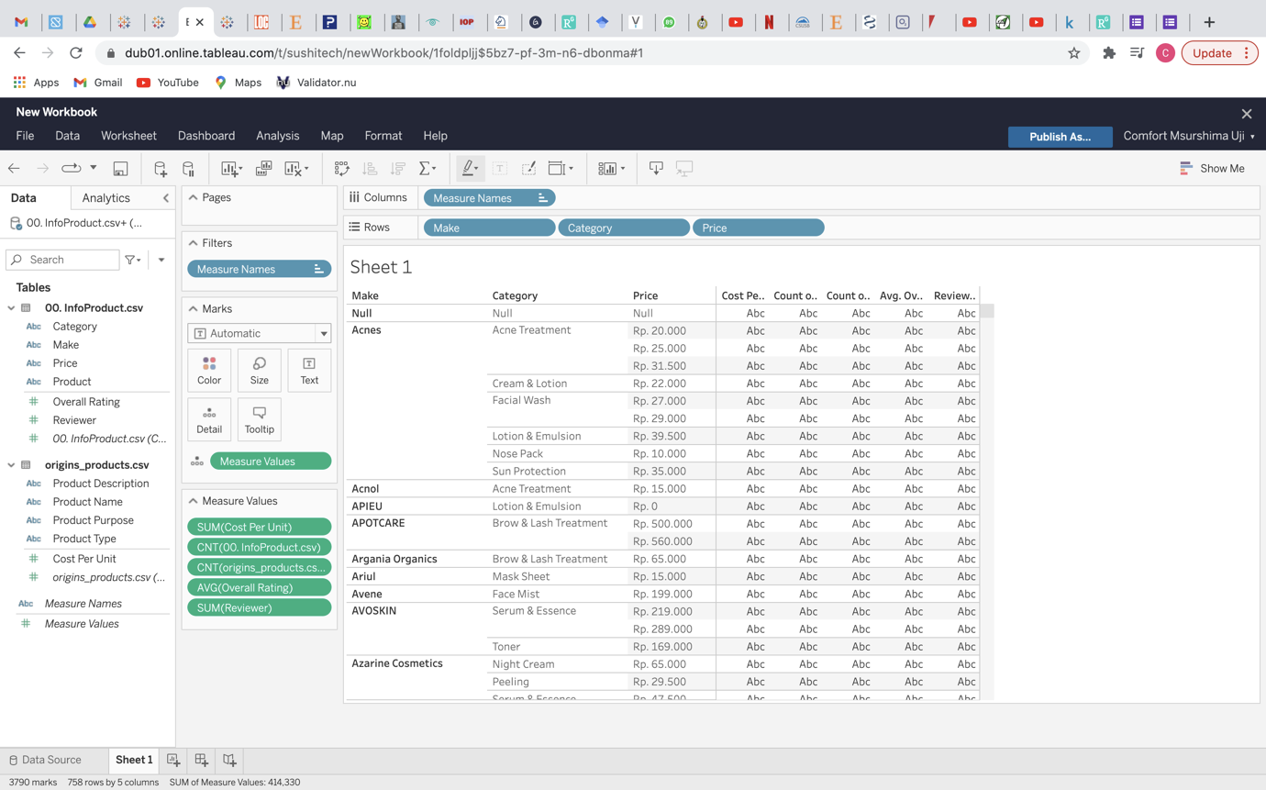

Figure 4. 26 Customer Purchase Data

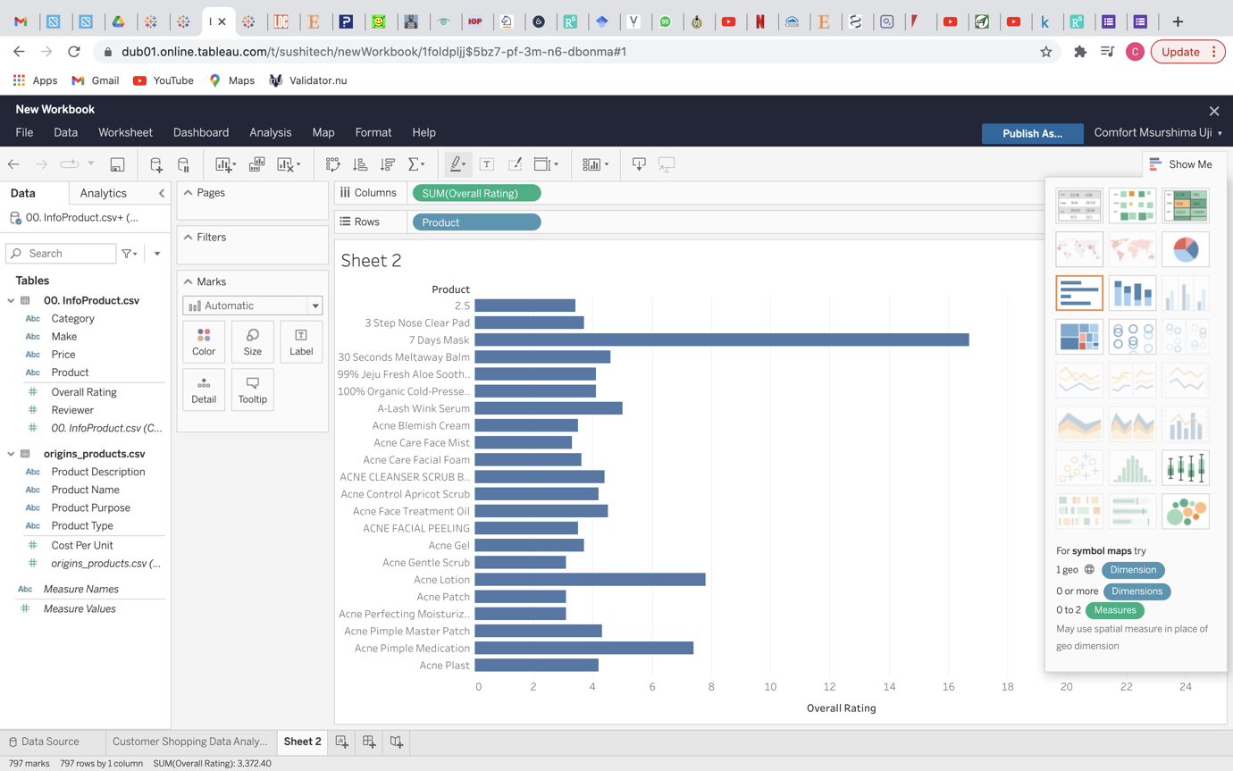

Figure 4. 27 Visualization of Customer Purchase Data I

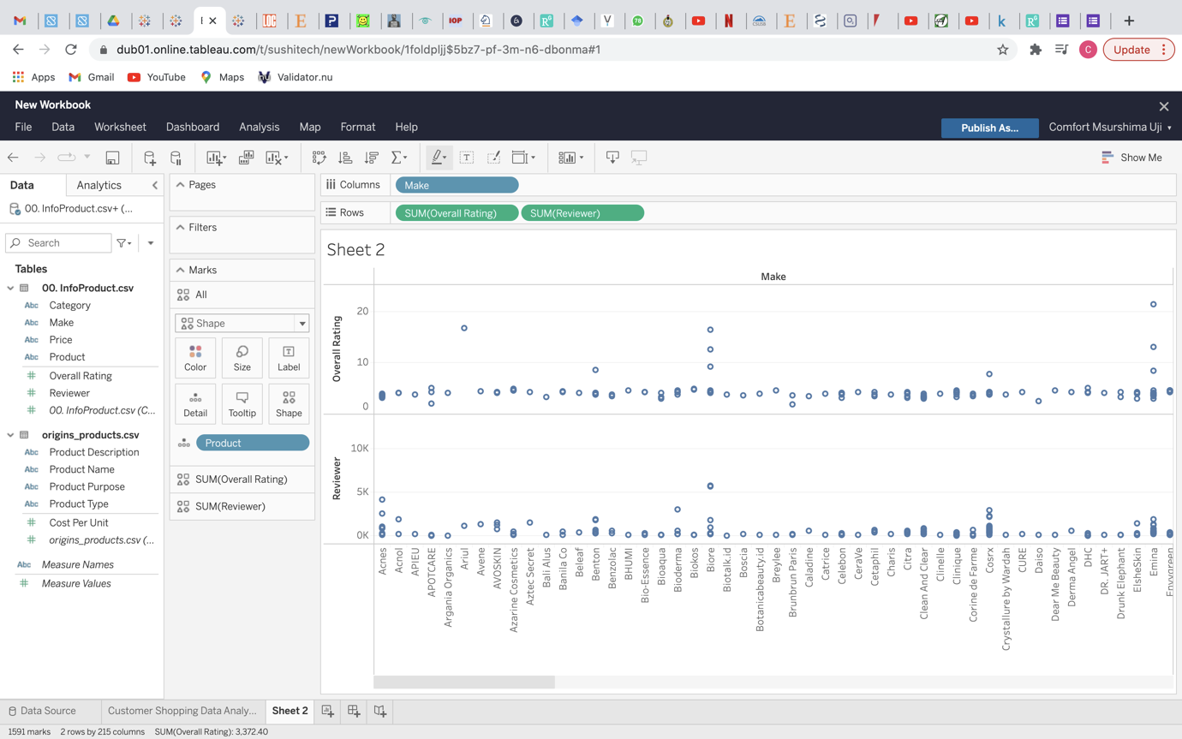

Figure 4. 28 Visualization of Customer Purchase Data II

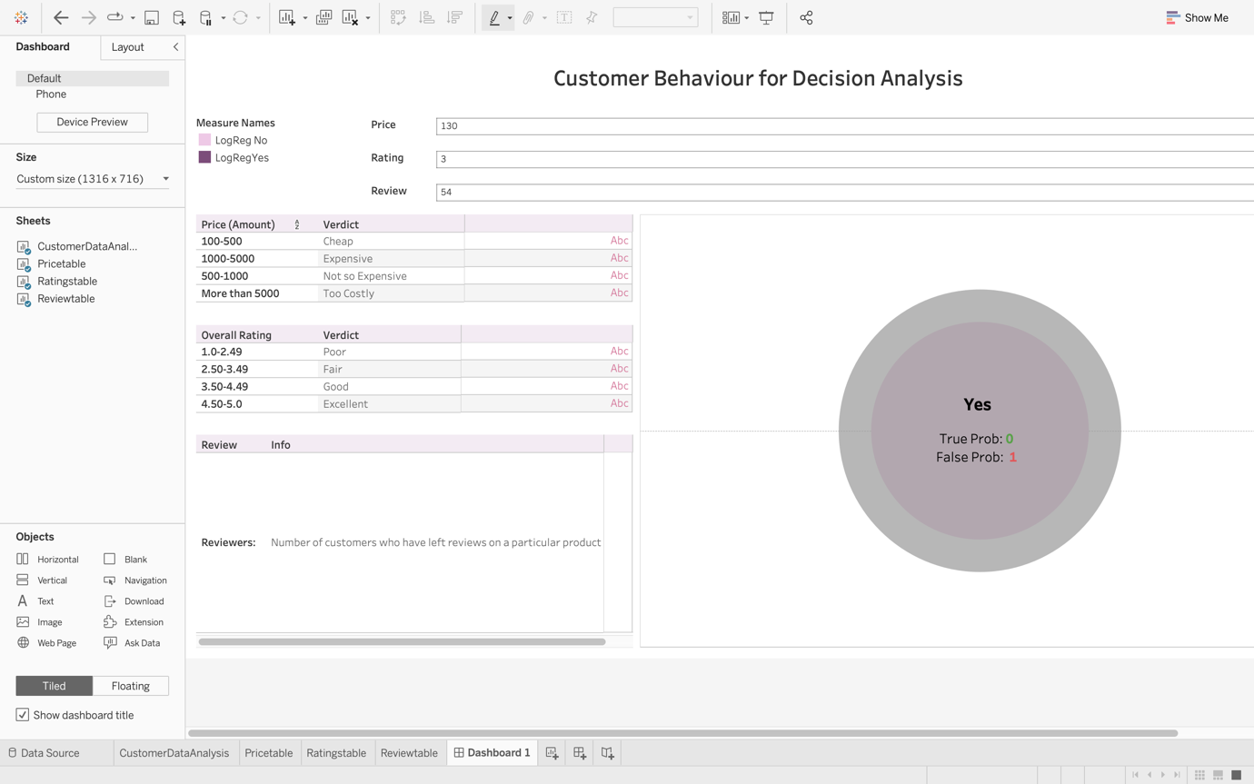

Figure 4. 29 Tableau Dashboard for prediction

The figure above shows the dashboard designed as front end for the prediction model, this dashboard is interactive as well as easy to navigate and understand. The top left side of the dashboard holds the major features (measure names) of the prediction represented as LogRegNo and LoRegYes standing for the probability that prediction is wrong and probability that prediction is right, this basically informs us on the accuracy of our prediction. The top right just beneath the dashboard title shows the pane where users in this case business owners can input details of the product (price, rating, review). The left side right beneath the measure names holds three tables, vertically lined right next to each other. These tables contain information on the three variables on which prediction lies and then the right side of the dashboard which has a pie-chart looking figure is the result display pane which shows the return of the prediction. Prediction result is either Yes or No which signifies if a customer would be willing or not to purchase a particular product and then in this circle the probabilities of the customer’s will being a yes or no is displayed as well. This result can help a beauty brand owner decide if putting a particular product on sale is worth the hassle or not and in the long run save the business money and preserve quality as well as raise profits and cut losses.

## **4.4.1. Technologies implemented**

In order to successfully build the prediction model for this research, a number of technologies were utilised;

The entirety of the computational work was hinged on Python programming language. Anaconda ide was used to launch Jupyter notebook, the python ide first used to sample and clean the data in order to obtain only the necessary features for the implementation of our project. The Tableau business intelligence (bi) software was used to bring the data to life and visualise the untouched and touched data. Google forms was used in designing our data gathering questionnaire as well as the feedback receiving forms. The popular Kaggle data science hub was used to outsource for whole external data which was used for the entire prediction and which made part of our data population.

Technologies used thus include:

* Python programming language
* Anaconda ide of Jupyter notebook
* Tableau bi
* Tabpy (Tableau Python)
* Kaggle
* Google forms

# **CHAPTER FIVE: SUMMARY AND CONCLUSIONS**

## **5.1. Introduction**

Gathering and analysing data with the aim to predict customer behaviour, in this case next move, in order to make inferences that would affect one’s beauty business positively is the whole point of this research’s documentation and implementation. To understand one’s audience (customer) is to know what to deliver and to know what to deliver is to know how to make money and to know how to make money is to know how to make profit and to know how to make profit is to know how to maximise profit. (Uji, 2022). Making and maximising profit is the major reason for many business establishments, the entirety of our work is to enhance business optimization.

## **5.2. Summary**

Many researchers have proven over time that conducting customer analysis through feedbacks does increase firm or business profitability. Customer analysis is an important factor. It influences the firm performance mostly by increase in cash flows. Customer analysis allows to rank customers according to their profitability. (Doligalski & Tomczyk, 2016). This research answers the research question on whether customer behaviour analysis and prediction increase business optimization. This process is concluded by making predictions and taking business decisions based on the prediction and assessing business growth in the timeline of making the decisions influenced by predictions made earlier. This is the point of this thesis.

Summarily, BDA simplifies the entire data processing and analysis process and makes data easier to visualise and understand in order to make inferences, applying the available techniques in order to optimise business and provide business solutions is a win-win situation as it saves time and cost. In conducting this research, using the sample data from Kaggle, the work done was largely simplified and the analysis also made easier, computation was done primarily using python solutions which further simplifies the steps in reaching a conclusion. Machine Learning has come to put data science in our palms, letting us do with it what we will; taking advantage of BDA classification algorithms is one of the things we can do with ML to the advantage of business growth and profitability while still maintaining a representation of real world and real time status quo.

## **5.3. Findings Of the Study**

In the end of every algorithm ran and every BDA classification technique used on the sample data. Accuracy percentage of every computation as well as the match to actual data was collected for comparison, to select which algorithm is most accurate and best predicts the chances of a customer’s inclination to buy a product or not. The accuracy score of each model is the one of the metrics from which the best fit model is selected.

Logistic Regression model had an accuracy score of 0.94

Decision Trees model has an accuracy model of

Random Forest model has an accuracy score of 0.81

K-Nearest Neighbours has an accuracy score of

In carrying out this research and sampling the data utilised, a few scenarios were observed:

**SCENARIO 1**

It was observed that customer data is hardly uniform, in the sense that customers do not always leave recordings on every product or sometimes leave partial feedback information on some products. This scenario leaves an issue of null data or empty data fields which resulted in data inconsistencies handled in the data cleaning process where partially empty data fields are assumed based on the previous data entered by other customers and then completely empty data fields or responses recorded as null are dropped from the entire dataset.

**SCENARIO 2**

Another scenario, the Tableau business intelligence software environment is suited exactly for the sort of analysis needed to be conducted, data visualization was a seamless process. In visualizing the data prepared and the raw data; tableau data conversions for visualization made it straight forward and direct saving the whole work process. This is a scenario that explains why tableau is the BI for this research. Although, the software has restrictions to the sort of possible visualizations that could be done depending on the data being visualised and analysed.

**SCENARIO 3:**

A good amount of response gathered from customers in the data sets utilised for predictions had customers rating products highly even when the price was up, this turned out to tally with the questionnaire data, where beauty business owners had their customers spending the most on skincare products irrespective of price hike and the products most rated and reviewed irrespective of amount from the Kaggle dataset were skin care products; this highlights a behaviour theory of customers that basically goes to prove that customers as consumers will buy what they want to buy no matter the price list as long as the means to purchase it is available.

**SCENARIO 4:**

Results from our python and Tableau computation was mostly seamless except for a few analytic extension errors which held up computation at one point or the other. Using python libraries and importing functions and formulars to run the statistical computations, the process was simply tasking when it came to processing what method best suits the model and what approach of evaluation should be implemented. Using Tableau proved to be quite an optimal decision and the BI software fits the objectives of this research in more ways than one.

## **5.3.1. Limitations of the study**

For every successful process, there are most times setbacks and limitations discovered when undertaking the process. For this research process and the model building for prediction, a number of limitations exist in our models:

1. The different models cannot all be certified as perfect for prediction as each model has a different accuracy score which shows which model is best and better suits our objective. This means that if beforehand the perfect model was known, there is almost no need to have to try out every other algorithm when just one algorithm makes the selected choice in the end thus this whole process takes more time than necessary.
2. The basis for prediction perfection is simply the accuracy score of the algorithms utilised for the prediction model, other metric of perfection is not taken into cognisance for the purpose of this research, this is something that can be fixed in further model versions or research.
3. This study is focused on a sect of beauty industry users (sample data) as opposed to a very large existing population of beauty industry subscribers in the world. This means the representation of the beauty industry sect might be biased based on region but this is sort of handled by random selection for sample data.
4. The variables and input fields to carry out prediction are only three major features which include: price, rating and reviewer total. This does give good data insight but more data insight can be achieved with more categories and features to the data.

## **5.4. Constitution to Knowledge**

In almost every business field, the adaptation of BDA is becoming a norm; the beauty industry is one of these business fields. This research paper dissects the necessity for the analysis of customer behaviour in the beauty industry market as well as a good number of classification schemes that can be implemented to conduct this analysis. Highlighting not just the need for understanding customer behaviour but showing a correlation between the predictive analysis and prescriptive analysis results with everything aiming at business growth through the implementation of Big Data Analytics Classification schemes. This work adds to and solidifies the existing body of evidence on the importance of data analysis in the business growth process through its own research process and implementation.

## **5.5. Conclusion**

Understanding customer data and consequently behaviour pattern in any business establishment or organisation is without doubt a very important way to ensure business growth as decisions based on the customer’s point of view concerning a business environment has the most potential to raise profits and improve the state of a business more than any factor. Utilising Big Data Analytics to analyse and understand data is even more profitable as the coverage that visualisation and BDA provides in terms of analytics is beyond whatever has existed in the status quo.

In conclusion of this paper, based on data gathered and prediction modelled, customers are most likely to purchase a beauty product if the price is less and the rating value is high as well as the number of reviewers who agree that the rating value is high, customers are likely to purchase a beauty product if the price is not so expensive or cheap and the rating is fair as well as number of reviewers on the product, customers are most likely to purchase a product if they want it so bad, based on our developed prediction model, customers are likely and more willing to purchase a product they deem recommended by many other customers on the grounds of rating value and reviewer total. Thus, it is safe to say, most consumer behaviour of beauty brand customers is hinged on influence from other customers and beauty brands would be indeed wise to always observe trends in their business dealings and consumer charts.

## **5.5. Recommendations**

Upon completion of this research, documenting the entire walk-through of conducting this research, I have a few recommendations on future works that would better optimize business solutions and enhance the growth of beauty brands especially up and coming start up beauty brands.

First, this research can be applied beyond the beauty industry the utilisation of data science for business optimization is a fast-growing skill and should be implemented in every business scale and model, once the data input and features are changed, this work can be modelled for their business environments.

Also, more classification algorithms and data set features can be used to make more expansive predictions when further research is conducted in a similar field.

This thesis makes a good data bank for other researchers and data scientists, it provides just enough information on the entirety of this project and its necessity as well as its implementation due to this necessity. More statistical documentation in further research would be a superb addition.

# **REFERENCES**

Ahmadi (2018) in Safara, F. (2020). Nature Public Health Emergency Collection. *A computational model to predict consumer behaviour during COVID-19 pandemic.* DO1:10.1007/S10614-020-10069-3.

Ahmed, I., Ahmed, M., Jeon, G. & Francesco, P. (2021). Big Data Research. *A framework for pandemic prediction using big data analytics.* Vol 25.

Alex Douglas, Jackie Douglas & Hannah Cooke. (2013). *The impact of customer behaviours on other customers’ service experience.* 17TH International Conference on ISO and TQM.

Ali, Z. & Bhaskar, B. (2016). Indian Journal of Anesthesia. *Basic statistical tools in research and data analysis.* Vol 60 (9): 662-669. Doi: 10.4103/0019-5049.190623.

Amberg, N. & Gyenge, B. (2020). 12TH International Conference of J. Selye University Economics section. *Model development opportunities for analyse customer behaviour in the cosmetics market.* DOI: 10.36001/3754.2020.09.

Amberg, N. & Gyenge, B. (2020). 12TH International Conference of J. Selye University Economics section at Komarno, Slovakia. *Model development opportunities for analyse customer behaviour in the cosmetics market.* DOI: 10.36001/3754.2020.09.

Apampa, O. (2016). Journal of International Technology & Information Management. *Evaluation of classification and ensemble algorithms for bank customer marketing response prediction.* Vol 25 (4)*.*

Beauty tips & Blogs. (2014). Avenue Five Institute. *A brief history of the beauty industry.*

Broyd, S. (2020). Clarkson Consulting. *Transforming the beauty industry with data and analytics.*

Culliney, K. (2020). News & Analysis on Cosmetics Formulation & Packaging in Europe. *Getting to the truth: technology is the future of deep consumer insights.*

Data Collection Methods. (2022). Research-Methodology. *Research-Methodology-Data-Collection.* <https://research-methodology.net/research-methods/data-collection/>

Doligalski, T. & Tomczyk, P. (2016). JOUR*. Customer analysis and firm performance in the polish insurance market. Perspective of customer profitability and lifetime value.* Vol 6.

Formplus Blog. (2020, January 23). *Correlational Research Designs: Types, Examples & Methods*. Formplus; Formplus. <https://www.formpl.us/blog/correlational-research>.

Henry (1990) in KENPRO. (2012, August 25). *Sampling Procedures - Kenya Projects Organization [KENPRO]*. Kenya Projects Organization [KENPRO]. http://www.kenpro.org/sampling-procedures/

Jason, B (2020). Machine Learning Mastery. *4 types of classification tasks in machine learning.*

Joy App (2019). *Big data in the beauty industry.* [www.medium.comthejoy-app/big-data-in-the-beauty-industry-growth](http://www.medium.comthejoy-app/big-data-in-the-beauty-industry-growth)

KENPRO. (2012, August 25). *Sampling Procedures - Kenya Projects Organization [KENPRO]*. Kenya Projects Organization [KENPRO]. <http://www.kenpro.org/sampling-procedures/>

Kyra, S. (2020). EPSILON. *How beauty brands can bridge their customer data gap.*

*Lim, A. (2018).* News & Analysis on Cosmetics Formulation & Packaging in Asia-Pacific. *Data is power: indie beauty brands get personal with bug data.*

Manoranjitham Sathiyaseelan. (2015). Research instruments. *Indian Journal of Continuing Nursing Education*, *16*(2), 57. <https://www.ijcne.org/article.asp>

Michael (2011) in KENPRO. (2012, August 25). *Sampling Procedures - Kenya Projects Organization [KENPRO]*. Kenya Projects Organization [KENPRO]. <http://www.kenpro.org/sampling-procedures/>

Morphitou, R. (2011). International Journal of Management Cases. *A consumer behaviour analysis of the cosmetic industry in cyprus: the case of the seventeen brand.* Vol 12(3). DOI: 10.5848/APBJ.2011.00053.

Nazar, K. (2021). INOXOFT. *Complete guide to predictive analytics and big data analytics.*

Oberoi, P. & Oberoi, P. (2018). Journal of Emerging Technologies and Innovative Research. *Consumer behaviour towards cosmetic products: a case of delhi ncr.* Vol (5) 11. [www.jetir.org](http://www.jetir.org) (ISSN- 2349-5162).

PAT Research. (2013). Analytics Best Practices. *Big data analytics and predictive analytics.*

Perera, W.K.R., Diliniyi, K.A. & Kulawansa, T. (2018). International Conference on Information Technology Research (ICIITR). *A review of big data analytics for customer relationship management.* DOI: 10.1109/ICITR.2018.8736131.

Polit & Beck (2012) in Manoranjitham Sathiyaseelan. (2015). Research instruments. *Indian Journal of Continuing Nursing Education*, *16*(2), 57. <https://www.ijcne.org/article.asp>

Pritha Bandari (2020). *What is qualitative research.* Scribbr Journal.

Ramshida, A.P. & Manikandan, K. (2014). International Journal of Social Science & Interdisciplinary Research. *Cosmetics usage and its relation to sex, age and marital status.* Vol 3 (3).

Raorane & Kulkarmi (2011) in Apampa, O. (2016). Journal of International Technology & Information Management. *Evaluation of classification and ensemble algorithms for bank customer marketing response prediction.* Vol 25 (4)*.*

Revive Blog (2021). Revive Blog. *Personalization and data privacy balance in the beauty industry.* [www*.*revive.com/resources/personalization-data-privacy-balance-in-beauty](http://www.revive.com/resources/personalization-data-privacy-balance-in-beauty)

Safara, F. (2020). A computational model to predict consumer behaviour during COVID-19 pandemic. *Nature Public Health Emergency Collection.* DO1:10.1007/S10614-020-10069-3.

Salakshmi, Y.P. & Suresh, M.B. (2019). IRE Journals. *Study of factors that influence the consumer behaviour towards cosmetics- conceptual framework.* Vol (2) 7. ISSN: 2456-8880.

Samar (2017) in Usman Yunusa (2021). Data analytics as a catalyst for improving evidence-based teaching and learning in baze university utilizing mixed methods approach. *Department of Computer Science.*

Seyedan, M. & Mafakheri, F. (2020). Predictive big data analytics for supply chain demand forecasting: methods, applications and research opportunities. *Journal of Big Data.* Vol 7 (53).

Shorten, A. & Smith, J. (2017). Mixed methods research: expanding the evidence base.  *Evidence Based Nursing.* 20(3), 74-75. <https://doi.org/10.1136/eb-2017-102699>.

Statistics Solutions (2020). *Complete dissertation by statistics solutions- reliability and validity.* Statistics Solutions.

Sunil, T. (2019). Forbes New York Business Council. *How digital customer data is boosting beauty industry growth.*

Szecsei Szabolcs (2022) in Capital Counsellor. *30 breath taking beauty industry statistics for a pretty 2022.*

Tudor, Bara & Botha (2011) in Apampa, O. (2016). Journal of International Technology & Information Management. *Evaluation of classification and ensemble algorithms for bank customer marketing response prediction.* Vol 25 (4)*.*

Gallon, V. (2016). Innovation & New Products. *The big data revolution is well underway in the cosmetics industry.*

Weng, S., Yang, M., Koo, T. & Hsiou, P. (2016). SpringOpen Journal. *Modelling the prediction of business intelligence system effectiveness.* Vol 5 (737).

Yadav, R., Monika, Kumar, T. & Garima (2016) in Perera, W.K.R., Diliniyi, K.A. & Kulawansa, T. (2018). International Conference on Information Technology Research (ICIITR). *A review of big data analytics for customer relationship management.* DOI: 10.1109/ICITR.2018.8736131.

Youngsil MA BA & Ki Han Kwon PhD. (2021). Journal of Cosmetic Dermatology. *Changes in purchasing patterns in the beauty market due to post-COVID-19- literature review.* DOI: <https://doi.org/10.1111/jocd.14357>

# **APPENDIX**

**Appendix A:** Informal Discussion Procedure.

**Appendix B:** Questionnaire.

**Appendix C:** Value of Data and Specification Table.

**Appendix D:** Tableau, Jupyter Data Visualization.

## **Appendix A: Informal Discussion Procedure**

The research used the following techniques to conduct any informal discussions:

1. The researcher conducted some informal discussions with stakeholders using loosely structured questions.
2. The researcher had real time un-planned sessions with stakeholders such as some customers and some beauty store owners outside of the questionnaire in order to assess the relevance of the dissertation. Questions took the form of “Do you feel like brands actually use your feedback when you leave them?” “Do you think feedback is important when customers leave them?’ “Are customers always, right?”
3. This informal discussion was not an interview but just a probing session to understand stakeholder insights off the record.
4. The researcher summarized these discussions by transforming them to her own ideas and translating them through the work of this dissertation, finding that proceedings from the discussion mostly reinstated the necessity of taking into cognisance customer influence in the beauty industry.
5. For the informal discussion procedure, to preserve data and try to retain originality of the idea presented by stakeholders, simple paraphrased note taking was done and incorporated in the emphasis of this thesis.

## **Appendix B: Questionnaire**

Questionnaire detailing:

|  |  |
| --- | --- |
| S/N | Data collected from the questionnaire as well include the following questions: |
|  | Which aspect of the beauty industry are you into? |
|  | How many customers do you usually get in a day? |
|  | Which beauty product do customers buy the most? |
|  | Which is your most expensive beauty product? |
|  | Which month of the year are customers most frequent? |
|  | Which season of the year are customers most frequent? |
|  | How much are customers willing to spend on beauty products? |
|  | Which beauty product do customers purchase irrespective of price hike? |
|  | On a scale of 1-10, how useful would customer information be to you? |
|  | Do you think decisions can be made from customers’ feedback? |
|  | How many customers turn in feedback of any form after acquiring your service? |
|  | Does customer feedback help your business grow? |
|  | Would you like to understand the behaviour of your customers? |

## **Appendix C: Value of Data and Specification Table**

|  |  |
| --- | --- |
| **Subject** | Consumer, Beauty Industry, Understanding Customers, Psychology, User Data. |
| **Specific Subject Area** | Data Analysis, Big Data, Predictive Inference and Analysis, Classification Techniques. |
| **Type of Data** | Excel File (.xlsx, .csv) and .html form data |
| **Data Acquisition** | An online data bank (Kaggle) and an online questionnaire data, link: |
| **Data Format** | Raw |
| **Parameters of Data Collection** | The population was a sect of different beauty brands and target population was the online store from Kaggle. |
| **Description of Data Collection** | Kaggle surfing and the questionnaire link was shared via online platforms (social media). |
| **Data Accessibility** | Upon Request. |

Value of the Data

1. The dataset utilized are of significance to the fulfilment of the objectives of this dissertation as they represent an ideal evaluation of a real-world analysis.
2. The dataset and entire work will be useful to other researchers advancing on a similar path or examining similar concepts.
3. The dataset can be reused to evaluate or analyse certain knowledge gaps.
4. The data and its visualization more importantly provide an insight to the response of customer by brand owners and the reaction margin customers have to business changes.
5. This process is certainly useful to beauty brands and influences business decision making paths.

## **Appendix D: Tableau, Jupyter Data Visualizations**

**Technology Setup: Taby requirements**

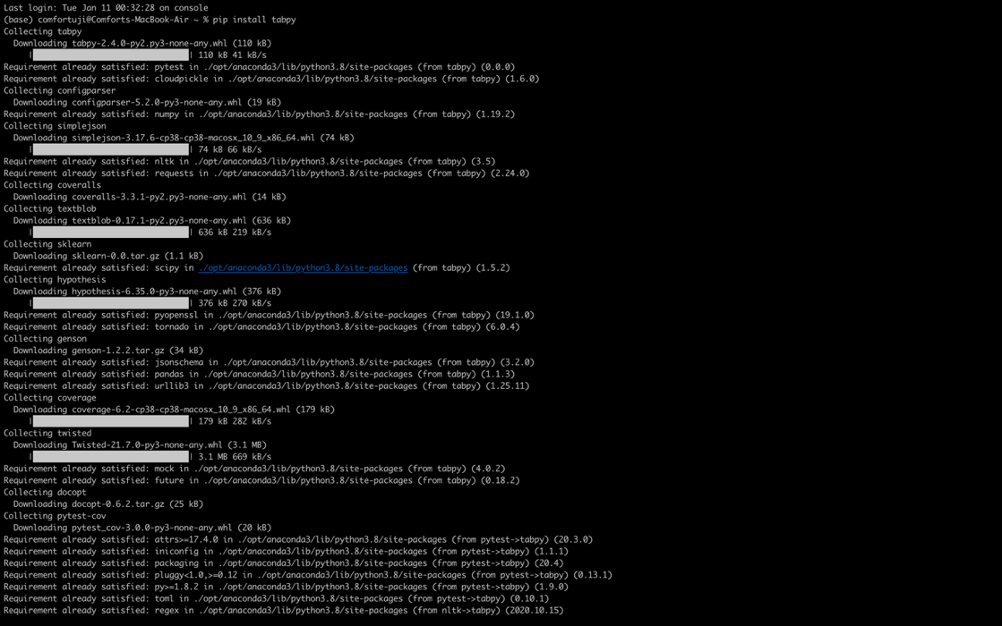

**Datasets Utilised**

A)

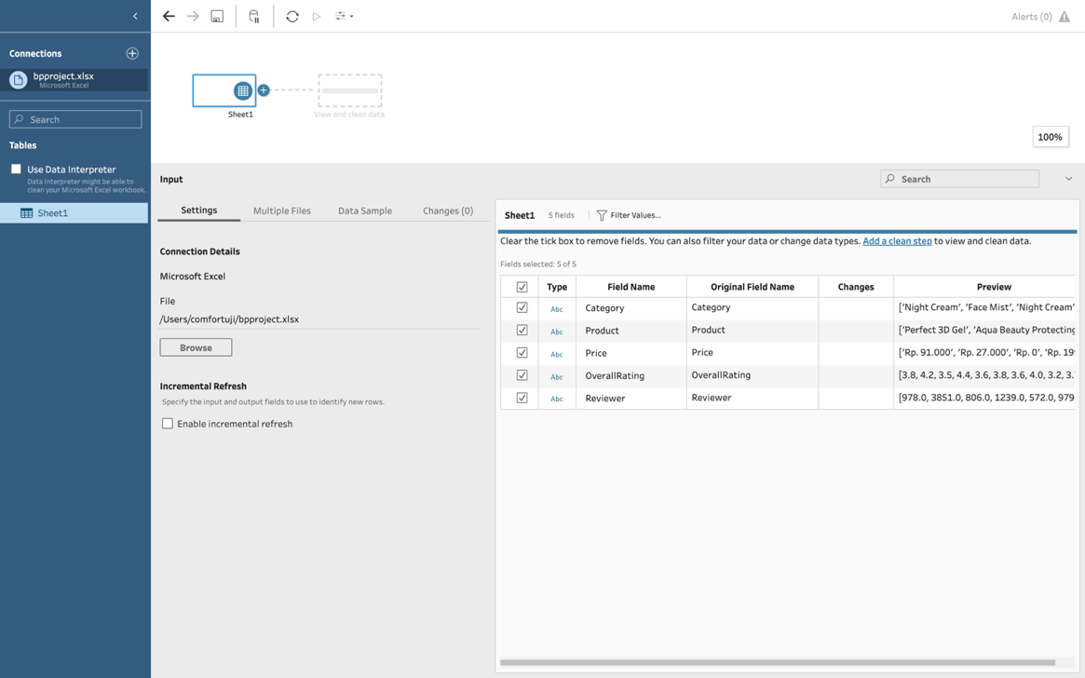

B)

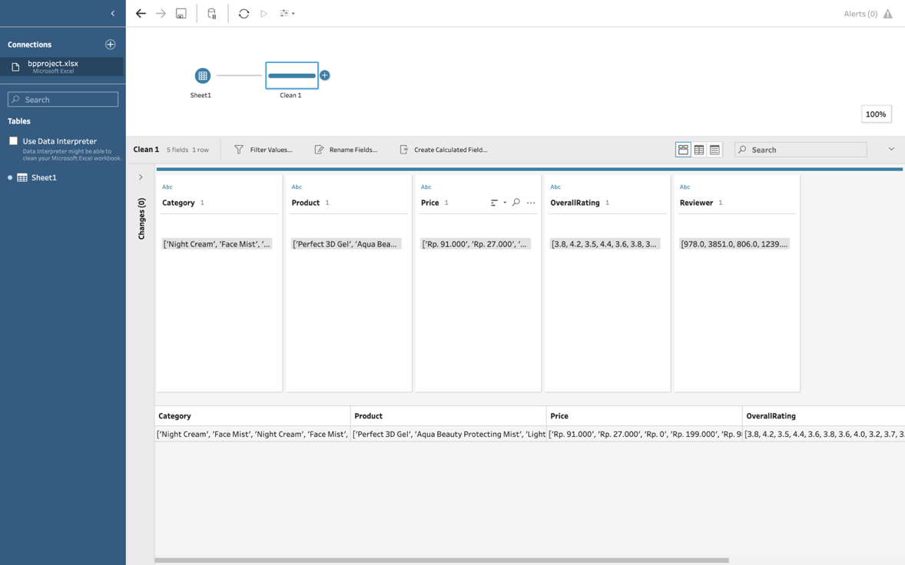

C)

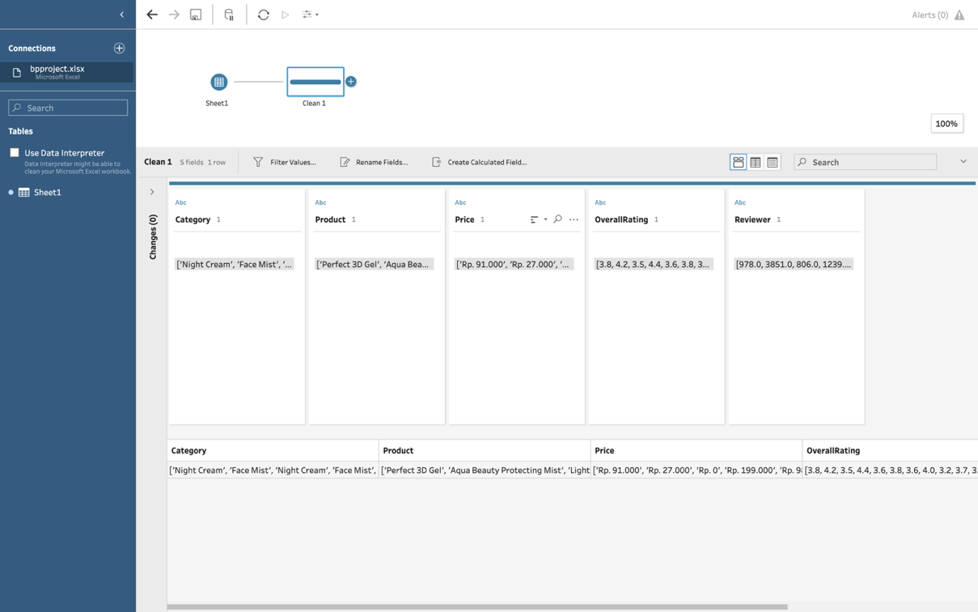

**Visualizations of the dataset on tableau**

A)

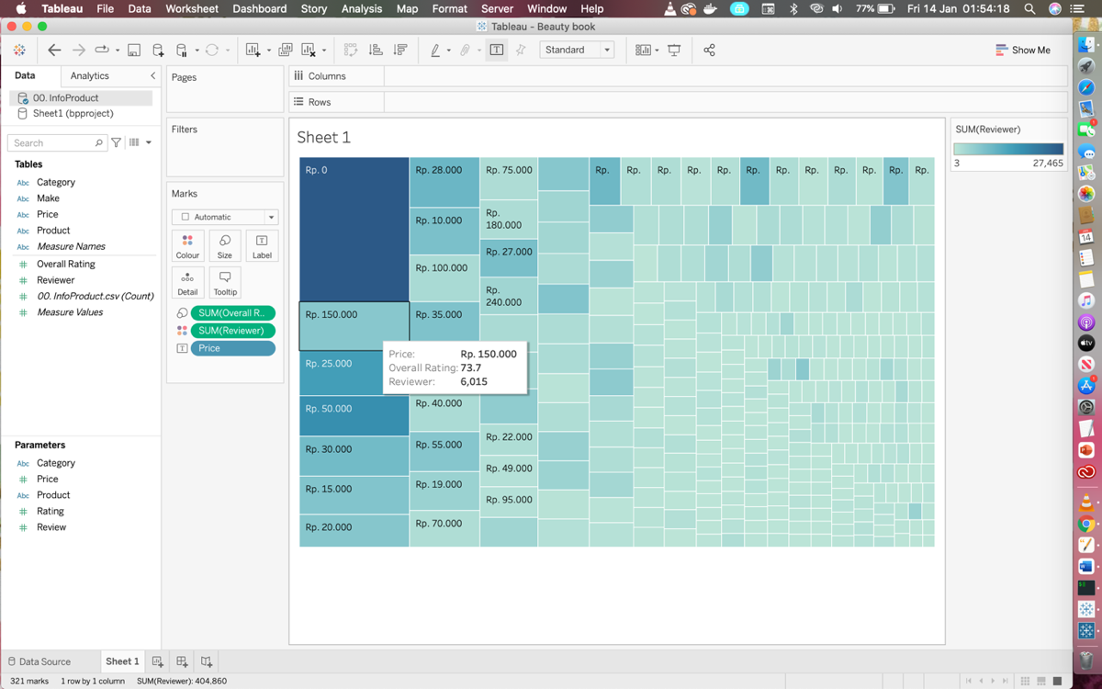

B)

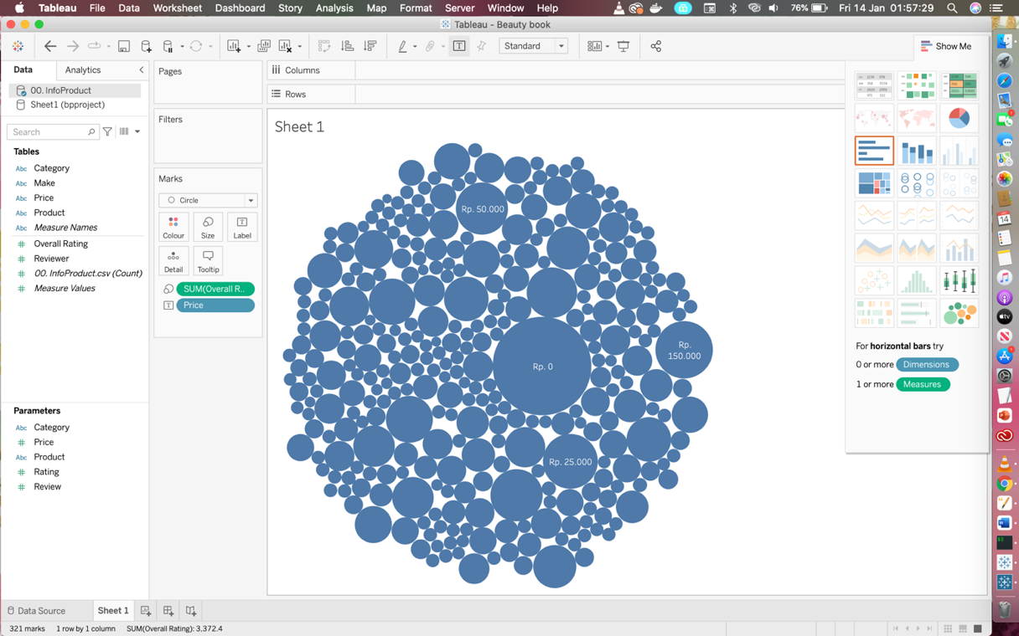

C)

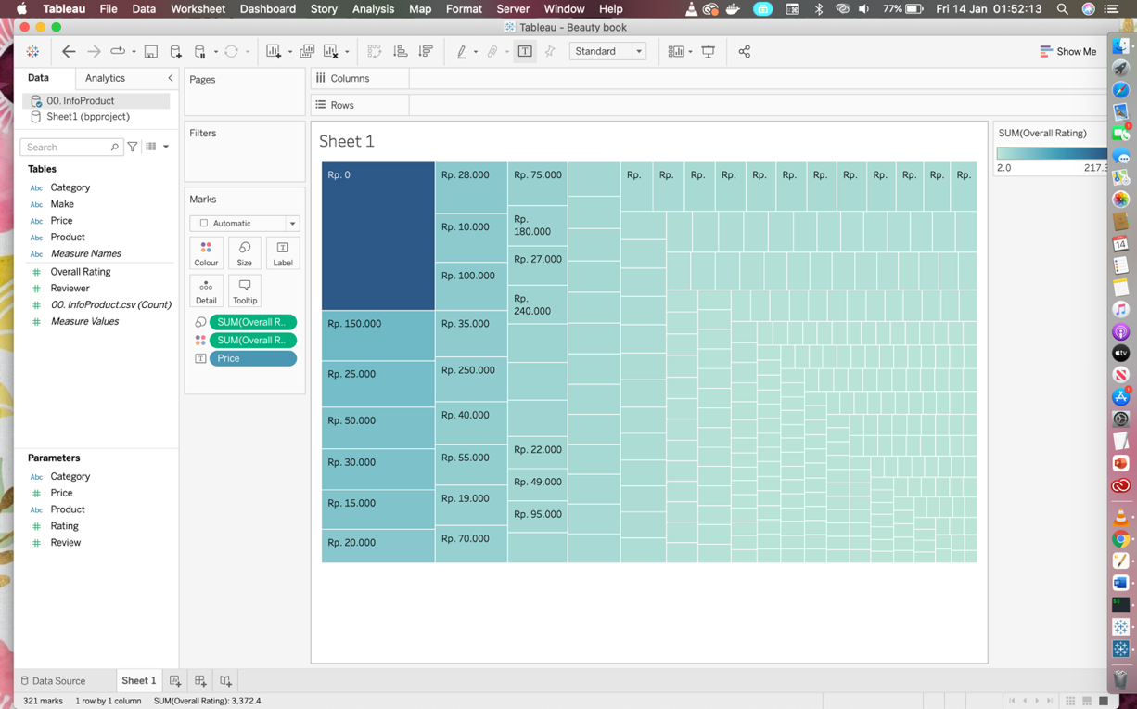

**LOGISTIC REGRESSION MODEL**

1. TabPy implementation



1. Model Computation

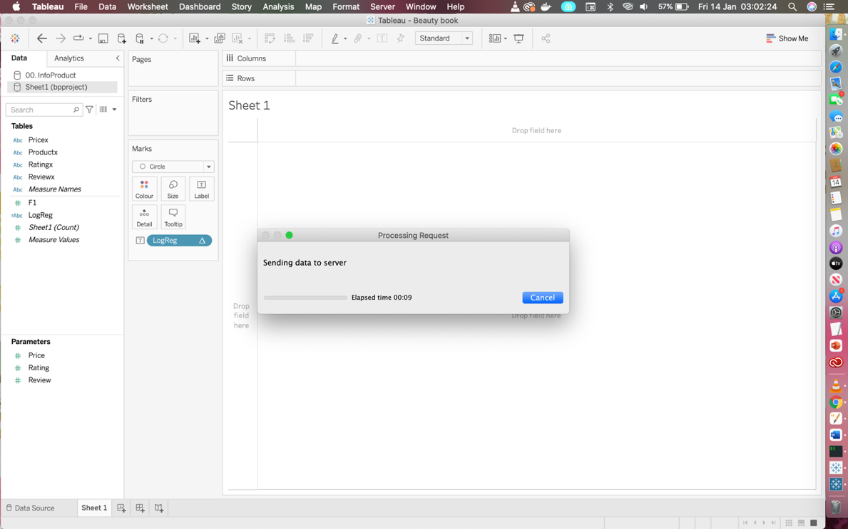

1. Logistic Regression Model Result

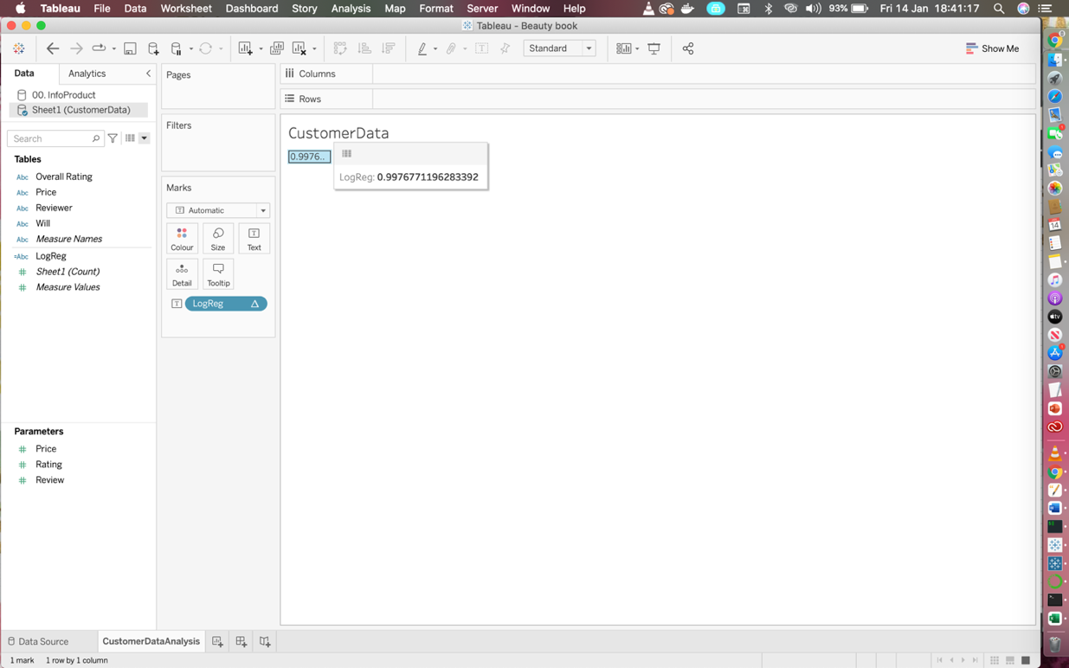

1. Model UI Components: Review Table

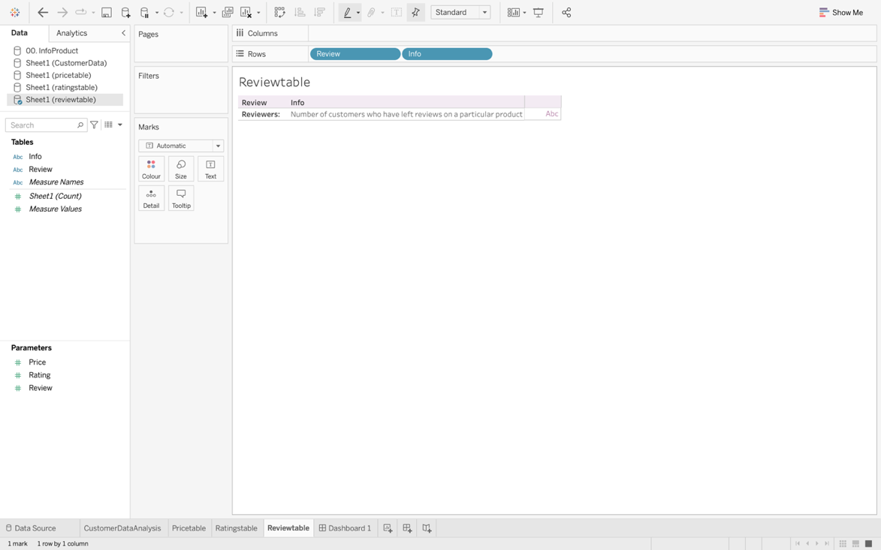

1. Model UI Components: Ratings Table

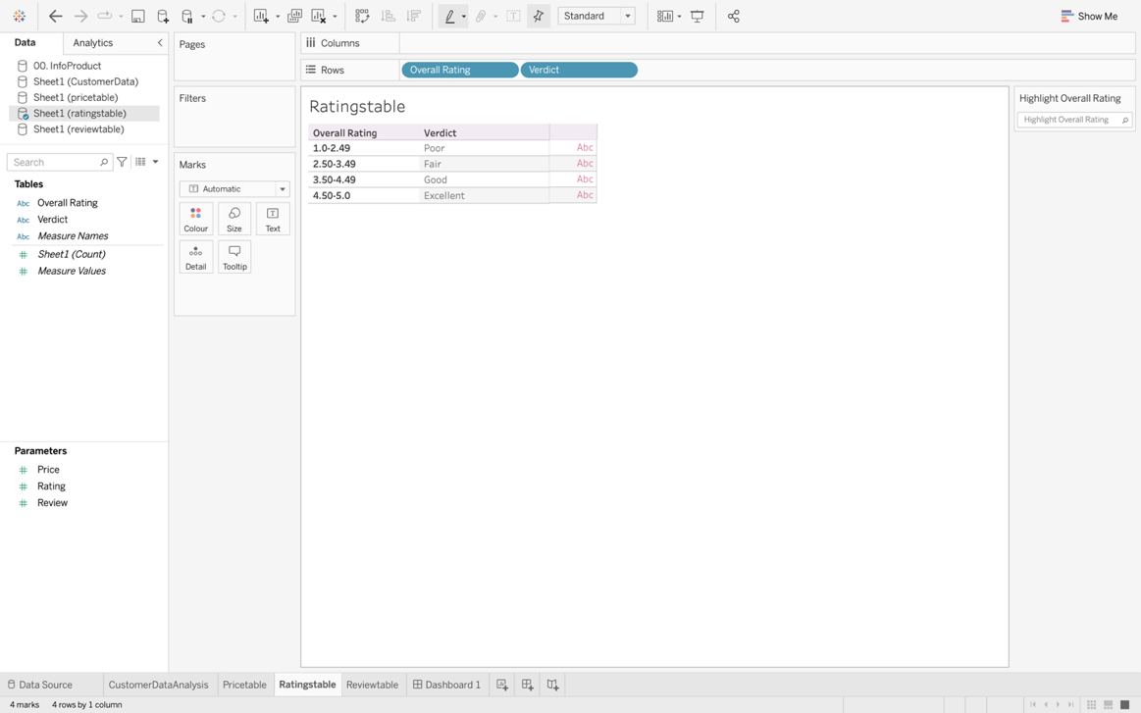

1. Model UI Components: Price Table

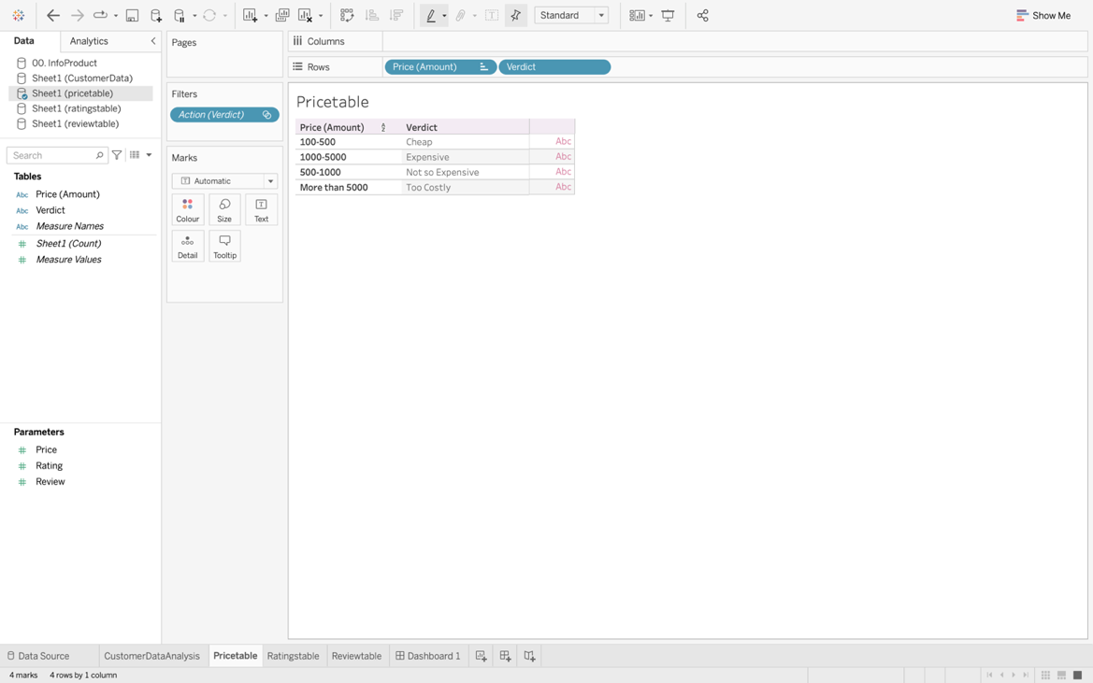

1. Model UI Components: Display Pane

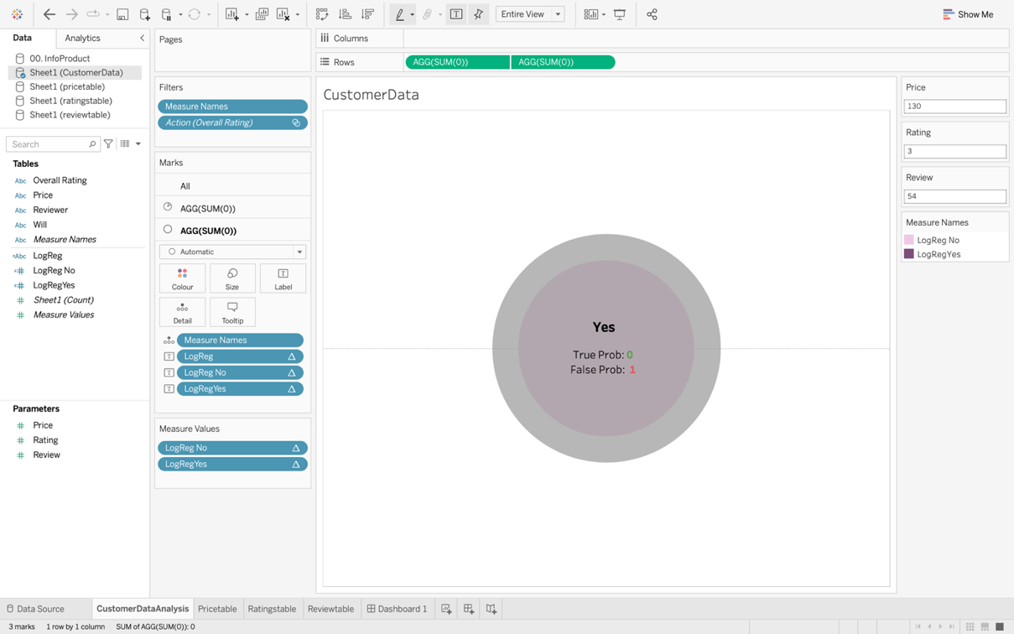

1. Model UI Components: Full Model User Interface

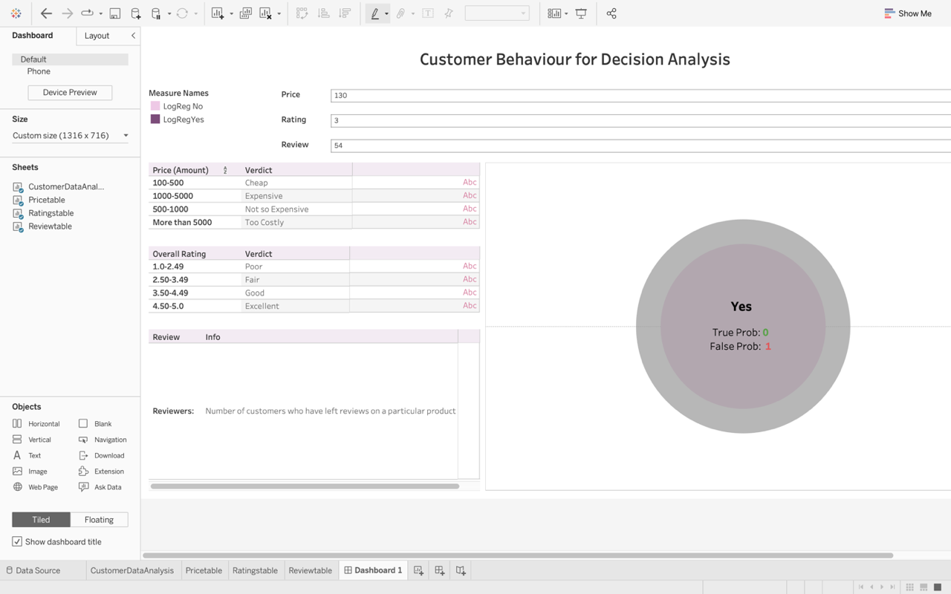

1. Technology Setup: Jupyter Notebook

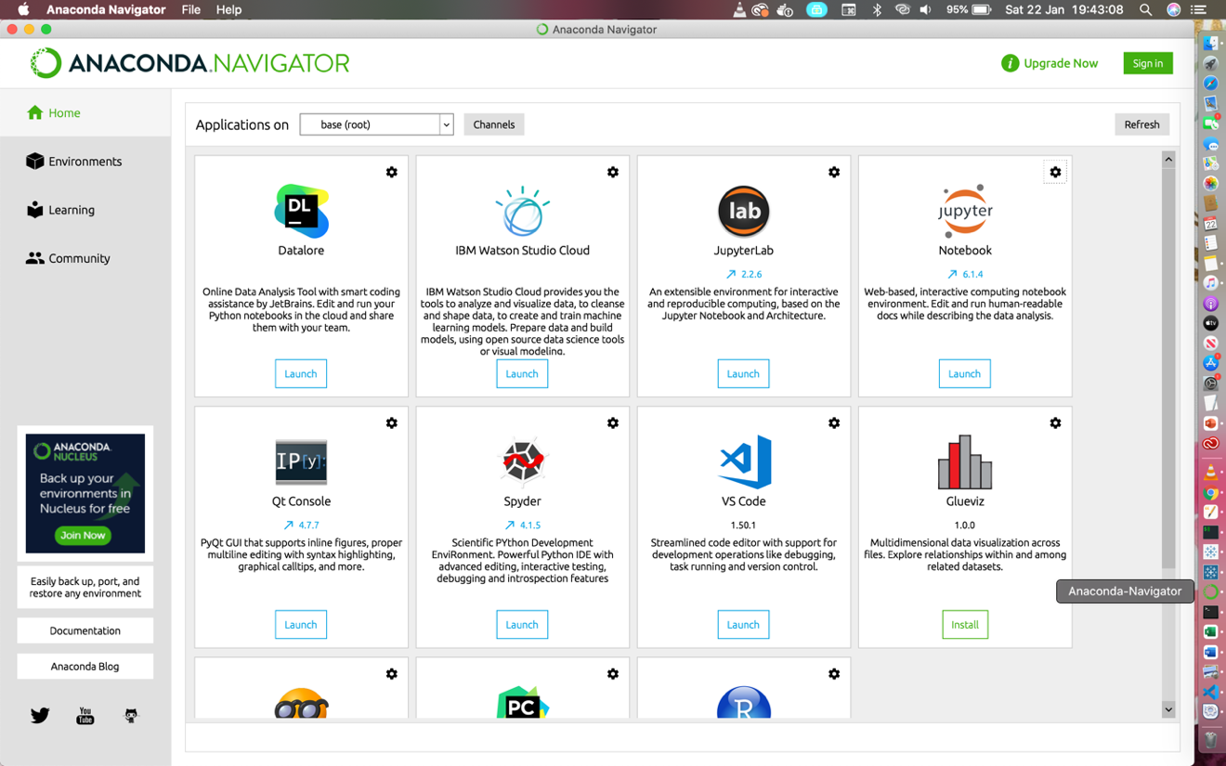

1. DECISION TREES MODEL

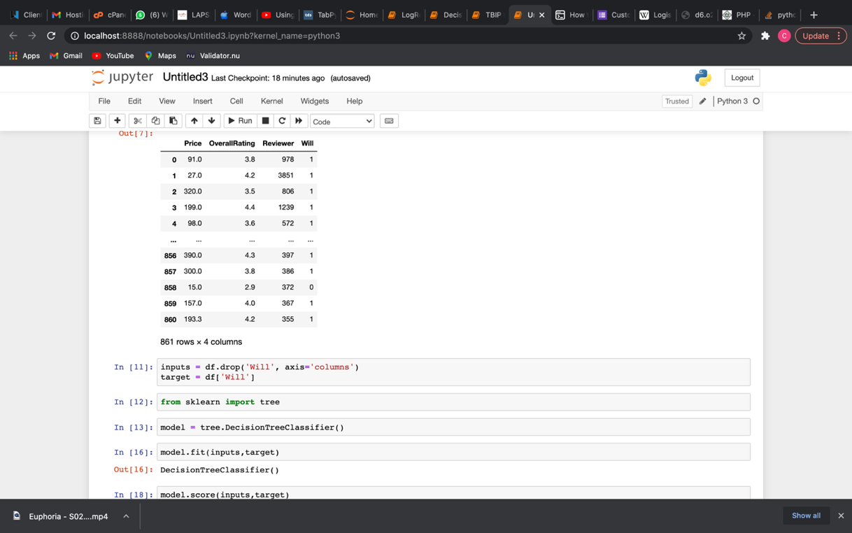

1. DECISION TREES MODEL II

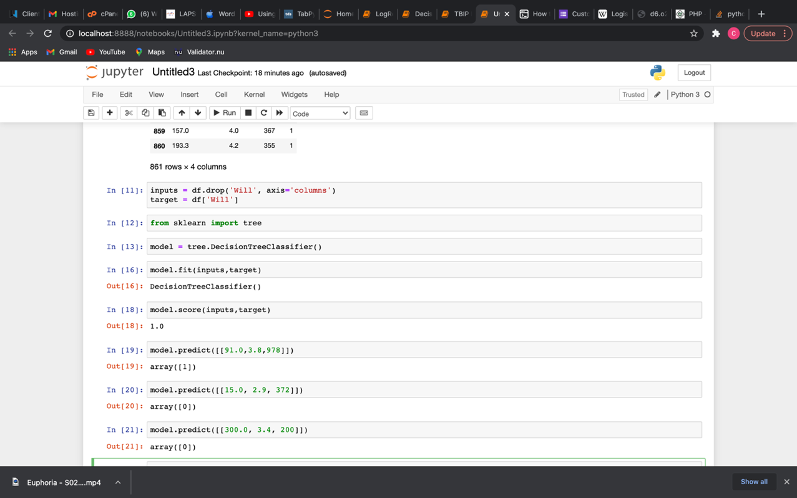

1. DECISION TREES MODEL III



1. RANDOM FOREST MODEL

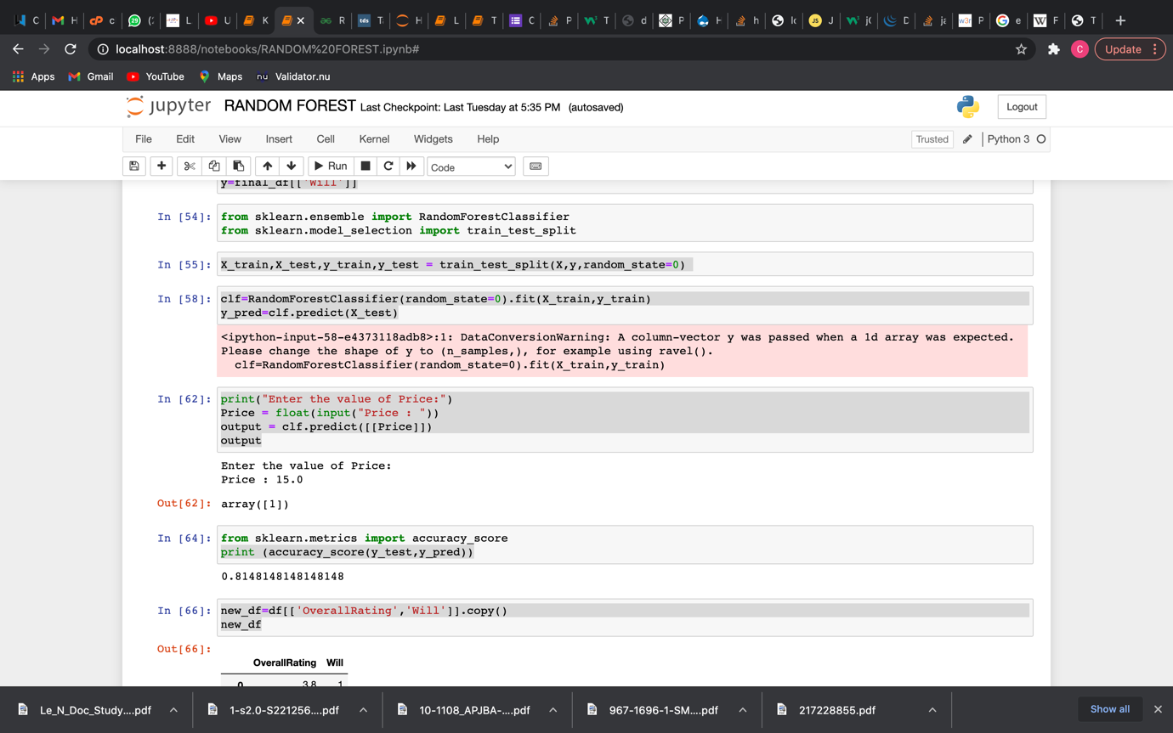

1. RANDOM FOREST MODEL II

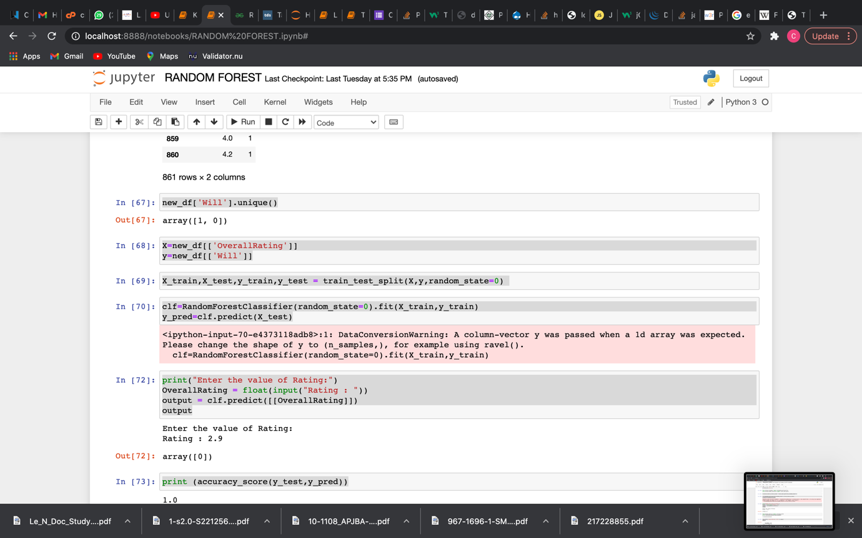

1. RANDOM FOREST MODEL III



**RANDOM FOREST MODEL VISUALIZATIONS**

A)

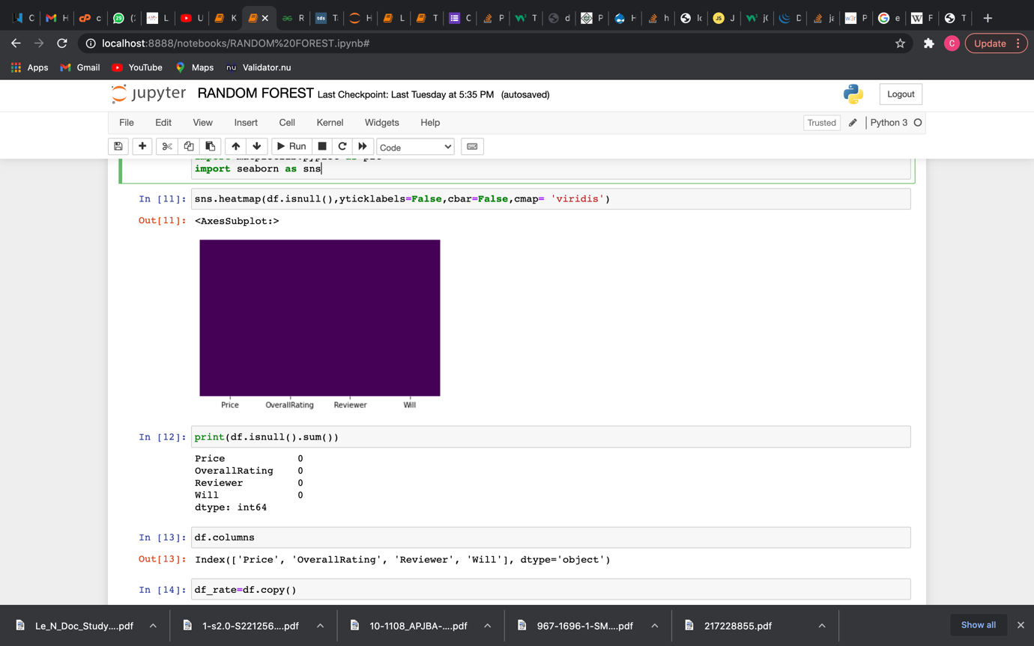

B)

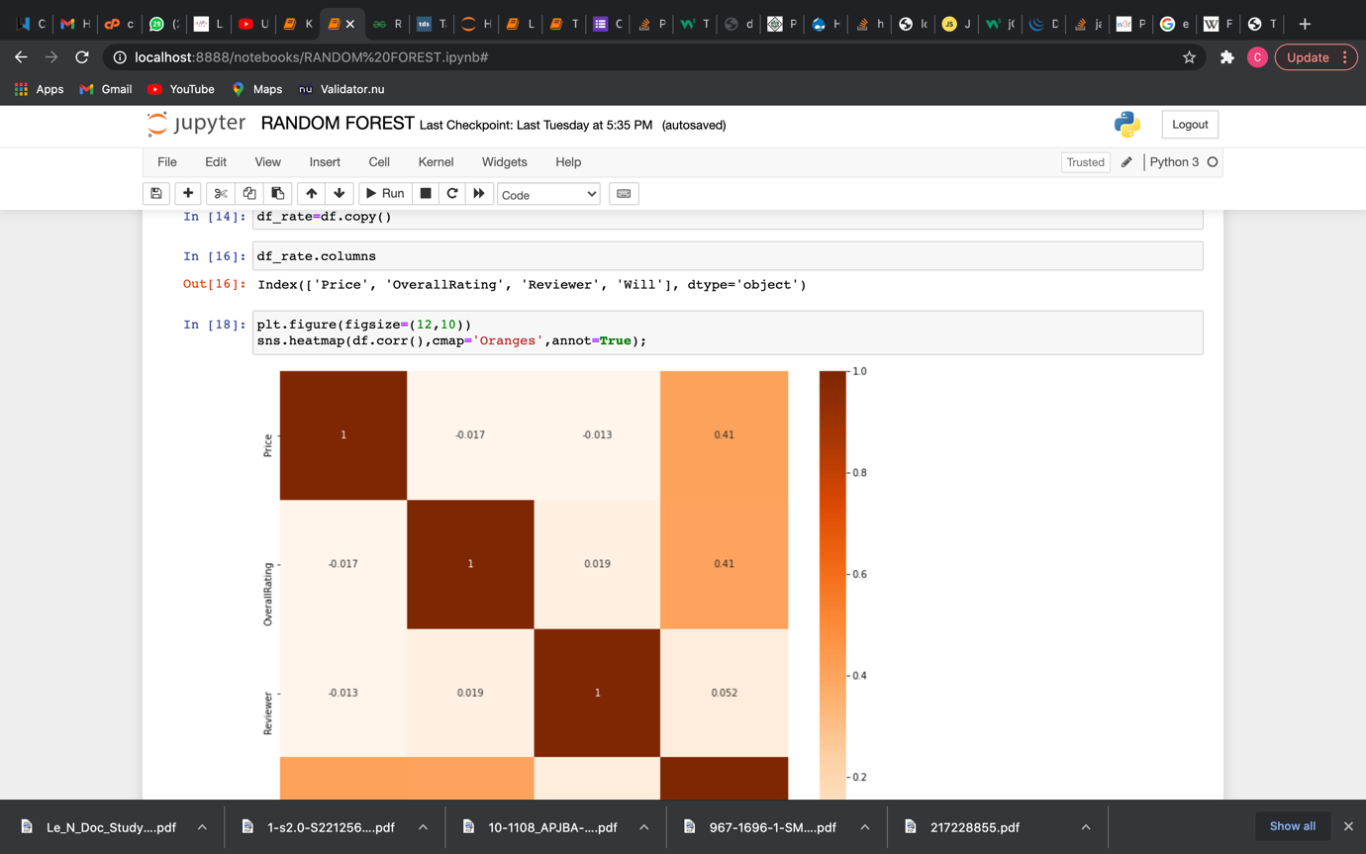

C)

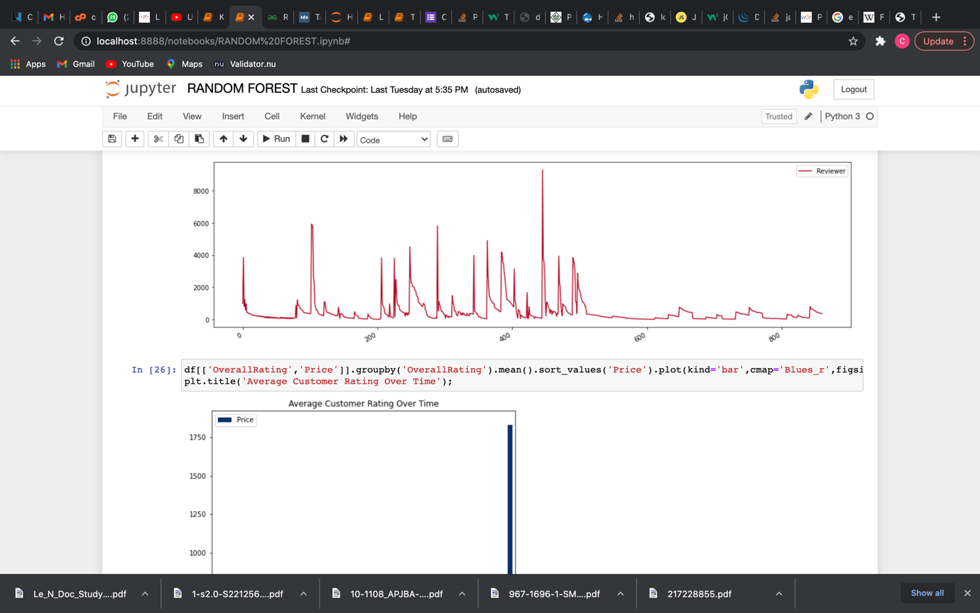

D)

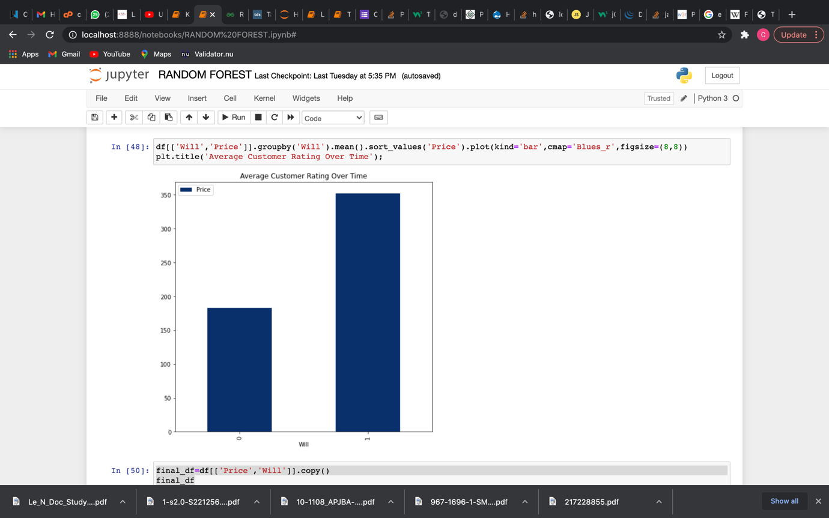

E)

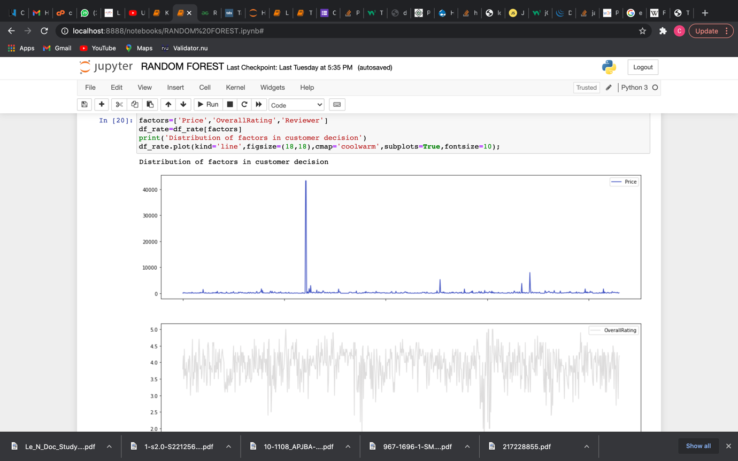

**K-NEAREST NEIGHBORS MODEL**

* DATA VISUALIZATIONS

A)

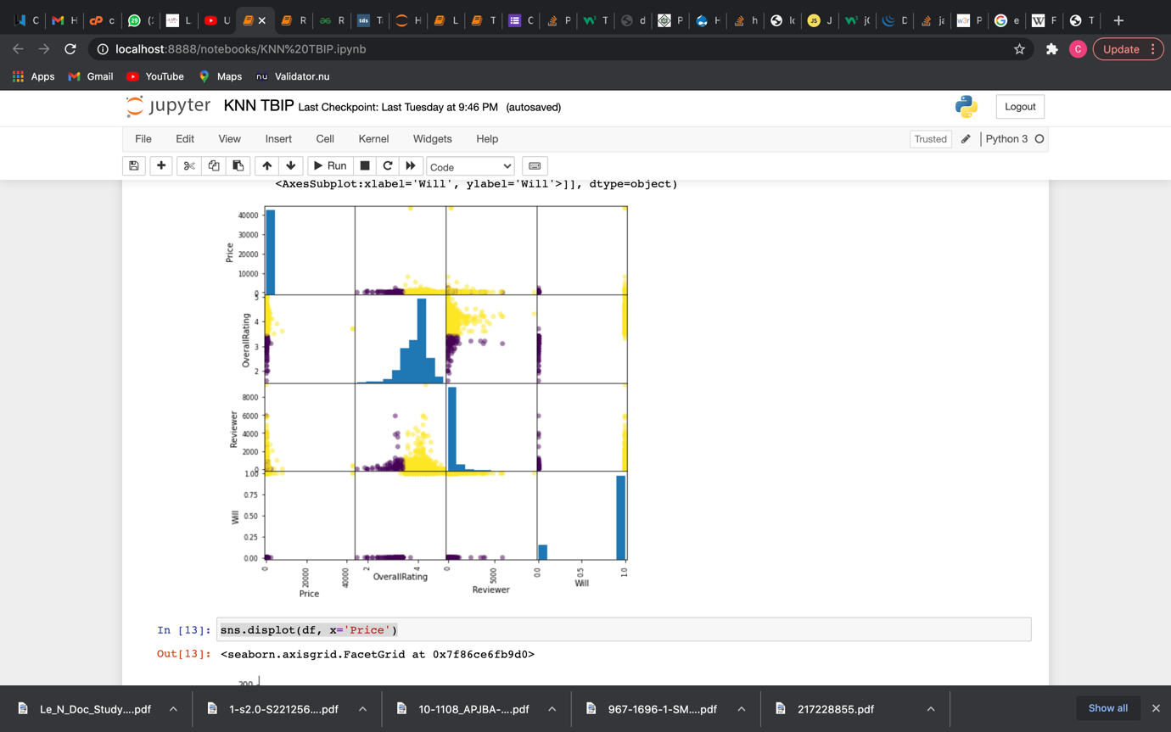

B)

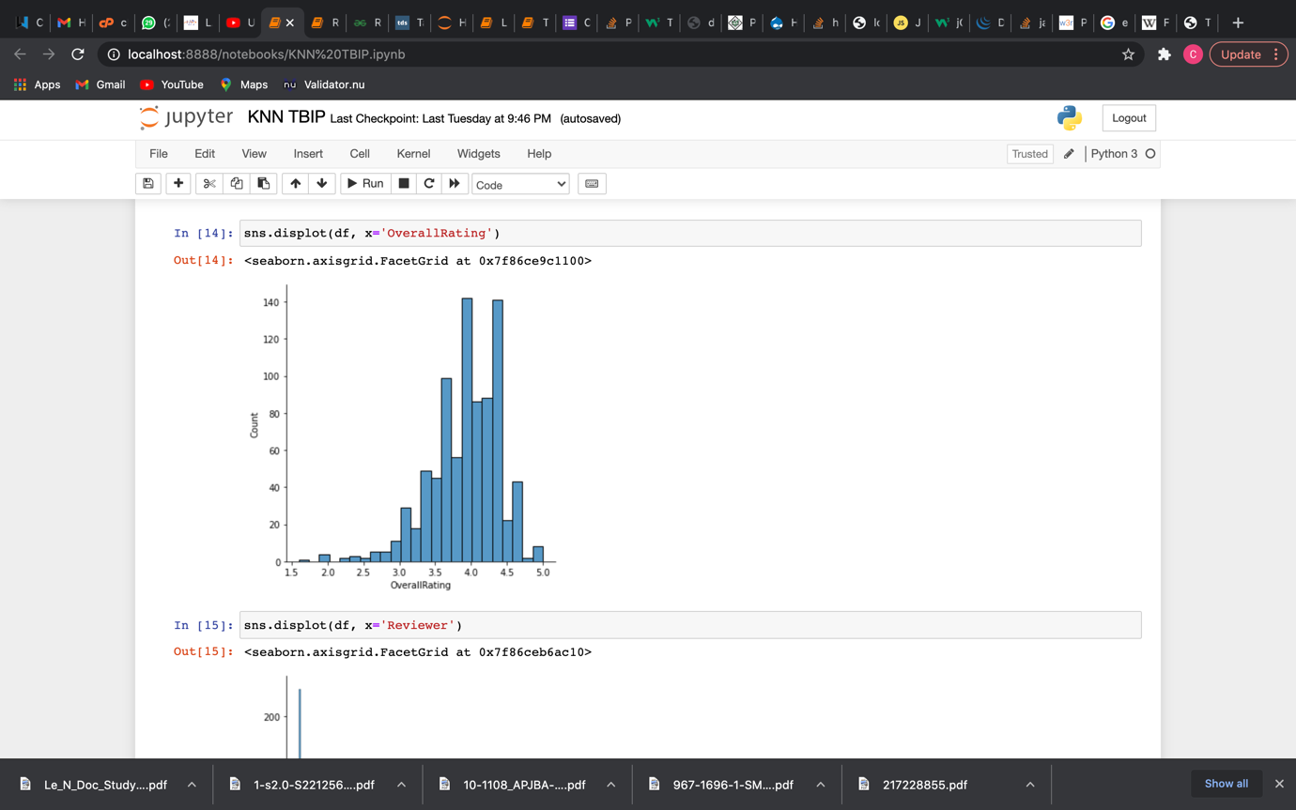

C)

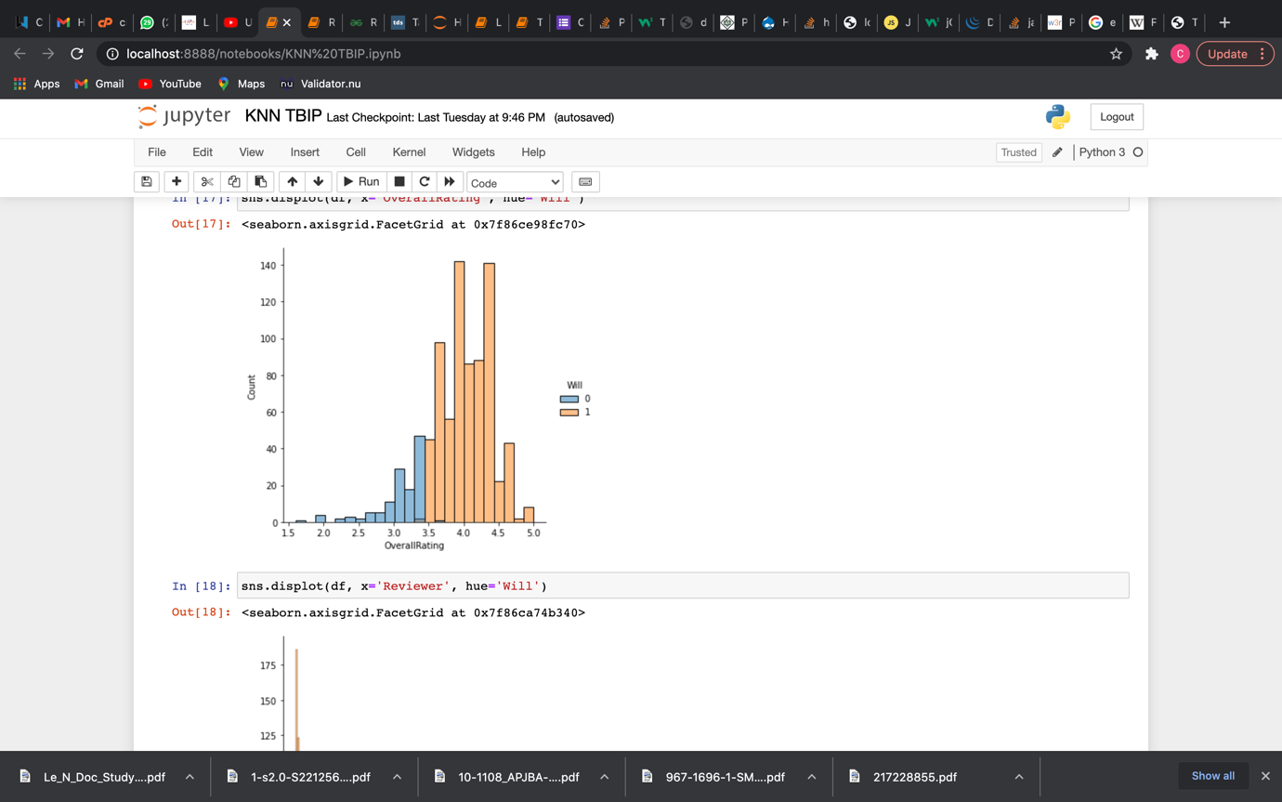

D)

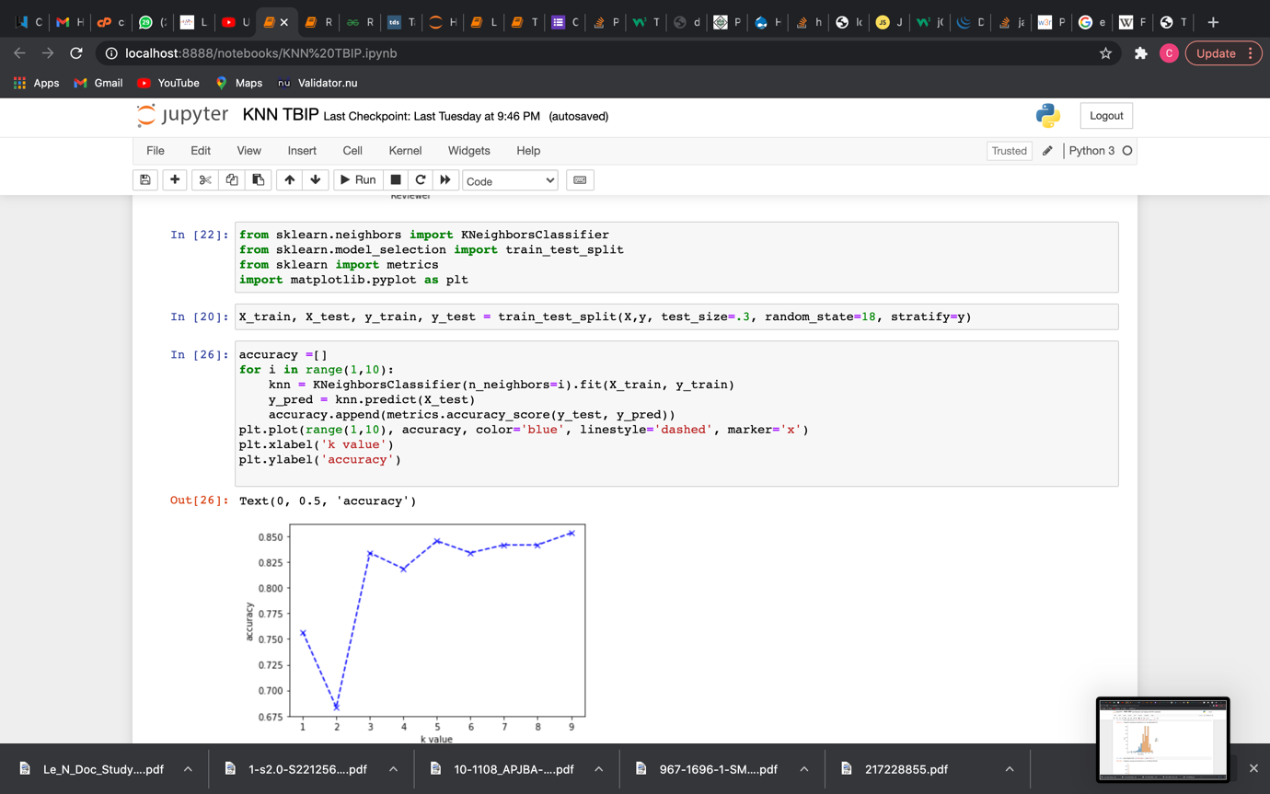

* IMPLEMENTATION OF THE KNN MODEL

A)

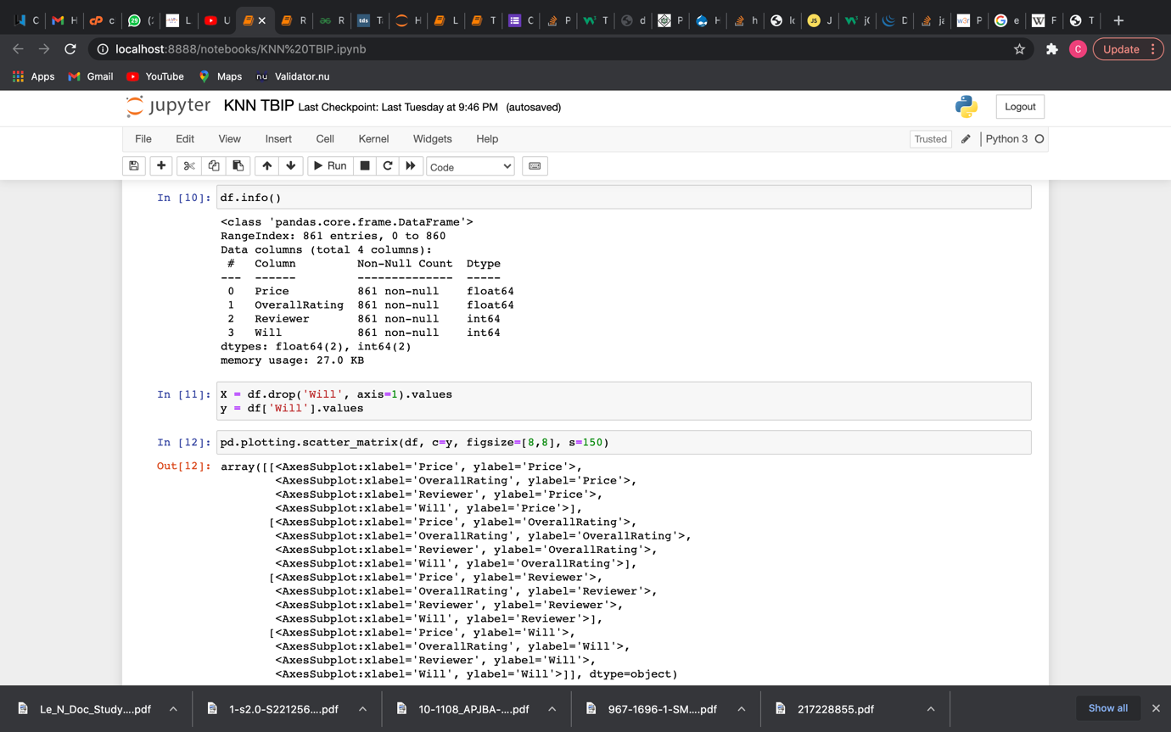

B)

